|  |
| --- |
| Javascript Basic to AdvancceArifur Rahman |



|  |
| --- |
| Var declare & assaign |
| Let redeclare & assaign |
| Scope |
| const |

|  |
| --- |
| Why need array |
| 3 way create array |
| Accesing array 1 way |
| Changing array eleme |
| Full arry access |

|  |
| --- |
| Why need function |
| How to create function |
| Arg & param |
| Function invocation |
| Function return undefi |
| () না দিলে কি হয় |
| Func as variable |
| Local variable |

|  |
| --- |
| Object create |
| Accessing obj property |
| This in object |
| Literal syntex |
| 4 way create obj |
| 2 way access in obj property |
| Value reassign in object |

|  |
| --- |
| String থেকে part extract   1. slice() 2. subString() 3. substr() |
| replace replaceAll() |
| toUpperCase()  ToLowerCase() |
| Concate() |
| Trim() |
| padStart() padEnd() |
| chartAt() chartCodeAt() |
| Split() |

|  |
| --- |
| indexOf() lastIndexOf()  Search() |
| match() |
| Includes() |
| startsWith() endsWith() |

|  |
| --- |
| interpolation |

|  |
| --- |
| Integer/floating precision |
| toString() |
| toFixed() toPrecision() |
| Number()  parseInt() parseFloat() |

|  |
| --- |
| toString() join() |
| Push() pop()  unshift() shift()  splice() |
| slice() |
| Changing element |
| Array.length |
| Concate() |

|  |
| --- |
| Sort() reverse() |
| Numeric sort() |
| Compare function |
| Higher and lower value |
| Sorting obj array |

|  |
| --- |
| forEach() map() |
| filter() |
| reduce() |
| every() |
| Some() |
| indexOf()  lastIndexOf() |
| Find() findIndex() |
| Array.form() |
| Includes() |

# Var

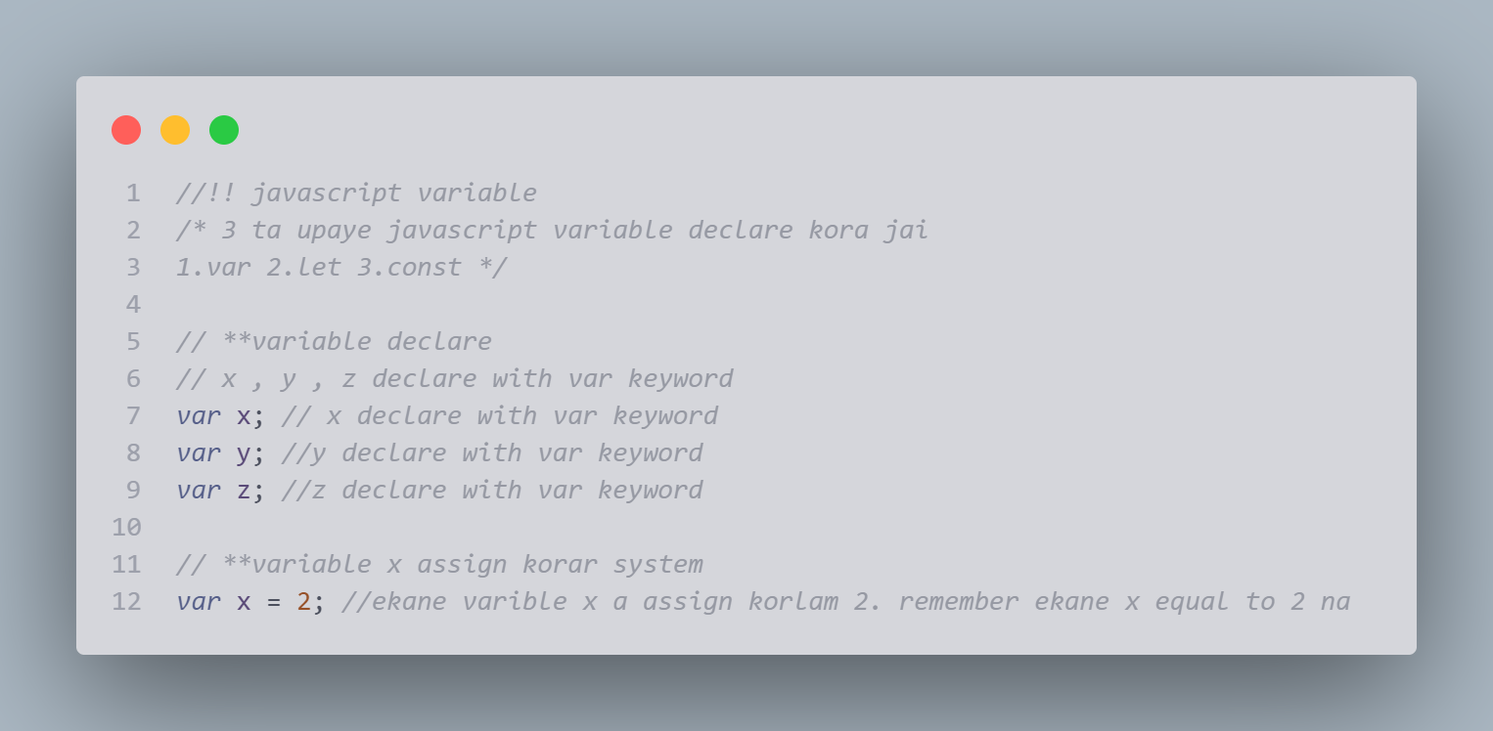

# Letlet 1

**let Redeclare kore jabe na

let x = "arifur";

let x = "rahman";

/* error dekabe -identifier 'x' has already been declared

koron var x already declaire hoye geche */

//** let a = "anwar";

//** let a = 2;

// let Redeclare kore jabe na

block scoop

/* scoop 3 type

1.global scoop 2.function scoop 3.block scoop

2015 age mane es6 er age javascript a 2 ta scoop chilo 1.global scoop 2.function scoop

es6 introduce let and const .and these keyword provide block scoop

variable can be declare inside a {} block cannot be access from outside block

*/

*// !block scoop*

*/* scoop 3 type*

*1.global scoop 2.function scoop 3.block scoop*

*2015 age mane es6 er age javascript a 2 ta scoop chilo*

*1.global scoop 2.function scoop*

*es6 introduce let and const .and these keyword provide block scoop*

*variable can be declare inside a {} block cannot be access from outside block*

*\*/*

{ *var* d = 5 };

console.log(d); *//{} scoop er betore varible declare korle outside theke tar value pawa jai*

*//**{}scoop block cannot be access from outside the block*

{

*let* e = 3

    console.log(e); *//ekane kaj korbe*

};

*/* console.log(e); //eakne kaj korbe na */*

*// **function scoop*

*let* f = 5; *//ekane f variable r function er f same na*

function account () {

*let* f = 4;

    console.log(f);

}

account();

console.log(f);

*let* w;

w = 'arifur';

w='rham'

console.log(w);

**Block scoop er let r block scoop er bahirer scoop totally differnt even they are same name

*// !!Redeclare*

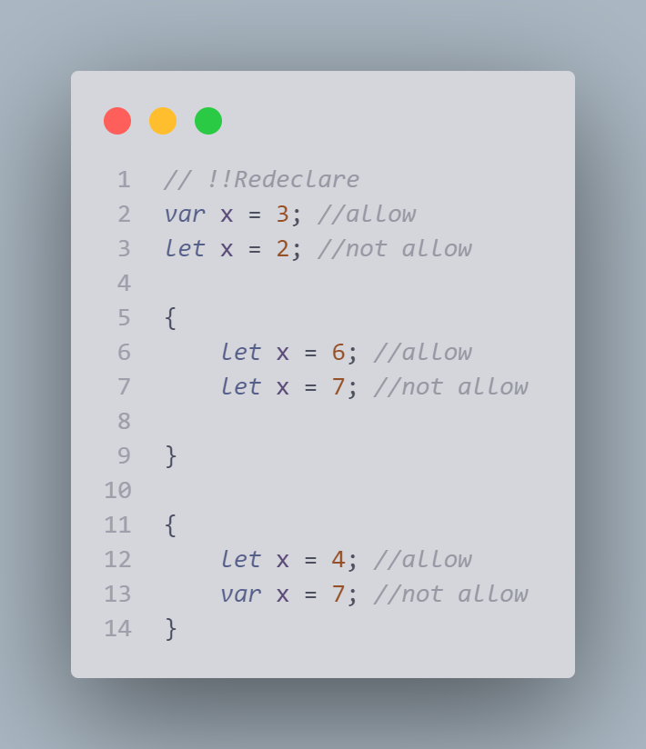

*/ !!let hoisting*

*// !!let hoisting*

carName = "toyota";

*var* carName;

console.log(carName);

*/* se prothome programme ta akbar deke nei.se deke nei kothi kothi var declairation ace.se asole protheme*

*hoist kore var declairation golo upore niye jai */*

*/* var carName;*

*carName=default */*

carName = "toyota";

*var* carName;

console.log(carName);

*// **let er ketree*

*/* busName = "toyota";*

*let busName;*

*console.log(busName); */*

*// Cannot access 'busName' before initialization.ei error ta asbe*

*// senario*

*// let busName;*

*// busName = "toyota";*

*// let busName;*

*// console.log(busName);*

Const

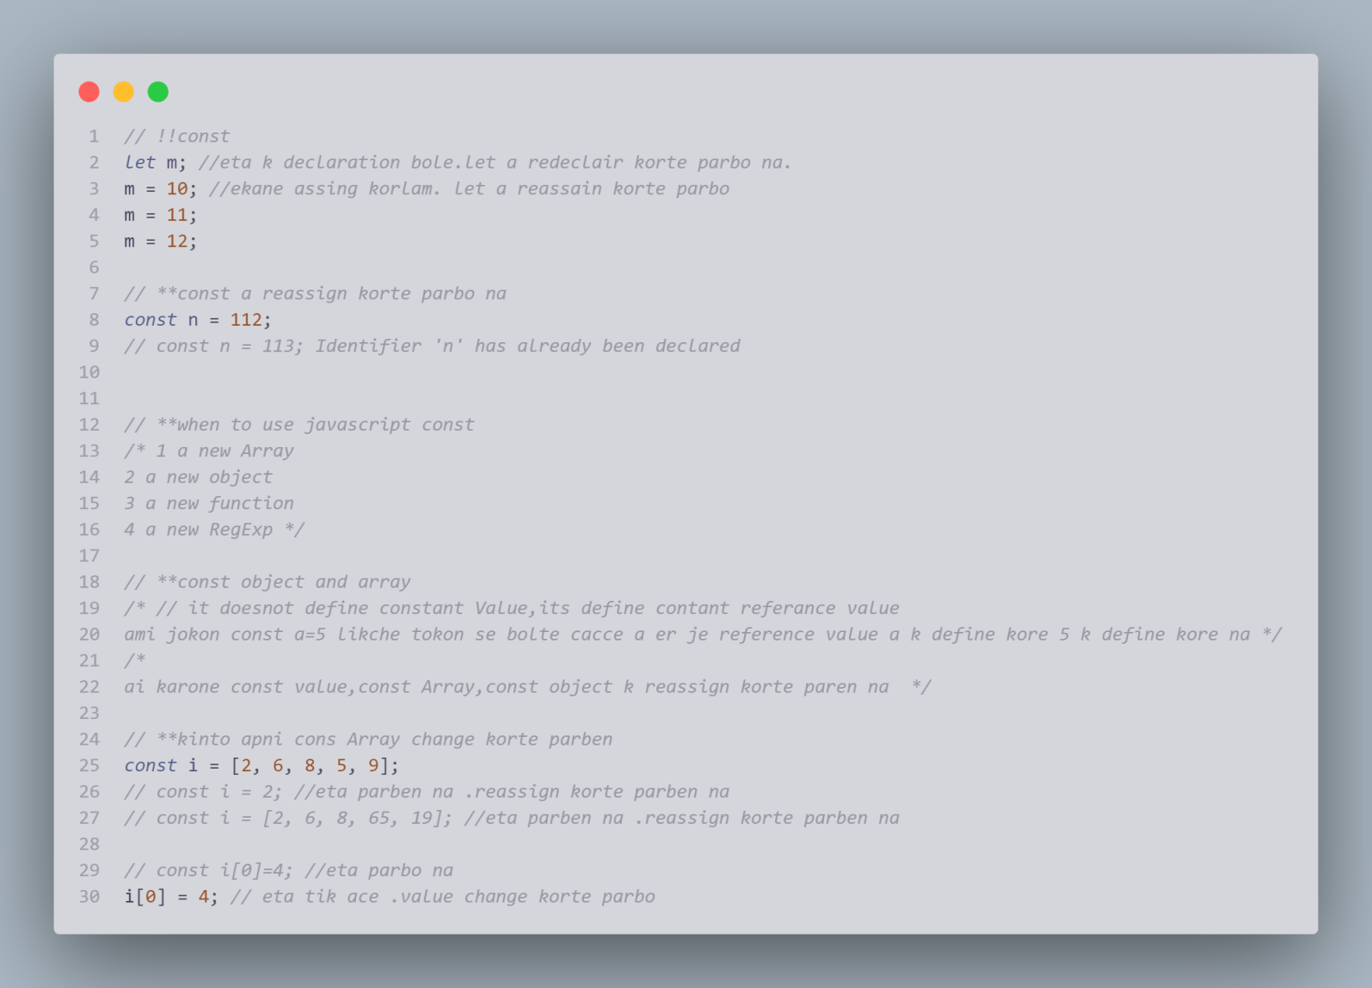

# Function

#### 7 things we will discuss here about function

* How to create function
* Argument and parameter
* Function invocation
* Function return (undefine in return example)
* () na dile ki hoi caller name a
* Function use as variable value
* Local variable

### How to create function

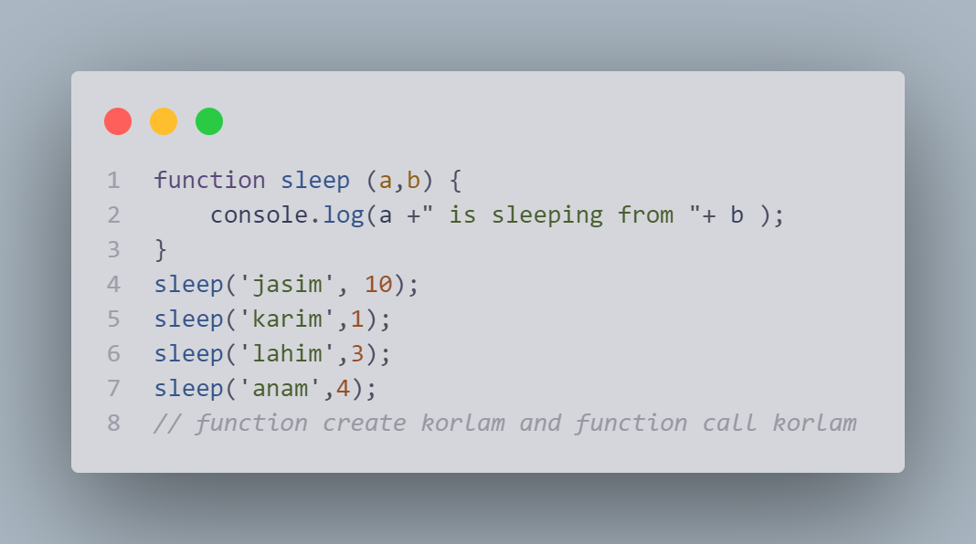

### Argument and parameter

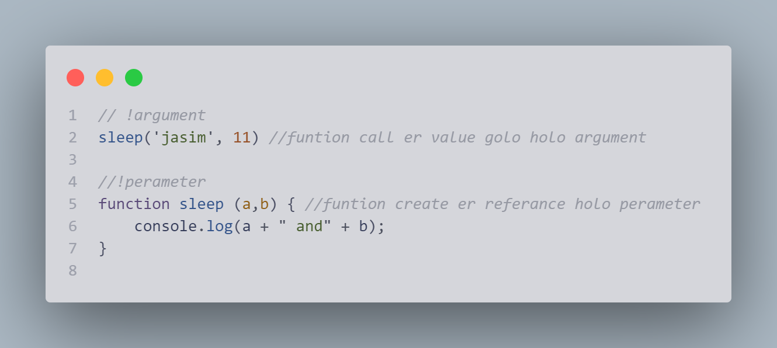

### Function invocation

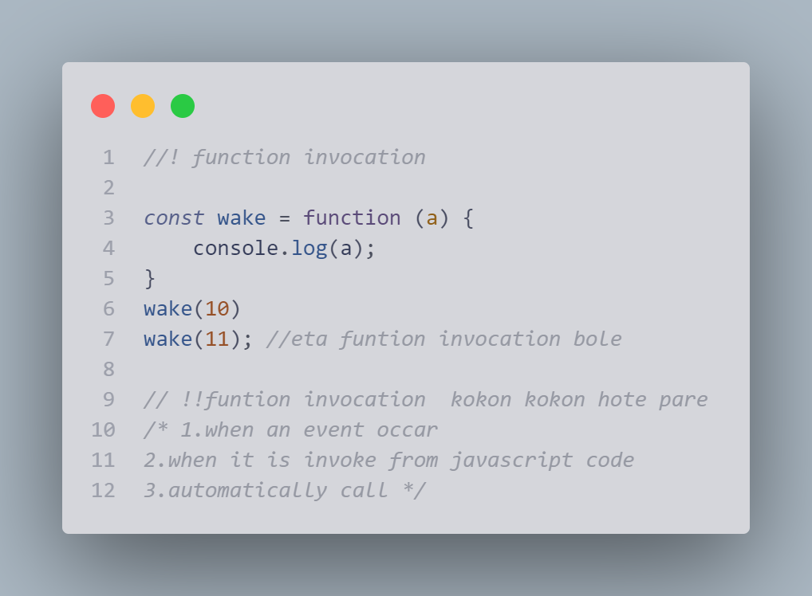

### Function return (undefine in return example)

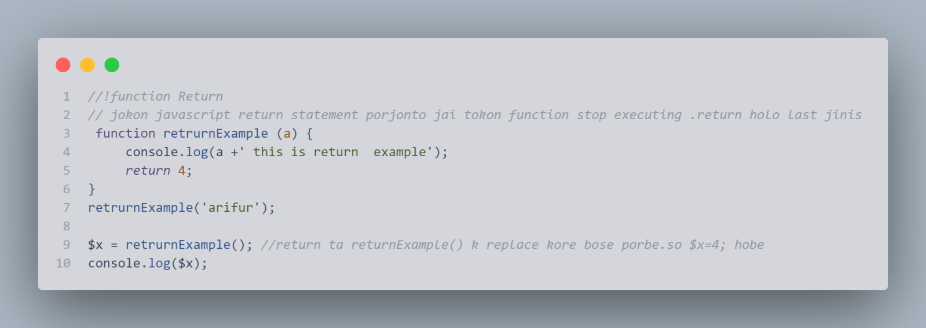

### function return more

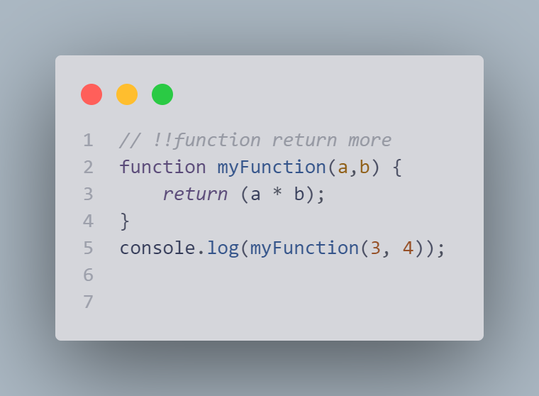

### undefine example

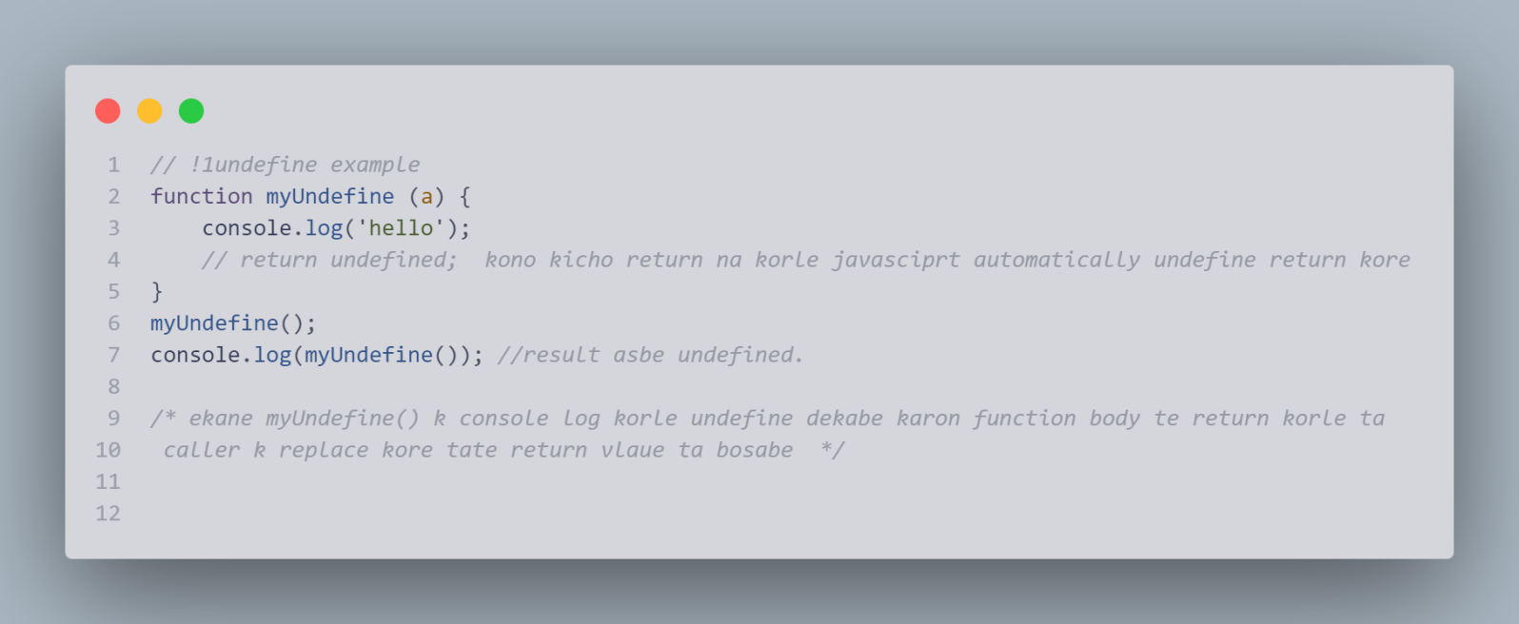

### () na dile ki hoi caller name a

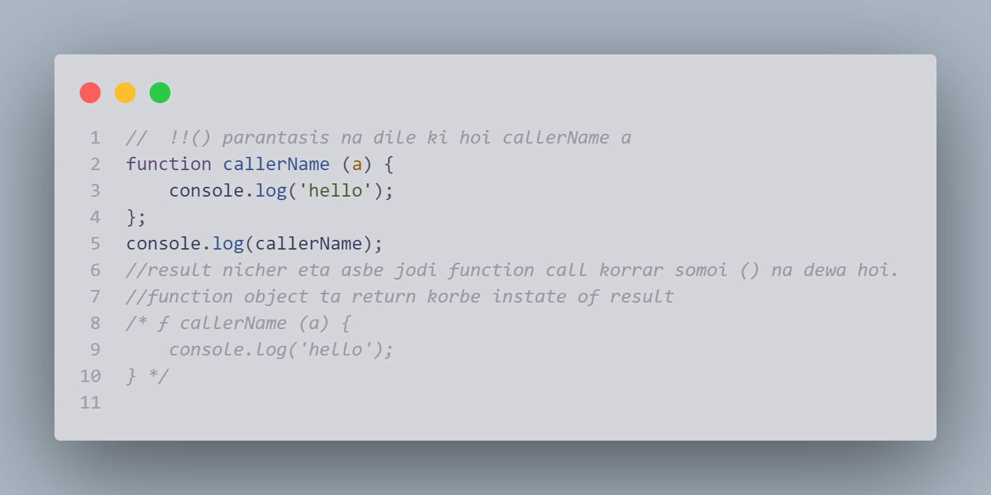

### Function use as variable value

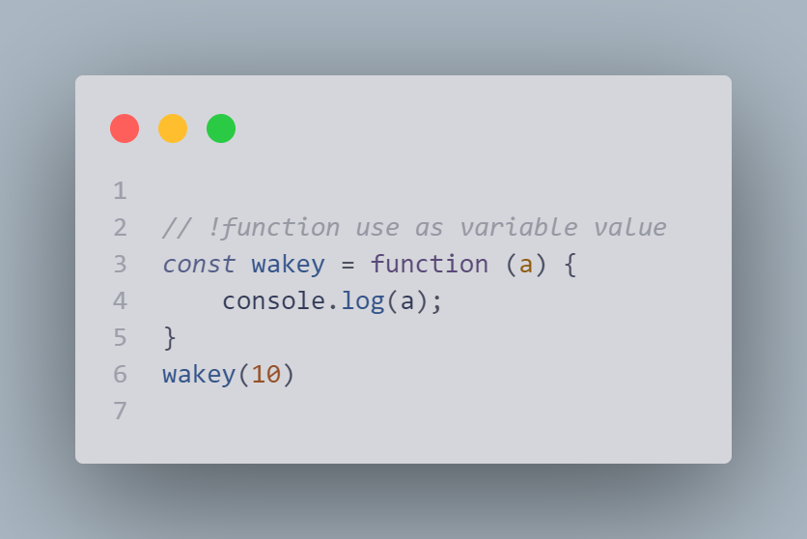

### Local variable

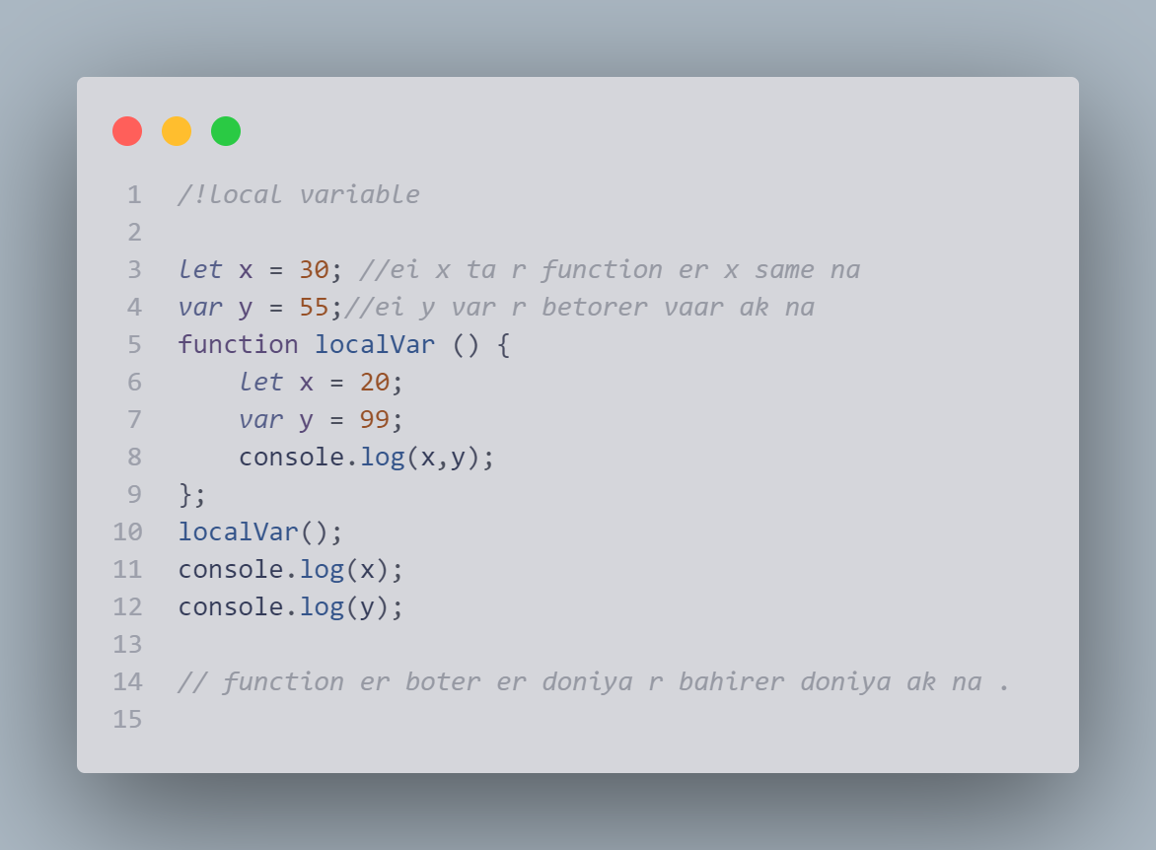

# 

# Javascript object

* Object create
* Accessing object property
* This in object
* Literal syntex
* 4ta upaye javascript object create kora jai
* two javascript object property te acces kora jai
* Javascript a object property and value assign korar system:

## Create an object

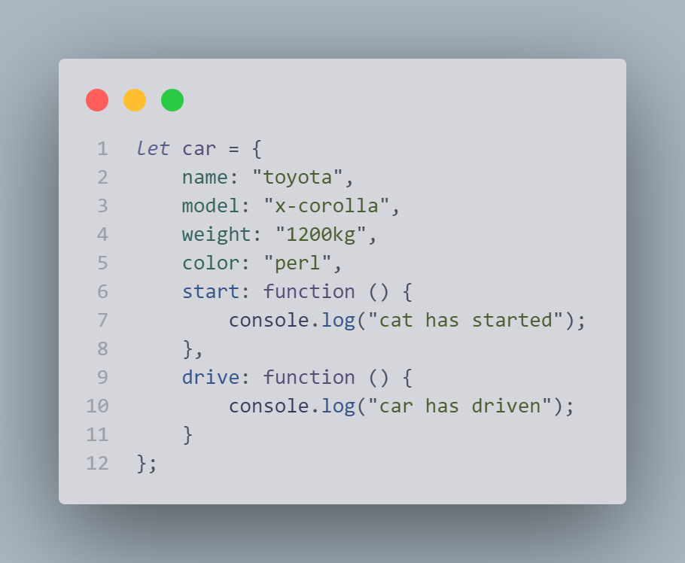

##### Best practice is use const in object

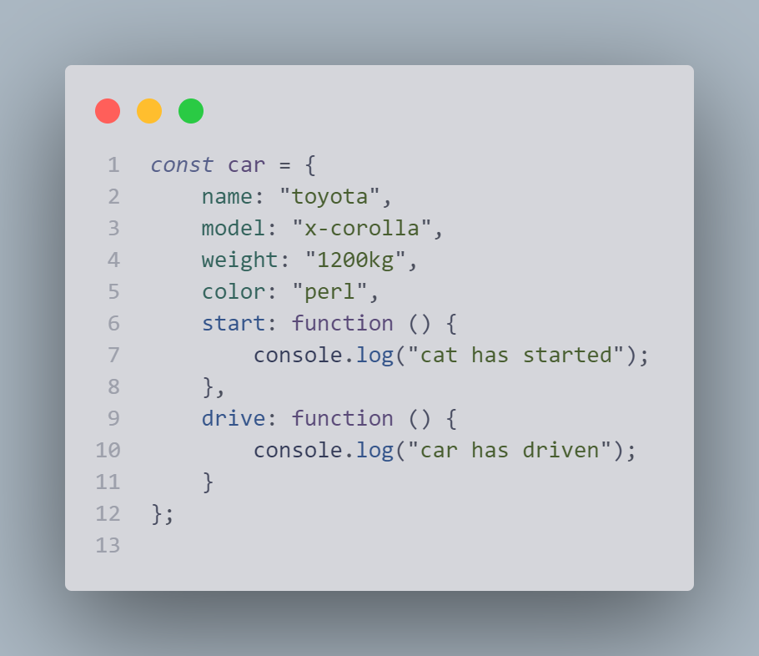

## Accessing object property:

two way we can access in object property

1. objectName.property ex car.name
2. As like array car[‘name’]

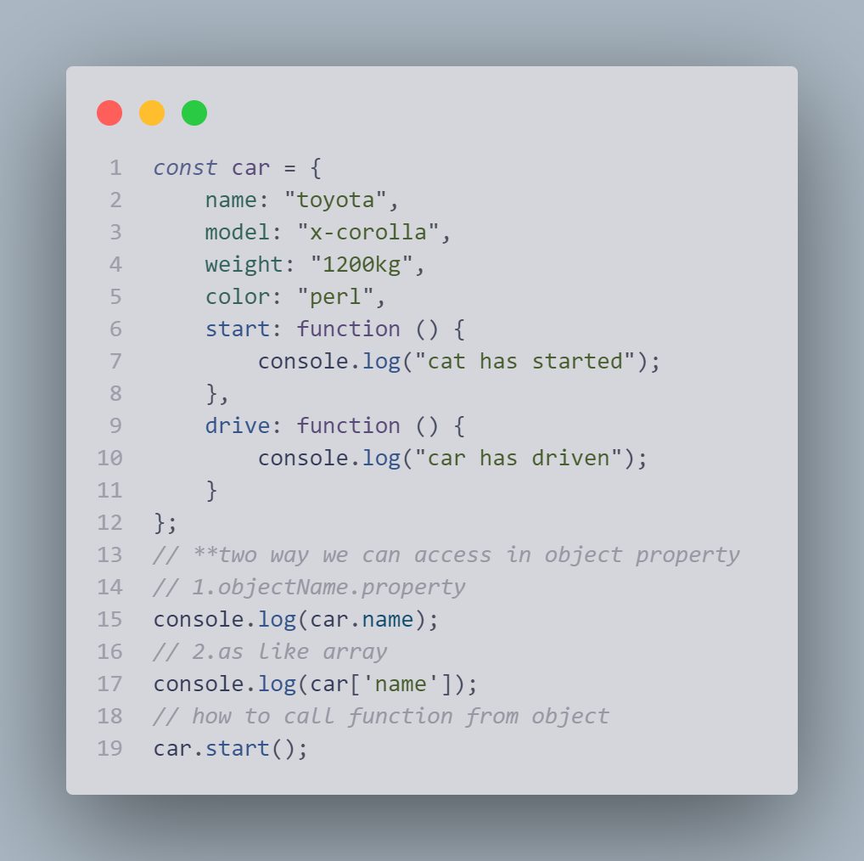

## This in object

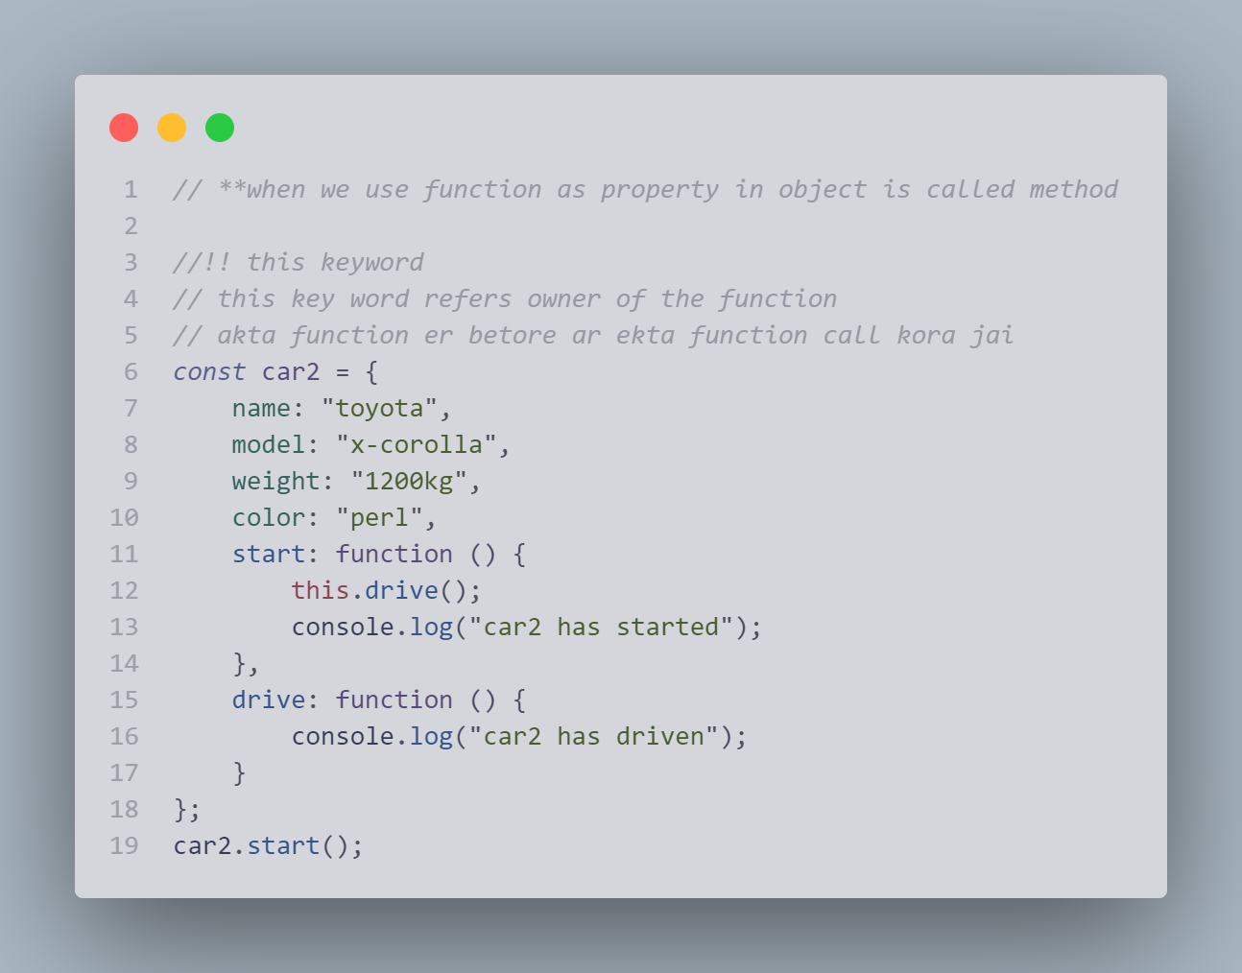

## Literal syntex

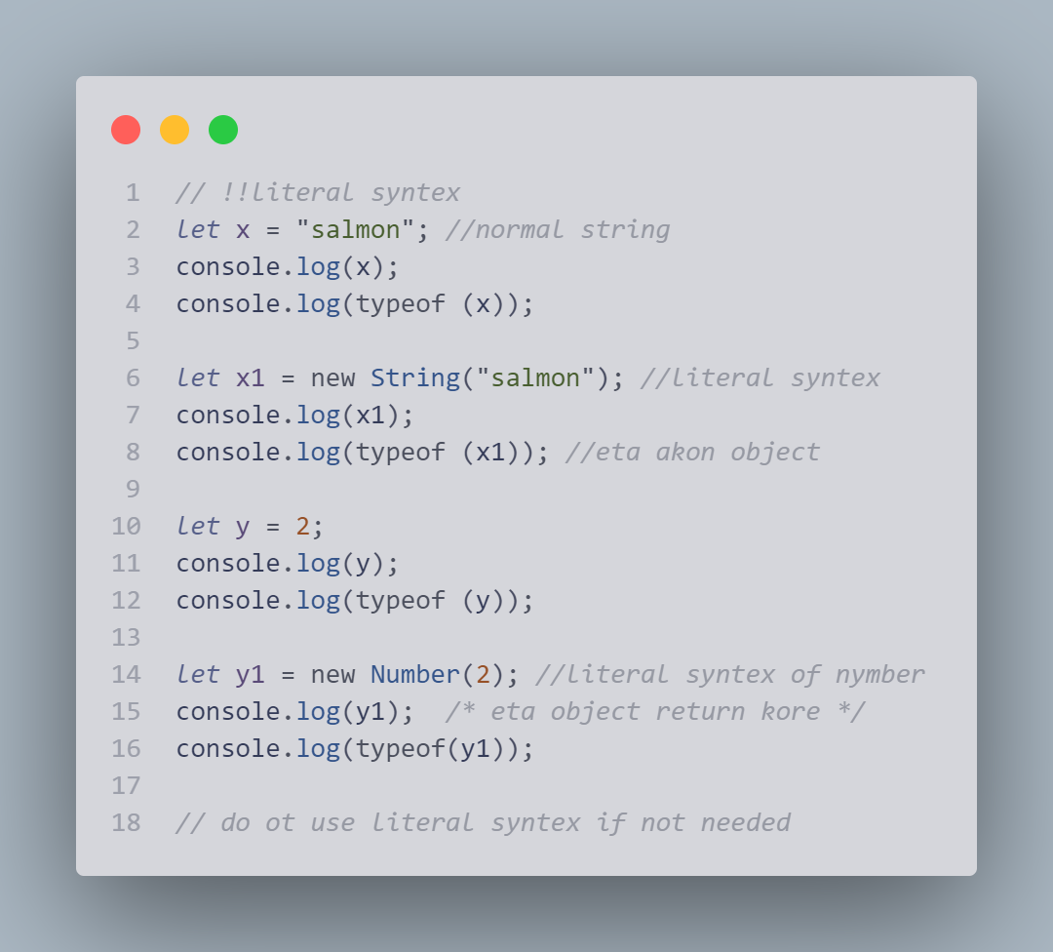

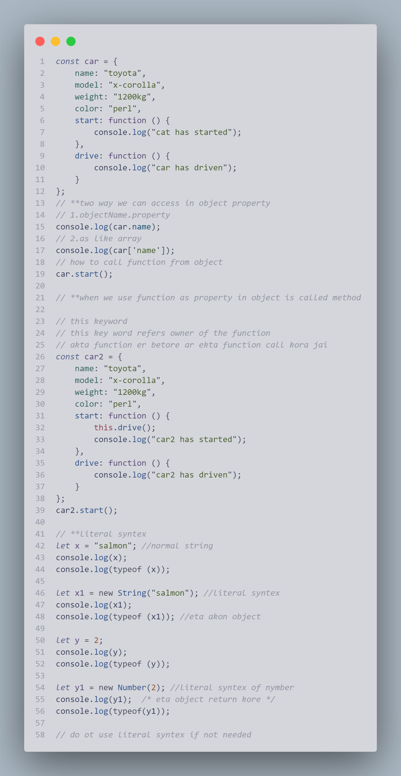

## 4ta upaye javascript object create kora jai

1. Object literal
2. New keyword
3. Object.create(property)
4. New function(params)

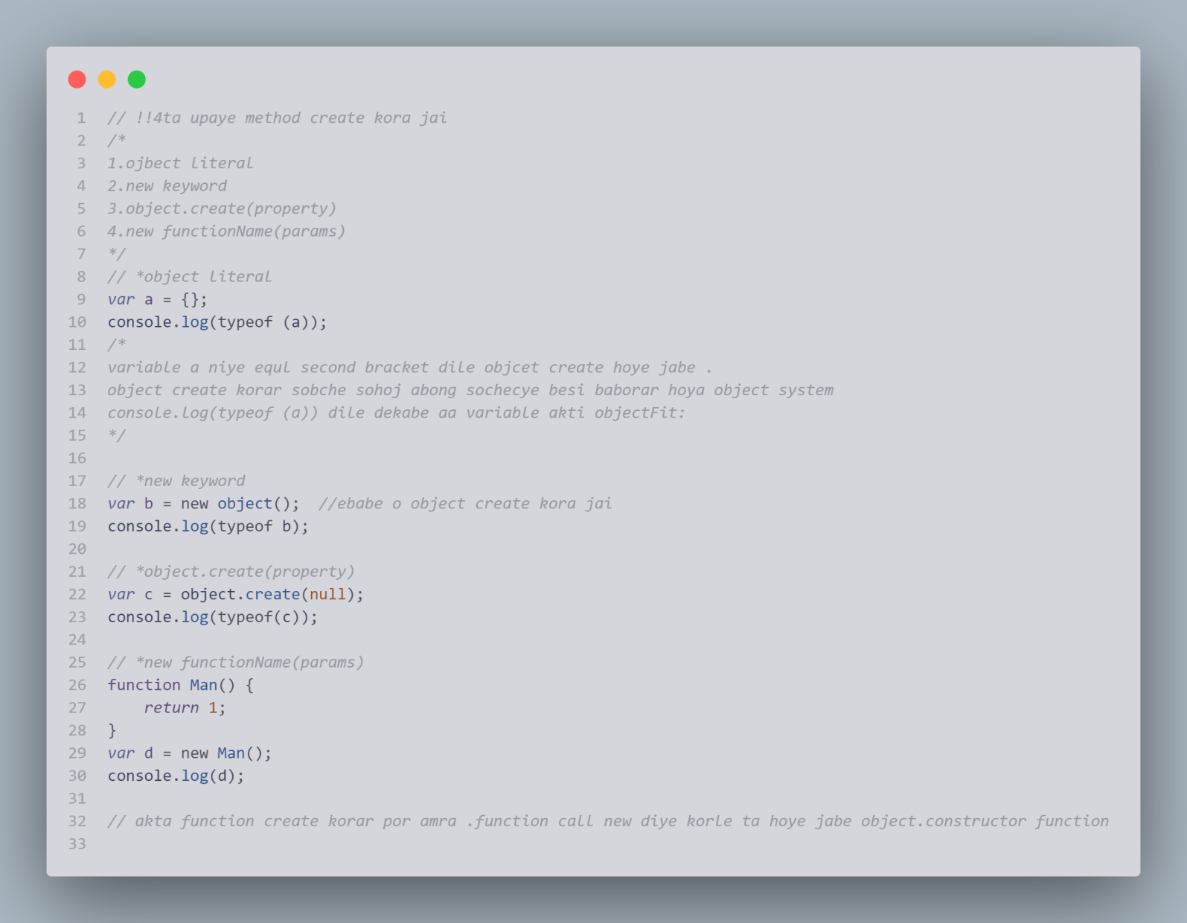

## two javascript object property te acces kora jai

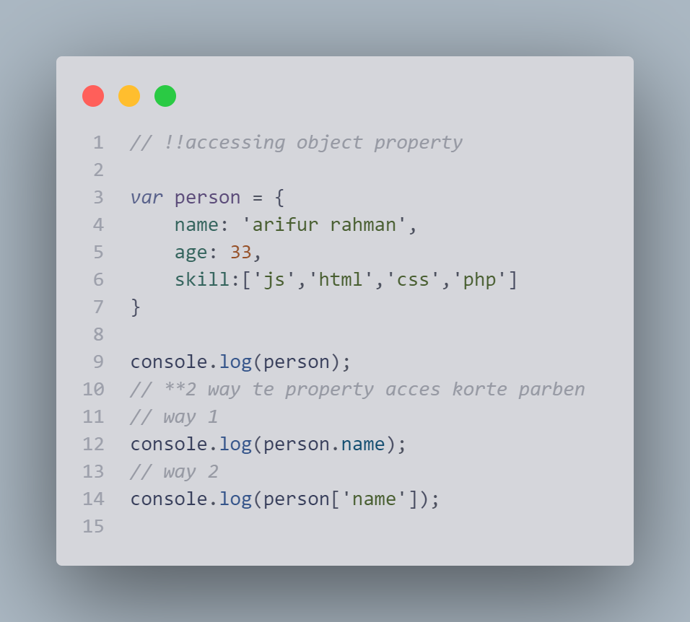

## Javascript a object property and value assign korar system:

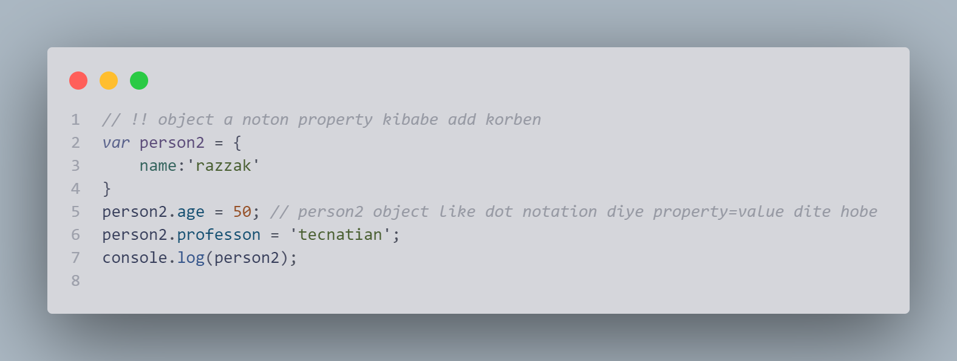

# Event in javascript

Ekane onclick holo event abong onclick er betor je functionta ace ta holo event handler

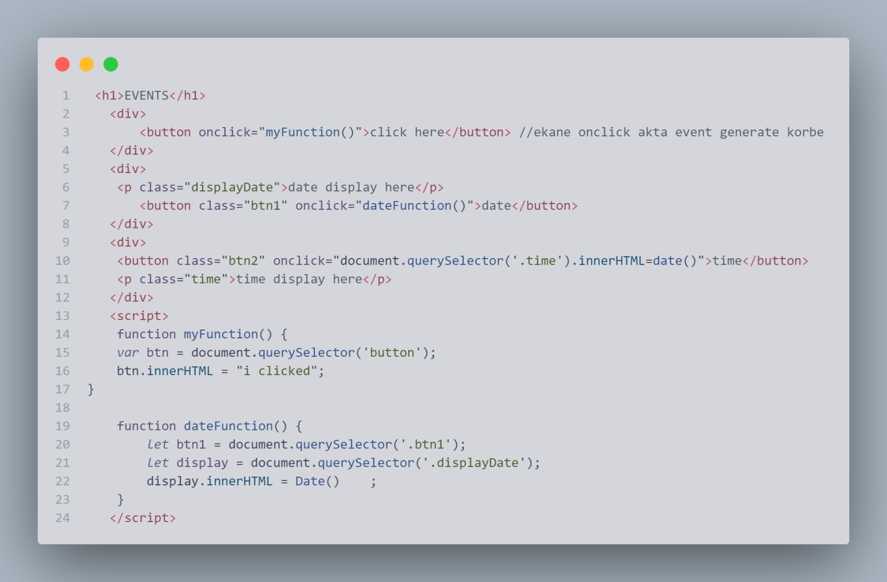

# Javascript String

1. What is string
2. String length
3. Escape character
4. String as object

## What is string

1. a javascript string is zero or more characters writter indside quote
2. You can use single or double quotes
3. bahire single qoute use korle betore double quotes use korte hobe

otoba bahire double quote use korle betore single qoute use korte hobe

## string length stringLength

## Escape Character

## escapeCharacter

## String as object

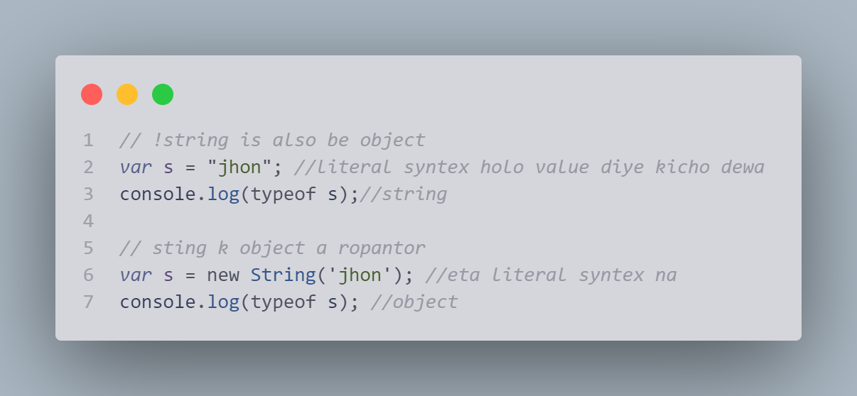

## More about string

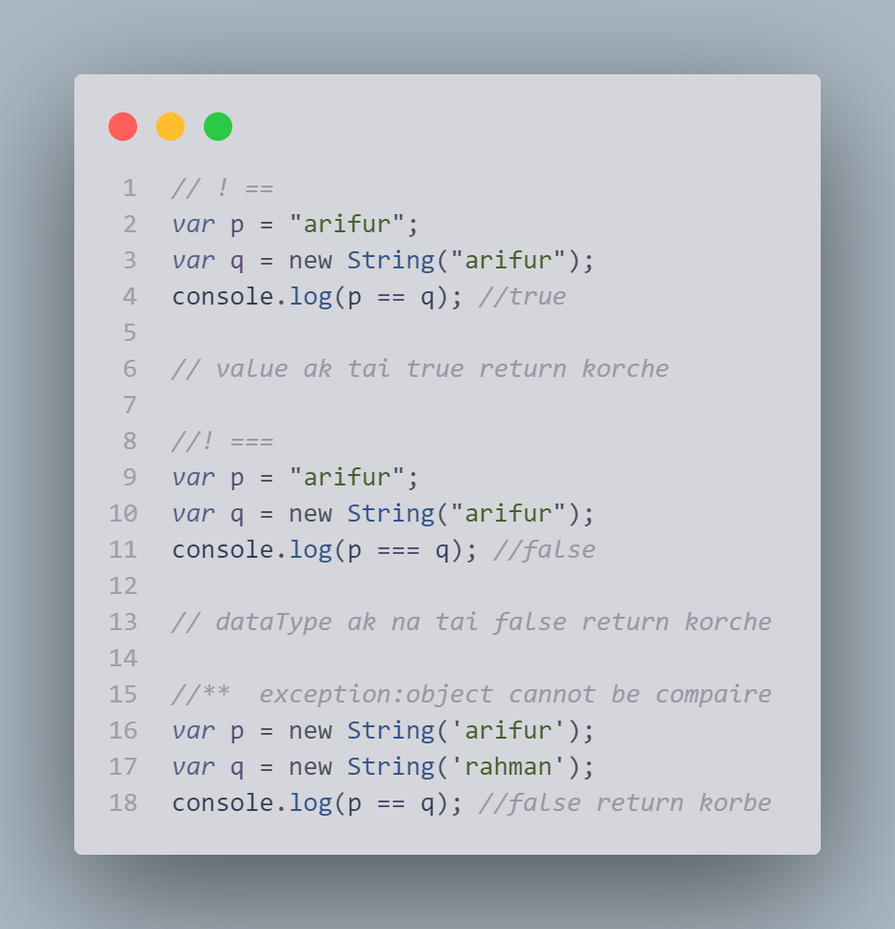

# JavaScript String Methods

|  |  |
| --- | --- |
| String length String slice() String substring() String substr() String replace() String replaceAll() String toUpperCase() String toLowerCase() String concat() | String trim() String trimStart() String trimEnd() String padStart() String padEnd() String charAt() String charCodeAt() String split() |

## JavaScript String Length

The length property returns the length of a string:

### Example

let text = "ABCDEFGHIJKLMNOPQRSTUVWXYZ";  
let length = text.length;

Console.log(length) // 26

## Extracting String Parts

There are 3 methods for extracting a part of a string:

* slice(start, end)
* substring(start, end)
* substr(start, length)

## JavaScript String slice()

slice() extracts a part of a string and returns the extracted part in a new string.

The method takes 2 parameters: start position, and end position (end not included).

### Example

Slice out a portion of a string from position 7 to position 13:

*let* text2 = "Apple, Banana, Kiwi";

console.log(text2.slice(7, 13)); *// Banana*

console.log(text2); *// Apple, Banana, Kiwi*

## Note

JavaScript counts positions from zero.

First position is 0.

Second position is 1.

If you omit বর্জন the second parameter, the method will slice out the rest of the string:

*let* text3 = "Apple, Banana, Kiwi";

console.log(text3.slice(7)); *//Banana, Kiwi*

console.log(text3); *// Apple, Banana, Kiwi*

###### If a parameter is negative, the position is counted from the end of the string:

*let* text4 = "Apple, Banana, Kiwi";

console.log(text4.slice(-12)); *//Banana, Kiwi*

console.log(text4);  *// Apple, Banana, Kiwi*

###### This example slices out a portion of a string from position -12 to position -6:

*let* text5 = "Apple, Banana, Kiwi";

console.log(text5.slice(-12, -6)); *// Banana*

console.log(text5); *// Apple, Banana, Kiwi*

## JavaScript String substring()

substring() is similar to slice().

The difference is that start and end values less than 0 are treated as 0 in substring().

*slice abong subSting er modde differnt holo subString a reverse hoi na mane index er value negative hoi na ]*

Example:

*let* str1 = "Apple, Banana, Kiwi";

console.log(str1.substring(7, 13)); *// Banana*

console.log(str1);  *//Apple, Banana, Kiwi*

###### If you omit the second parameter, substring() will slice out the rest of the string.

*let* str2 = "Apple, Banana, Kiwi";

console.log(str2.substring(7)); *// Banana, Kiwi*

console.log(str2); *// Apple, Banana, Kiwi*

## JavaScript String substr()

substr() is similar to slice().

The difference is that the second parameter specifies the **length** of the extracted part.

*let* str5 = "Apple, Banana, Kiwi";

console.log(str5.substr(7, 6)); *// Banana*

console.log(str5); *// Apple, Banana, Kiwi*

If you omit the second parameter, substr() will slice out the rest of the string.

*let* str6 = "Apple, Banana, Kiwi";

console.log(str6.substr(7)); *// Banana, Kiwi*

console.log(str6);  *// Apple, Banana, Kiwi*

If the first parameter is negative, the position counts from the end of the string.

*let* str7 = "Apple, Banana, Kiwi";

console.log(str7.substr(-4)); *//Kiwi*

console.log(str7);  *// Apple, Banana, Kiwi*

## Replacing String Content

The replace() method replaces a specified value with another value in a string:

*let* text = "i want to go to canada";

console.log(text.replace('canada', 'korea')); *//i want to go to korea*

console.log(text);*//i want to go to canada*

## Note

The replace() method does not change the string it is called on.

The replace() method returns a new string.

The replace() method replaces ****only the first**** match

If you want to replace all matches, use a regular expression with the /g flag set. See examples below.

By default, the replace() method replaces only the first match:

*let* text1 = "i want to go to canada and canada";

console.log(text1); *//i want to go to canada and canada*

console.log(text1.replace('canada', 'korea')); *//i want to go to korea and canada*

To replace case insensitive, use a regular expression with an /i flag (insensitive):

*let* text6 = "Please visit Microsoft!";

console.log(text6.replace(/MICROSOFT/i, "W3Schools")); *//Please visit W3Schools!*

console.log(text6); *//Please visit Microsoft!*

## Note

Regular expressions are written without quotes.

To replace all matches, use a ****regular expression**** with a /g flag (global match):

*let* text7 = "Please visit Microsoft and Microsoft!";

console.log(text7.replace(/Microsoft/g, "W3Schools")); *//Please visit W3Schools and W3Schools!*

console.log(text7); *//Please visit Microsoft and Microsoft!*

## JavaScript String ReplaceAll()

In 2021, JavaScript introduced the string method replaceAll():

*let* text8 = "I love cats. Cats are very easy to love. Cats are very popular";

console.log(text8.replaceAll("Cats", "Dogs"));

*// I love cats. Dogs are very easy to love. Dogs are very popular*

console.log(text8.replaceAll("cats", "dogs"));

*// I love dogs.Cats are very easy to love.Cats are very popular*

The replaceAll() method allows you to specify a regular expression instead of a string to be replaced.

If the parameter is a regular expression, the global flag (g) must be set set, otherwise a TypeError is thrown

*let* text9 = "I love cats. Cats are very easy to love. Cats are very popular";

console.log(text9.replaceAll(/Cats/g, "Dogs"));

*// I love cats.Dogs are very easy to love.Dogs are very popular*

console.log(text9.replaceAll(/cats/g, "dogs"));

*// I love dogs. Cats are very easy to love. Cats are very popular*

## Converting to Upper and Lower Case

A string is converted to upper case with toUpperCase():

A string is converted to lower case with toLowerCase():

*let* sentence = "this is a string need to check upper case and lower case"

console.log(sentence.toUpperCase());  *//THIS IS A STRING NEED TO CHECK UPPER CASE AND LOWER CASE*

console.log(sentence.toLowerCase()); *//this is a string need to check upper case and lower case*

## JavaScript String concat()

concat() joins two or more strings:

*let* s1 = "hello";

*let* s2 = "world";

console.log(s1.concat(s2)); *//helloworld*

The concat() method can be used instead of the plus operator. These two lines do the same:

text = "Hello" + " " + "World!";  
text = "Hello".concat(" ", "World!");

## Note

All string methods return a new string. They don't modify the original string.

Formally said:

Strings are immutable: Strings cannot be changed, only replaced.

## JavaScript String trim()

The trim() method removes whitespace from both sides of a string:

*// ! string.trim() method replace white space both side of string*

*let* whiteSpace = "    space   ";

console.log(whiteSpace); *//    space*

console.log(whiteSpace.trim()); *//space*

## JavaScript String trimStart()

ECMAScript 2019 added the String method trimStart() to JavaScript.

The trimStart() method works like trim(), but removes whitespace only from the start of a string.

*//trimStart()*

*let* text19 = "     Hello World!     ";

console.log(text19.trimStart()); *//Hello World!*

## JavaScript String trimEnd()

ECMAScript 2019 added the String method trimEnd() to JavaScript.

The trimEnd() method works like trim(), but removes whitespace only from the end of a string.

*//trimEnd()*

*let* text11 = "     Hello World!     ";

console.log(text11.trimEnd());*//     Hello World!*

## JavaScript String Padding

ECMAScript 2017 added two String methods: padStart() and padEnd() to support padding at the beginning and at the end of a string.

## JavaScript String padStart()

he padStart() method pads a string with another string:

*let* text44 = "5";

console.log(text44.padStart(4, "x")); *//xxx5*

Another example

*let* text55 = "5";

console.log(text55.padStart(4, "0")); *// 0005*

## Note

The padStart() method is a string method.

To pad a number, convert the number to a string first.

See the example below.

*let* numb = 5;

*let* text66 = numb.toString();

*let* padded = text66.padStart(4, "0");

console.log(padded); *//0005*

## JavaScript String padEnd()

The padEnd() method pads a string with another string:

*let* text77 = "7";

console.log(text77.padEnd(7, "x")); *//7xxxxxx*

## Note

The padEnd() method is a string method.

To pad a number, convert the number to a string first.

See the example below.

*let* numb5 = 5;

*let* text5 = numb5.toString();

*let* padded5 = text5.padEnd(4, "0");

console.log(padded5); *//5000*

## Extracting String Characters

The charAt() method returns the character at a specified index (position) in a string:

*let* txt11 = "HELLO WORLD";

console.log(txt11.charAt(0)); *//H*

## JavaScript String charCodeAt()

The charCodeAt() method returns the unicode of the character at a specified index in a string:

The method returns a UTF-16 code (an integer between 0 and 65535).

*let* txt12 = "HELLO WORLD";

console.log(txt12.charCodeAt(0)); *//72*

## Property Access

*let* access = "hello";

console.log(access[0]);  *//h*

## Note

Property access might be a little ****unpredictable:****

* It makes strings look like arrays (but they are not)
* If no character is found, [ ] returns undefined, while charAt() returns an empty string.
* It is read only. str[0] = "A" gives no error (but does not work!)

*let* access2 = "HELLO WORLD";

access2[0] = "A";

console.log(access2);   *// Gives no error, but does not work*

## Converting a String to an Array

If you want to work with a string as an array, you can convert it to an array.

## JavaScript String split()

A string can be converted to an array with the split() method:

*let* mkArray = "hello world ,bngladesh";

console.log(mkArray.split());  *// ['hello world ,bngladesh'] eta string k array te convert korche*

console.log(mkArray.split(",")); *// ['hello world ', 'bngladesh'] eta array te convert korche abong jekane comma ace sekane index alada korche*

console.log(mkArray.split(" ")); *// ['hello', 'world', ',bngladesh'] eta jekane space paiche sekane index alada korche*

*// s.split("") split in character*

console.log(mkArray.split("")); *//['h', 'e', 'l', 'l', 'o', ' ', 'w', 'o', 'r', 'l', 'd', ' ', ',', 'b', 'n', 'g', 'l', 'a', 'd', 'e', 's', 'h']*

# JavaScript String Search

## JavaScript Search Methods

* String indexOf()
* String lastIndexOf()
* String search()
* String match()
* String matchAll()
* String includes()
* String startsWith()
* String endsWith()

## JavaScript String indexOf()

The indexOf() method returns the index of (position of) the **first** occurrence of a string in a string:

*let* x = "arifur rahman abdur rahman arifur";

console.log(x.indexOf('rahman')); *//7*

*// rahman 7 number index a ace*

##### Note

JavaScript counts positions from zero.

0 is the first position in a string, 1 is the second, 2 is the third, ...

# JavaScript String lastIndexOf()

The lastIndexOf() method returns the index of the ****last**** occurrence of a specified text in a string:

*count position from zoro*

*আর string এর last এর ১ম  occarance টা return করে*

*var* y = "arifur rahman abdur rahman arifur";

console.log(y.lastIndexOf("rahman")); *//20*

**Both indexOf(), and lastIndexOf() return -1 if the text is not found:**

*var* y = "arifur rahman abdur rahman arifur";

console.log(y.indexOf("rahmani")); *// -1 mane pai nai*

console.log(y.lastIndexOf("rahmani")); *// -1 mane pai nai*

**Both methods accept a second parameter as the starting position for the search:**

*var* text = "Please locate where 'locate' occurs!";

console.log(text.indexOf("locate", 15)); *// 21*

The lastIndexOf() methods searches backwards (from the end to the beginning), meaning: if the second parameter is 15, the search starts at position 15, and searches to the beginning of the string.

*var* text = "Please locate where 'locate' occurs!";

console.log(text.lastIndexOf("locate", 15)); *// 7*

# JavaScript String search()

The search() method searches a string for a string (or a regular expression) and returns the position of the match:

*var* str = "Please locate where 'locate' occurs";

console.log(str.search('locate')); *//7 string index a locate ace*

**regular expression :**

*var* str = "Please locate where 'locate' occurs";

console.log(str.search(/locate/)); *//7 string index a locate ace*

### Did You Notice? indexOf() and search() এর মধ্যে diffent কি ?

The two methods, indexOf() and search(), are ****equal?****

They accept the same arguments (parameters), and return the same value?

The two methods are ****NOT**** equal. These are the differences:

* The search() method cannot take a second start position argument.
* The indexOf() method cannot take powerful search values (regular expressions).

*var* str = "Please locate where 'locate' occurs";

console.log(str.indexOf(/locate/))  *// -1*

*(regular express indexOf() e kaj kore na)*

## JavaScript String match()

The match() method returns an array containing the results of matching a string against a string (or a regular expression).

Array return করে

*let* textMatch = "Dark is black.Black luck is dark?";

console.log(textMatch.match(/dark/)); *// ['dark', index: 28, input: 'Dark is black.Black luck is dark?', groups: undefined]*

console.log(textMatch.match(/dark/i)); *// ['Dark', index: 0, input: 'Dark is black.Black luck is dark?', groups: undefined]*

console.log(textMatch.match(/dark/g)); *// ['dark']*

console.log(textMatch.match(/dark/ig)); *// (2) ['Dark', 'dark']*

## Note

If a regular expression does not include the g modifier (global search), match() will return only the first match in the string.

console.log(textMatch.match(/dark/)); *// ['dark', index: 28, input: 'Dark is black.Black luck is dark?', groups: undefined]*

## JavaScript String matchAll()

The matchAll() method returns an iterator containing the results of matching a string against a string (or a regular expression).

*let* text22 = "I love cats. Cats are very easy to love. Cats are very popular."

*const* iterator = text22.matchAll("Cats");

console.log(iterator); *// RegExpStringIterator {}*

console.log(Array.from(iterator)); *//*

*/\**

*0: ['Cats', index: 13, input: 'I love cats. Cats are very easy to love. Cats are very popular.', groups: undefined]*

*1: ['  Cats', index: 41, input: 'I love cats. Cats are very easy to love. Cats are very popular.', groups: undefined]*

*\*/*

If the parameter is a regular expression, the global flag (g) must be set set, otherwise a TypeError is thrown.

*let* text23 = "I love cats. Cats are very easy to love. Cats are very popular."

*const* iterator1 = text23.matchAll(/Cats/g); *// এখানে global g না দিলে error দেখাবে*

console.log(iterator1); *// RegExpStringIterator {}*

console.log(Array.from(iterator1)); *//*

*/\**

*0: ['Cats', index: 13, input: 'I love cats. Cats are very easy to love. Cats are very popular.', groups: undefined]*

*1: ['Cats', index: 41, input: 'I love cats. Cats are very easy to love. Cats are very popular.', groups: undefined]*

*\*/*

If you want to search case insensitive, the insensitive flag (i) must be set:

*let* text24 = "I love cats. Cats are very easy to love. Cats are very popular."

*const* iterator2 = text24.matchAll(/Cats/gi); *// এখানে global g না দিলে error দেখাবে*

console.log(iterator2); *// RegExpStringIterator {}*

console.log(Array.from(iterator2)); *//*

*/\**

*0: ['cats', index: 7, input: 'I love cats. Cats are very easy to love. Cats are very popular.', groups: undefined]*

*1: ['Cats', index: 13, input: 'I love cats. Cats are very easy to love. Cats are very popular.', groups: undefined]*

*2: ['Cats', index: 41, input: 'I love cats. Cats are very easy to love. Cats are very popular.', groups: undefined]*

*\*/*

# JavaScript String includes()

The includes() method returns true if a string contains a specified value.

Otherwise it returns false.

*let* textInclude = "hello bangladesh ,wellcome to padma bridge"

console.log(textInclude.includes("bangladesh")); *//true return korbe*

**Check if a string includes "**bangladesh**". Start at position 15:**

*let* textInclude2 = "hello bangladesh ,wellcome to padma bridge"

console.log(textInclude2.includes("bangladesh",15)); *//false return korbe*

*// 15 index এর পর bangladesh নাই*

includes() is case sensitive.

# JavaScript String startsWith()

The startsWith() method returns true if a string begins with a specified value.

Otherwise it returns false:

**True:**

*let* stringStartWith = "hello let check what is it";

console.log(stringStartWith.startsWith('hello')); *// return true*

*//* string ta hello diye start korche so its true*

**False:**

console.log(stringStartWith.startsWith('let')); *//return false*

*//* string ta let diye start hoi nai so false return korbe*

**A start position for the search can be specified:**

console.log((stringStartWith.startsWith('let', 6)));  *//return true*

*//*parameter 6 holo 6 er por count start hobe.*

startsWith(), endsWith() is case sensitive.

# JavaScript String endsWith()

The endsWith() method returns true if a string ends with a specified value.

Otherwise it returns false:

**Check if a string ends with "**it**" :**

*let* endWith = "hello let check what is it";

console.log(endWith.endsWith('it')); *//return true*

*//*ses hoyche it diye so eta true return korlo*

**Check if the 9 first characters of a string ends with "world":**

*let* endWith = "hello let check what is it";

console.log(endWith.endsWith('let', 9)); *//*true return korbe*

*//*hello let eta theke let check korbe*

# String method

1. string method
2. javascript kibabe boje eta object
3. string er bibinno part kibabe extract korbo
4. string content kibabe replace korbo
5. converting string uperCase or lowerCase
6. oncate() method
7. string.trim()
8. property accces
9. string k array te kibabe convert korbo

## string method

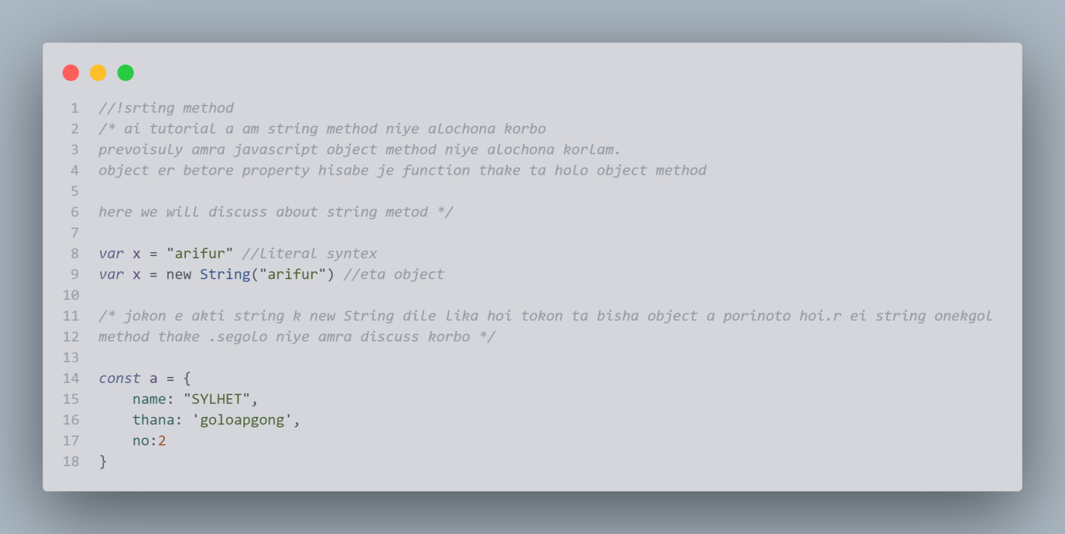

## javascript kibabe boje eta object

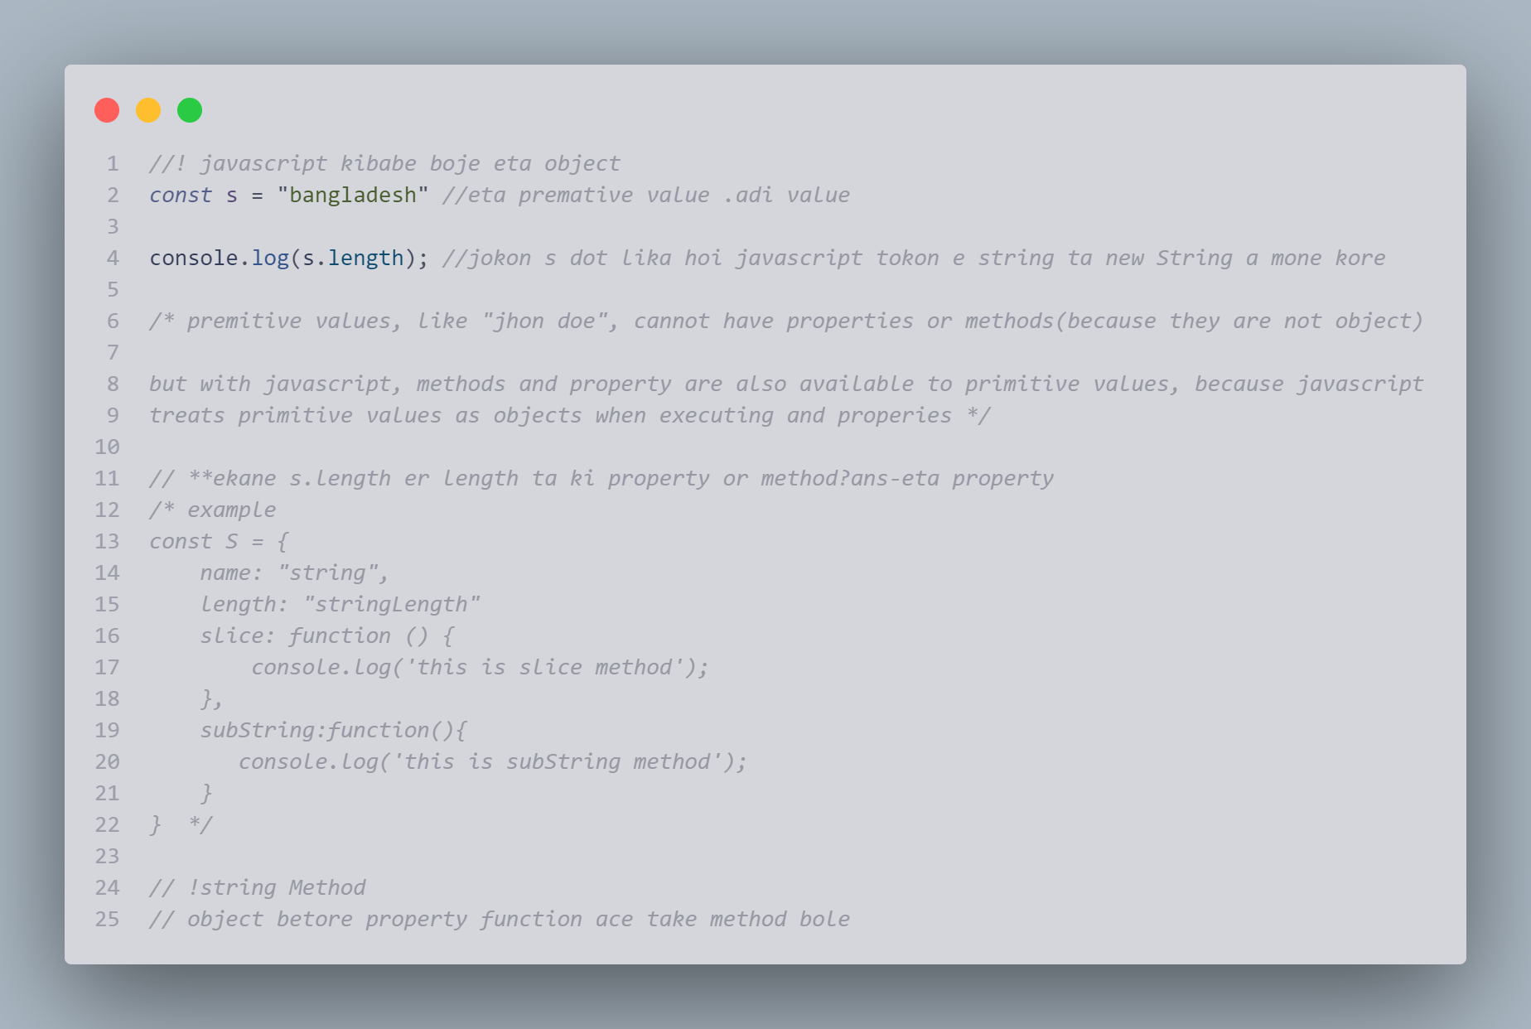

## string er bibinno part kibabe extract korbo

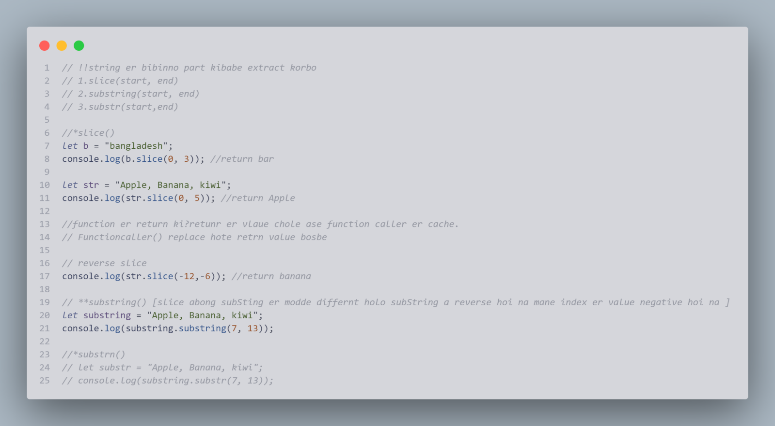

## string content kibabe replace korbo

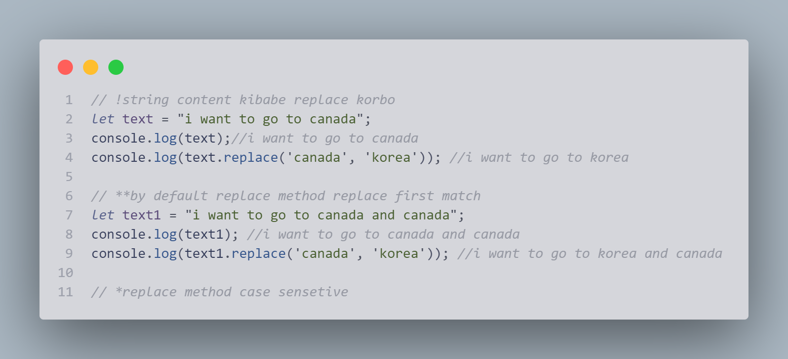

## converting string uperCase or lowerCase

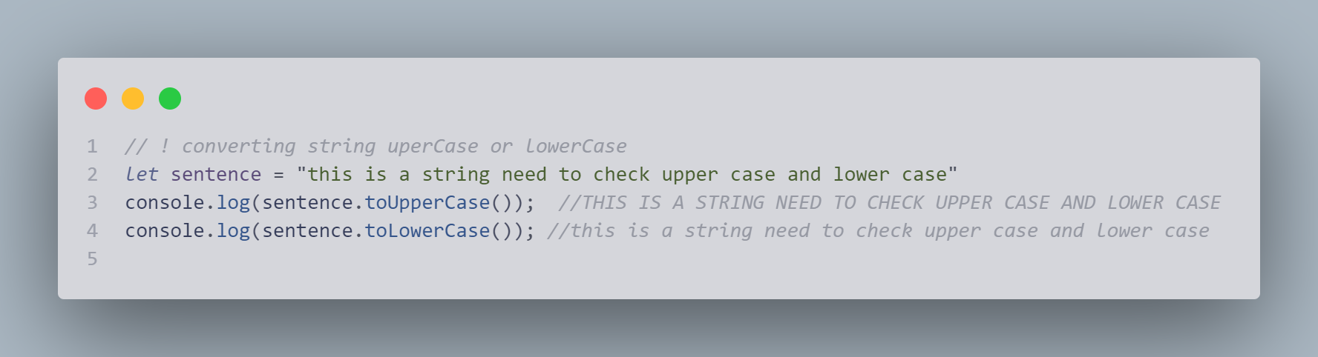

## concate() method

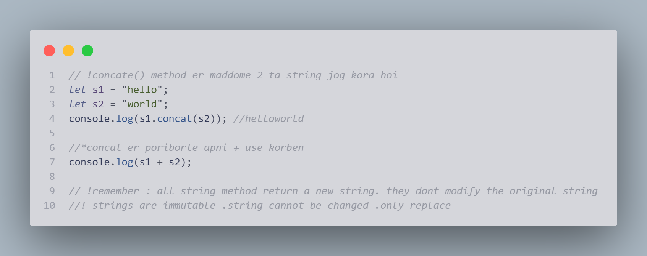

## string.trim()

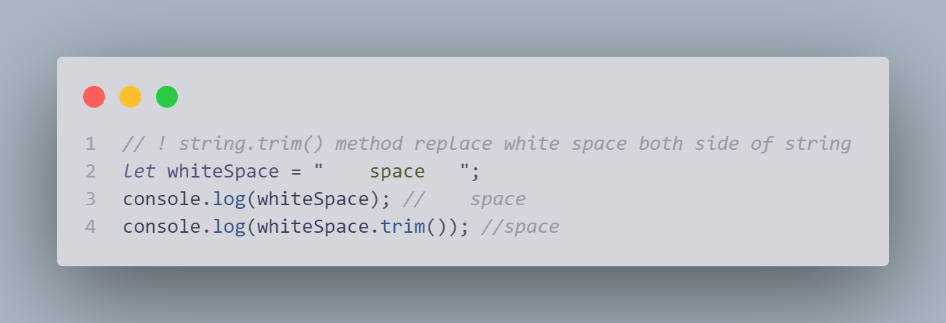

## property accces

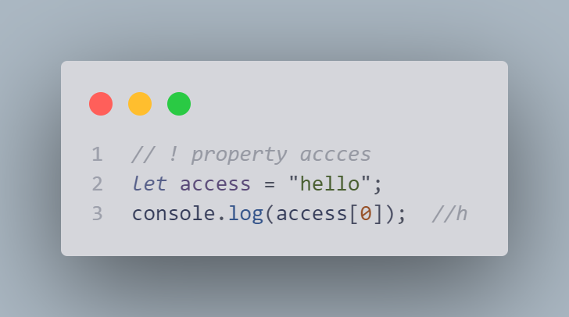

## string k array te kibabe convert korbo

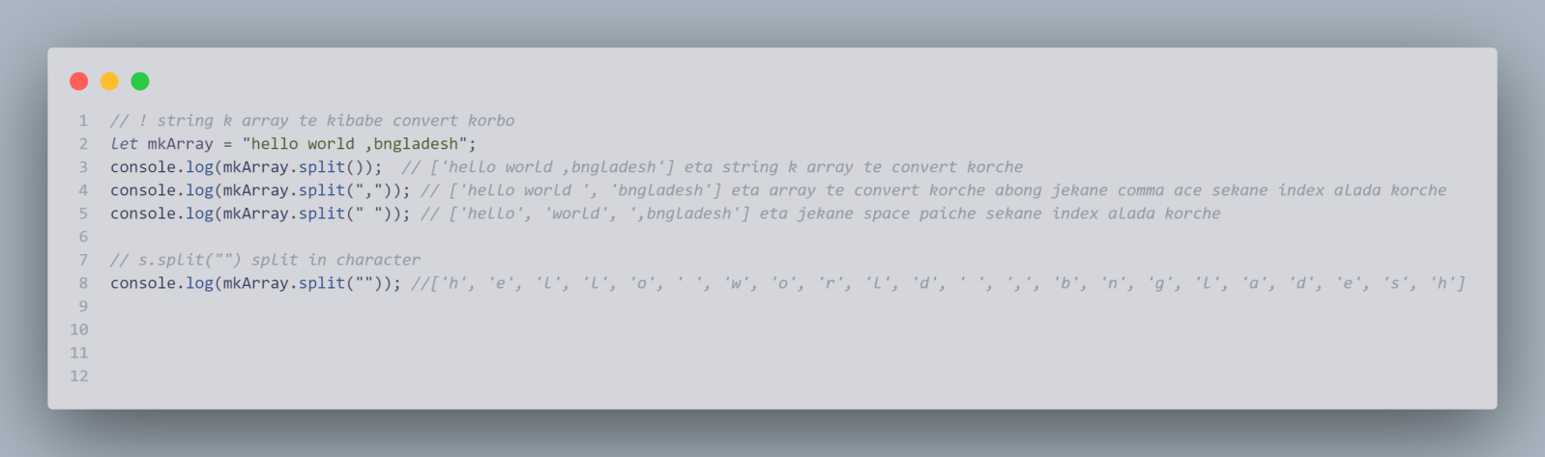

# Javascript string search

1. *➢String.indexOf()*
2. *➢String.lastIndexOf()*
3. *➢string.search()*
4. *➢String.match()*
5. *➢String.include()*
6. *➢String.startsWith()*
7. *➢String.endsWith()*

### String.indexOf()

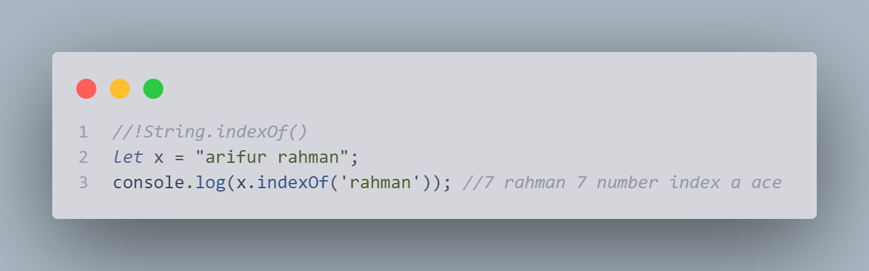

### ➢String.lastIndexOf()

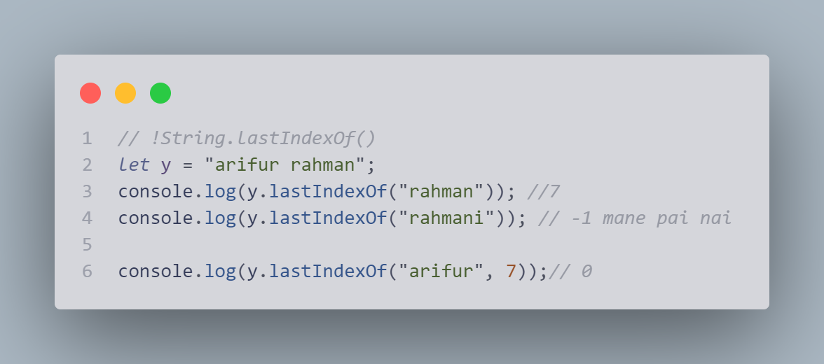

### ➢string.search()

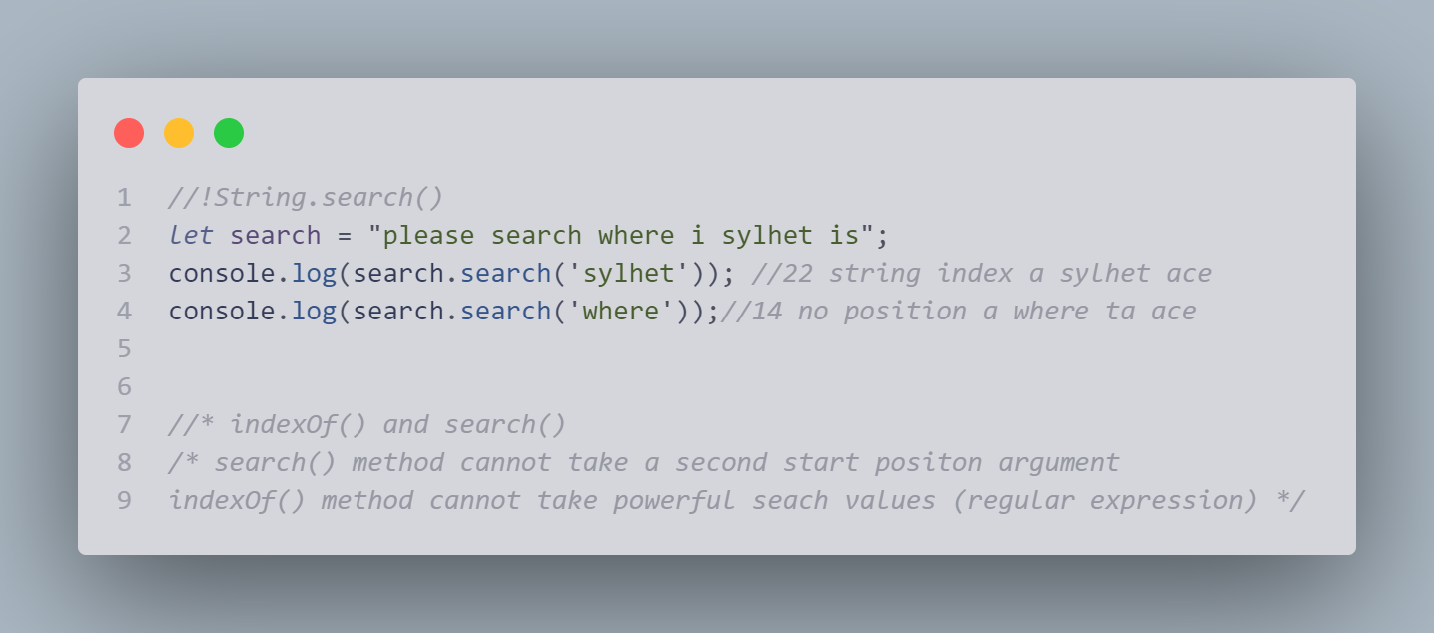

### ➢String.match()

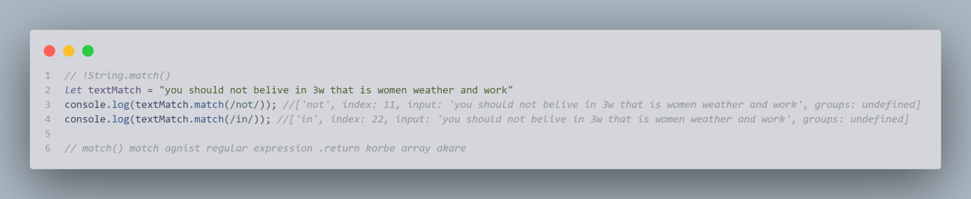

### ➢String.include()

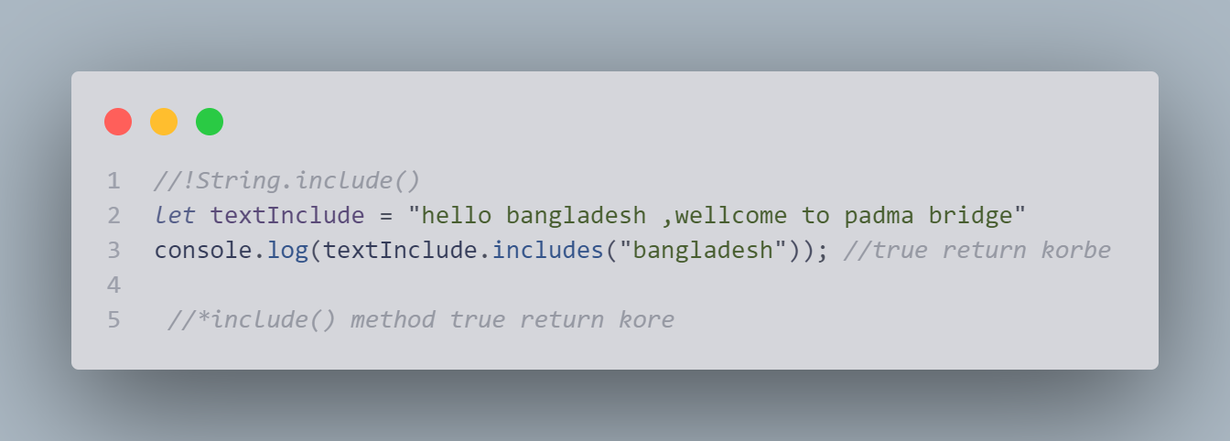

### ➢String.startsWith()

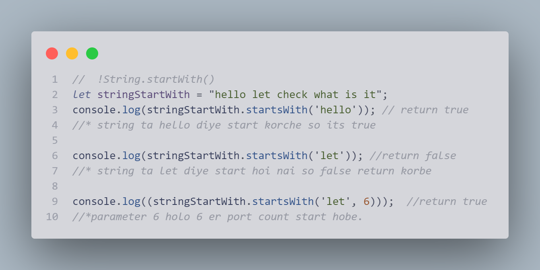

### ➢String.endsWith()



# Template literals

/* template literals

template String

string templates

back-tick syntex */

1. back-ticks
2. quotes
3. multiline
4. interpolation
5. substitutions
6. expressin
7. html template

### back-ticks

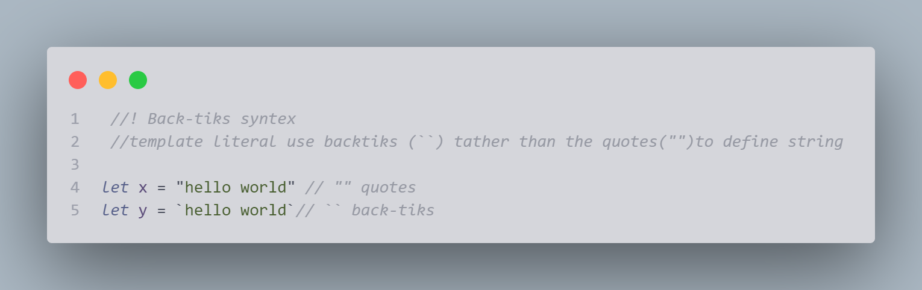

### Quotes/why need backtik

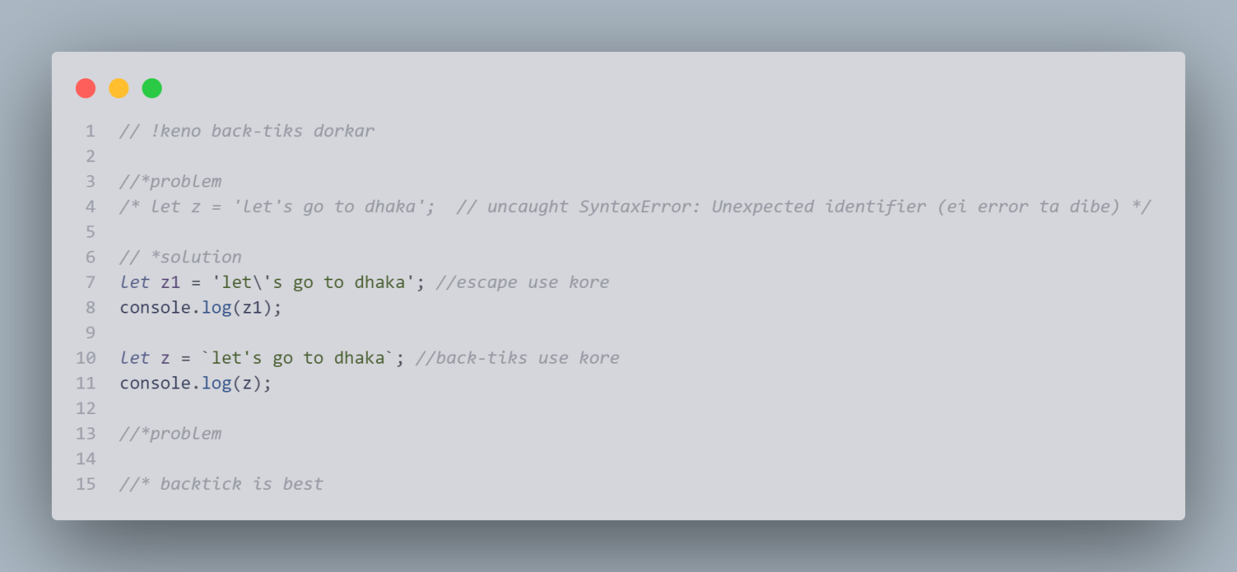

### Multiline

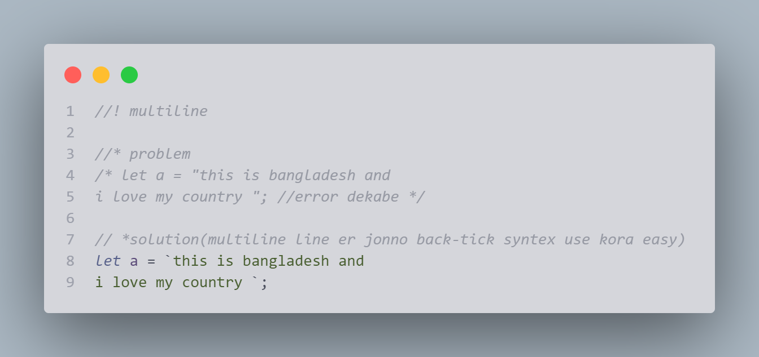

### Interpolation

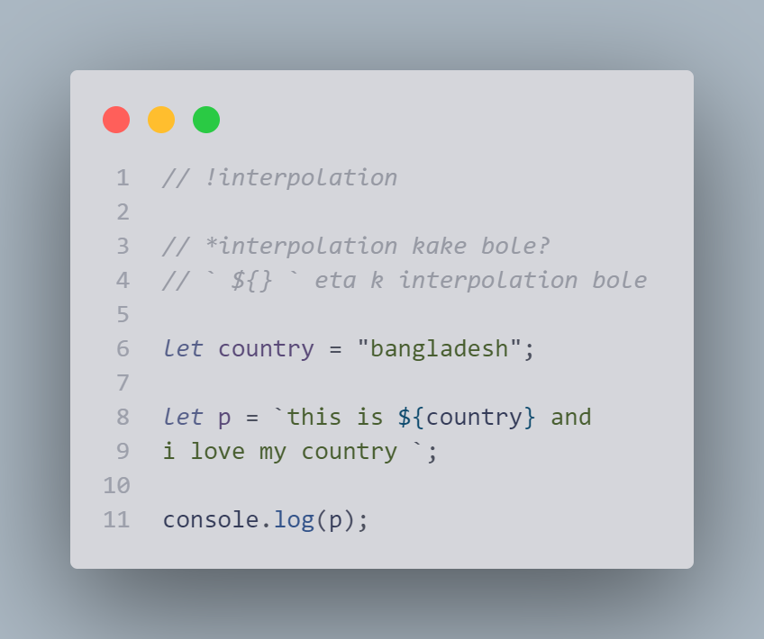

### Substitutions

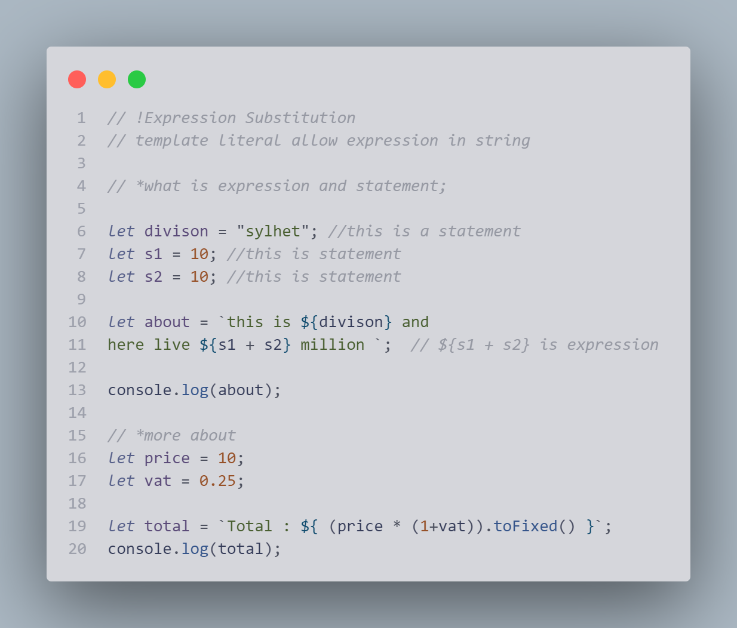

### html template

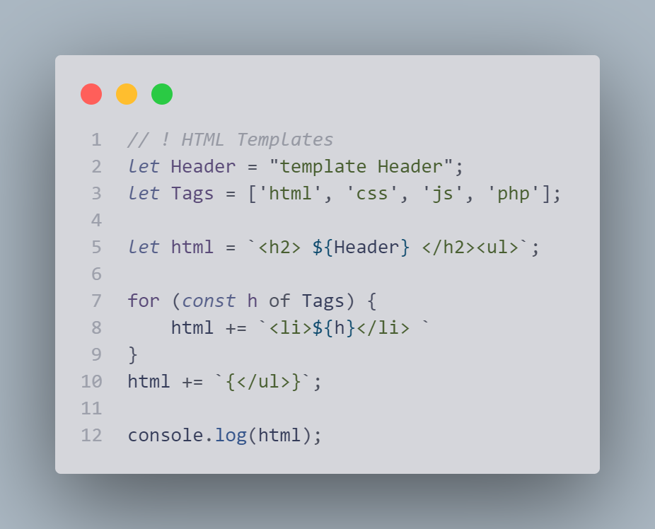

# Numbers

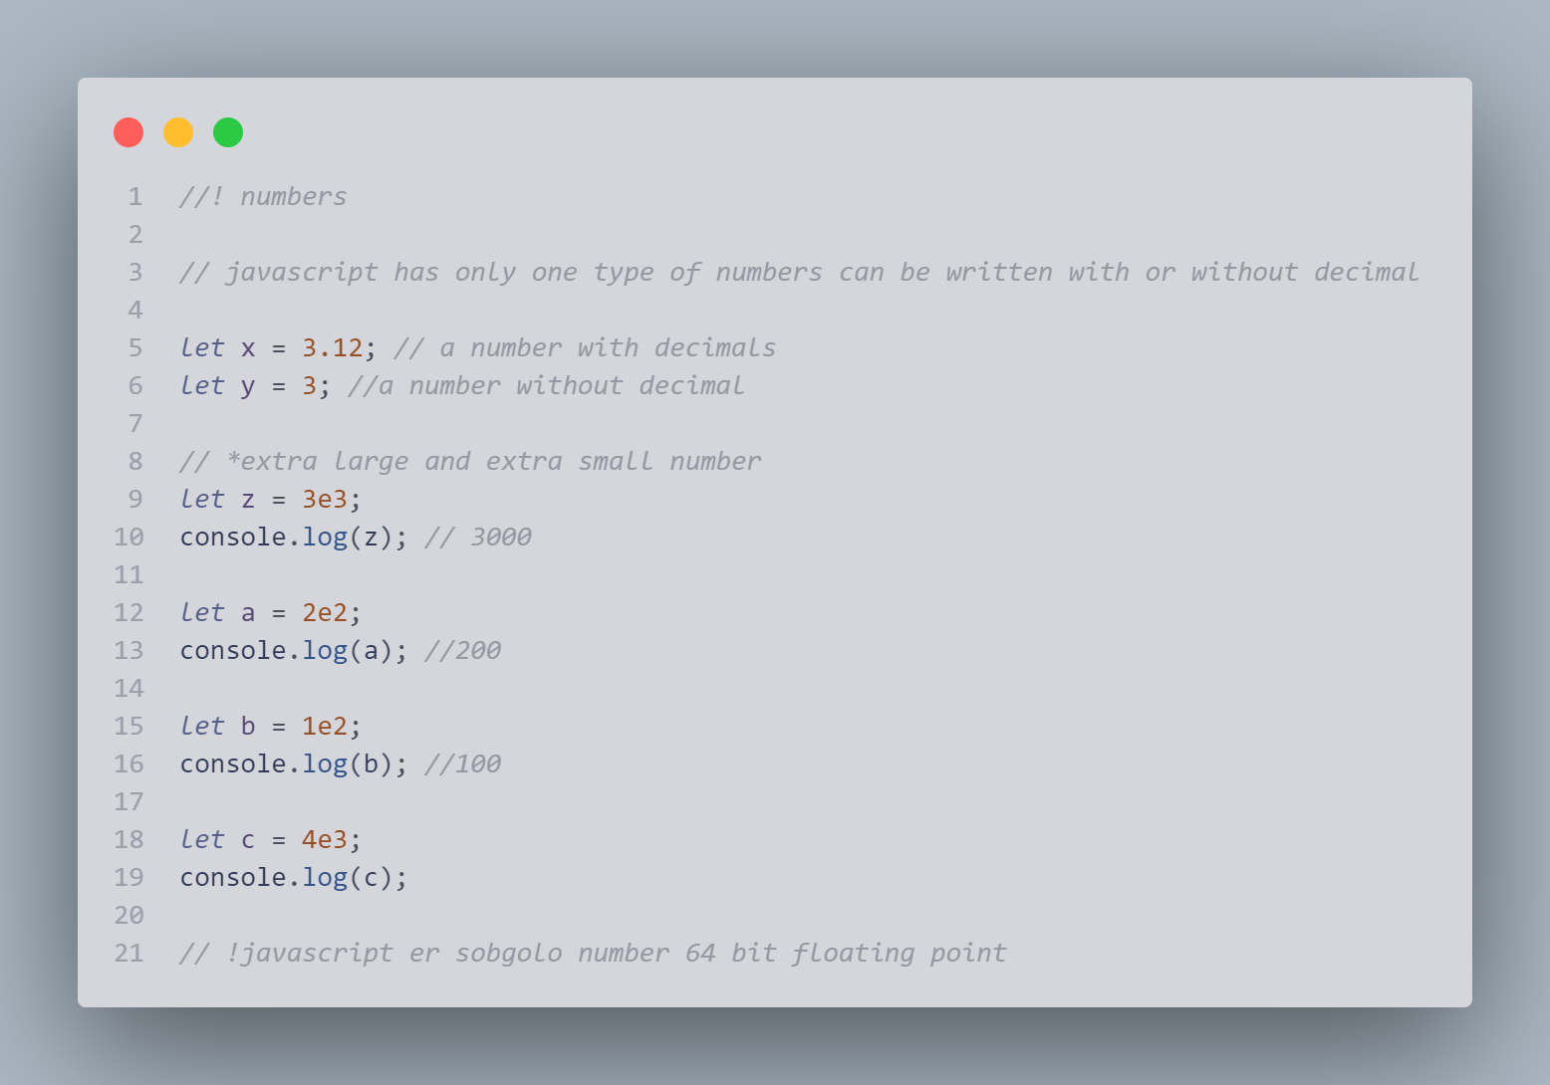

###### Floating Precision **নির্ভুলতা/**

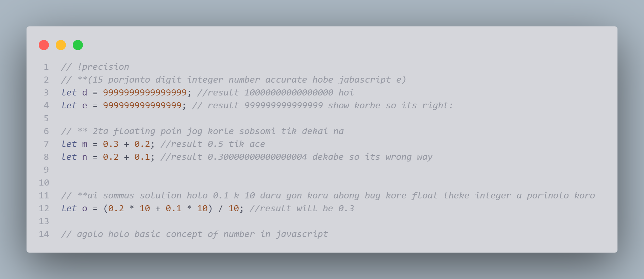

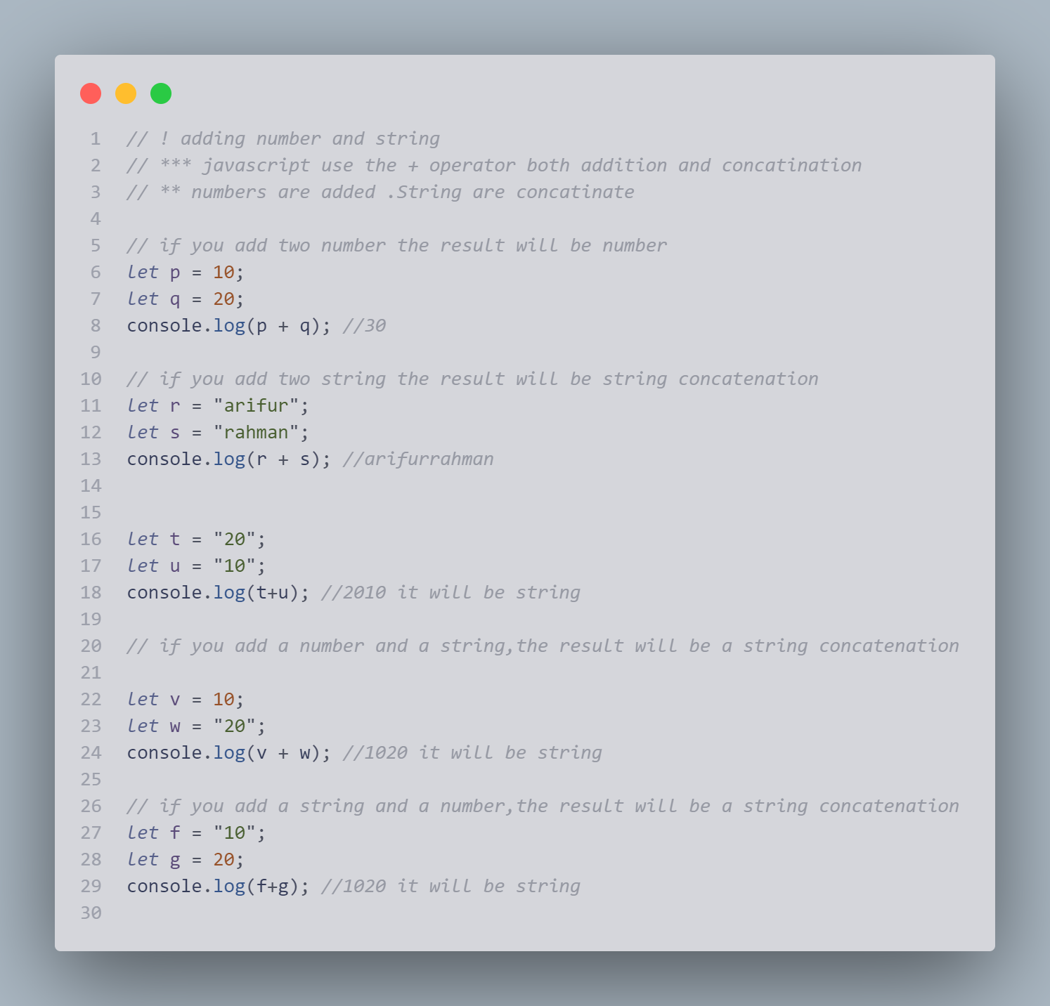

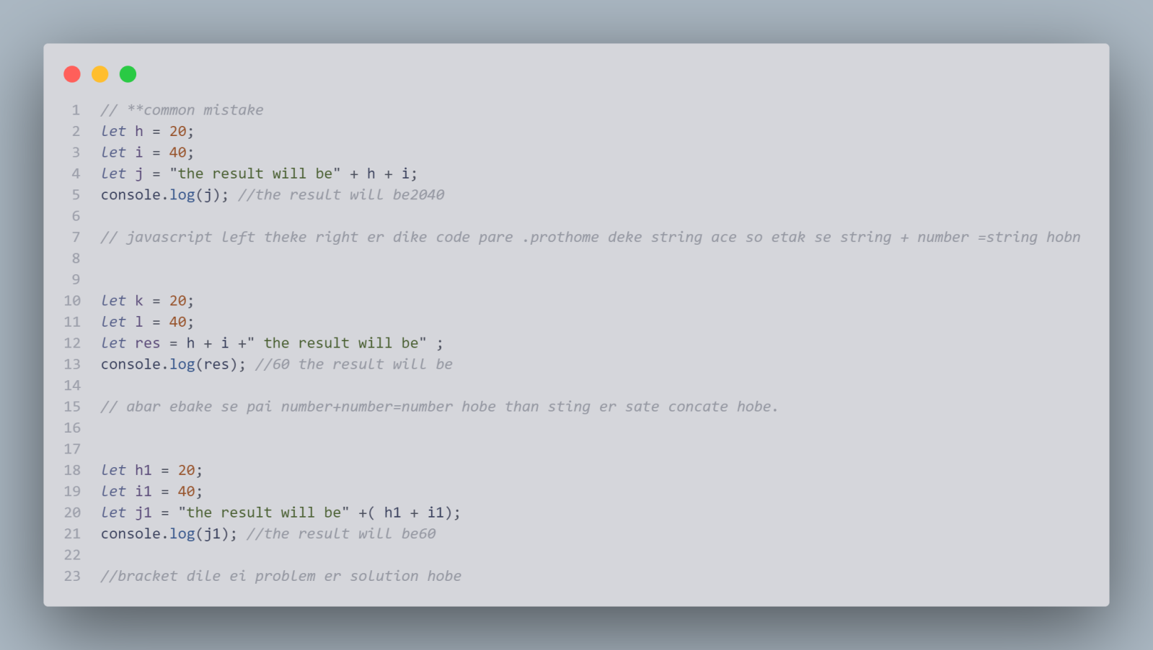

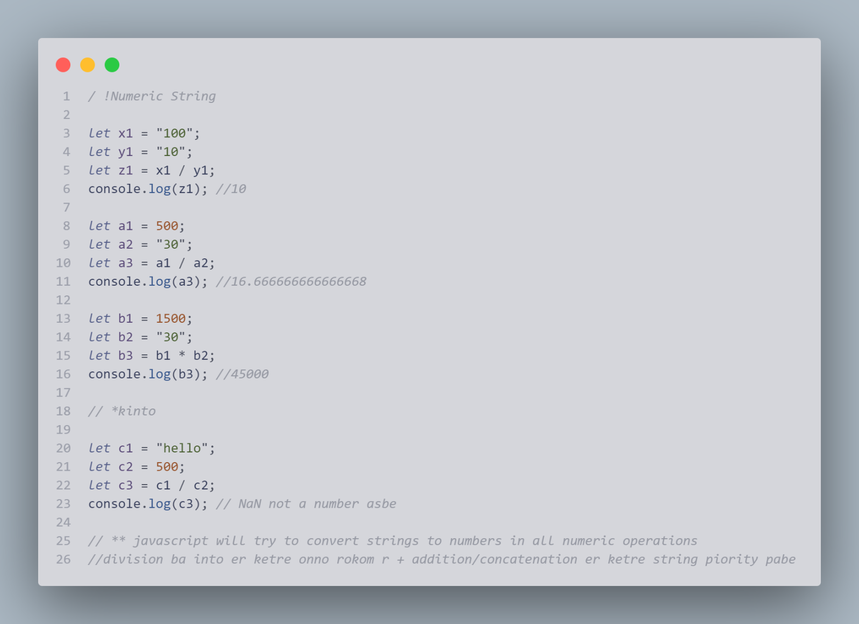

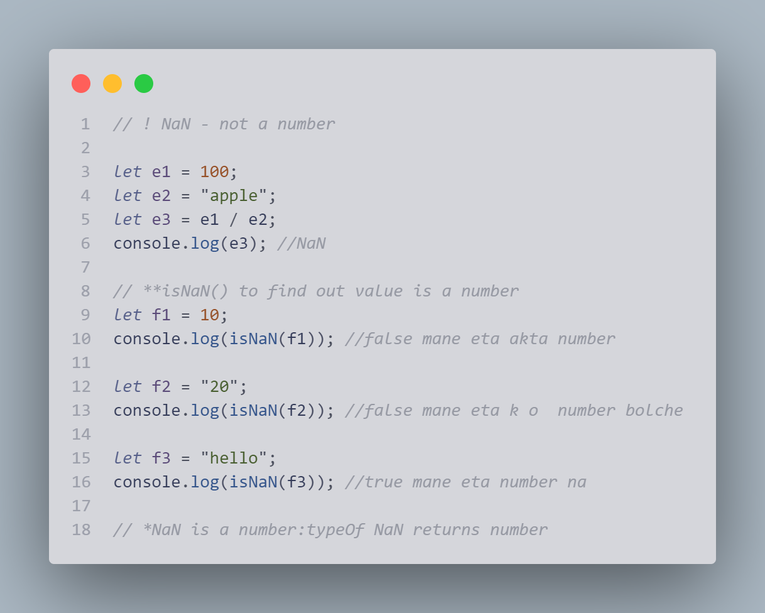

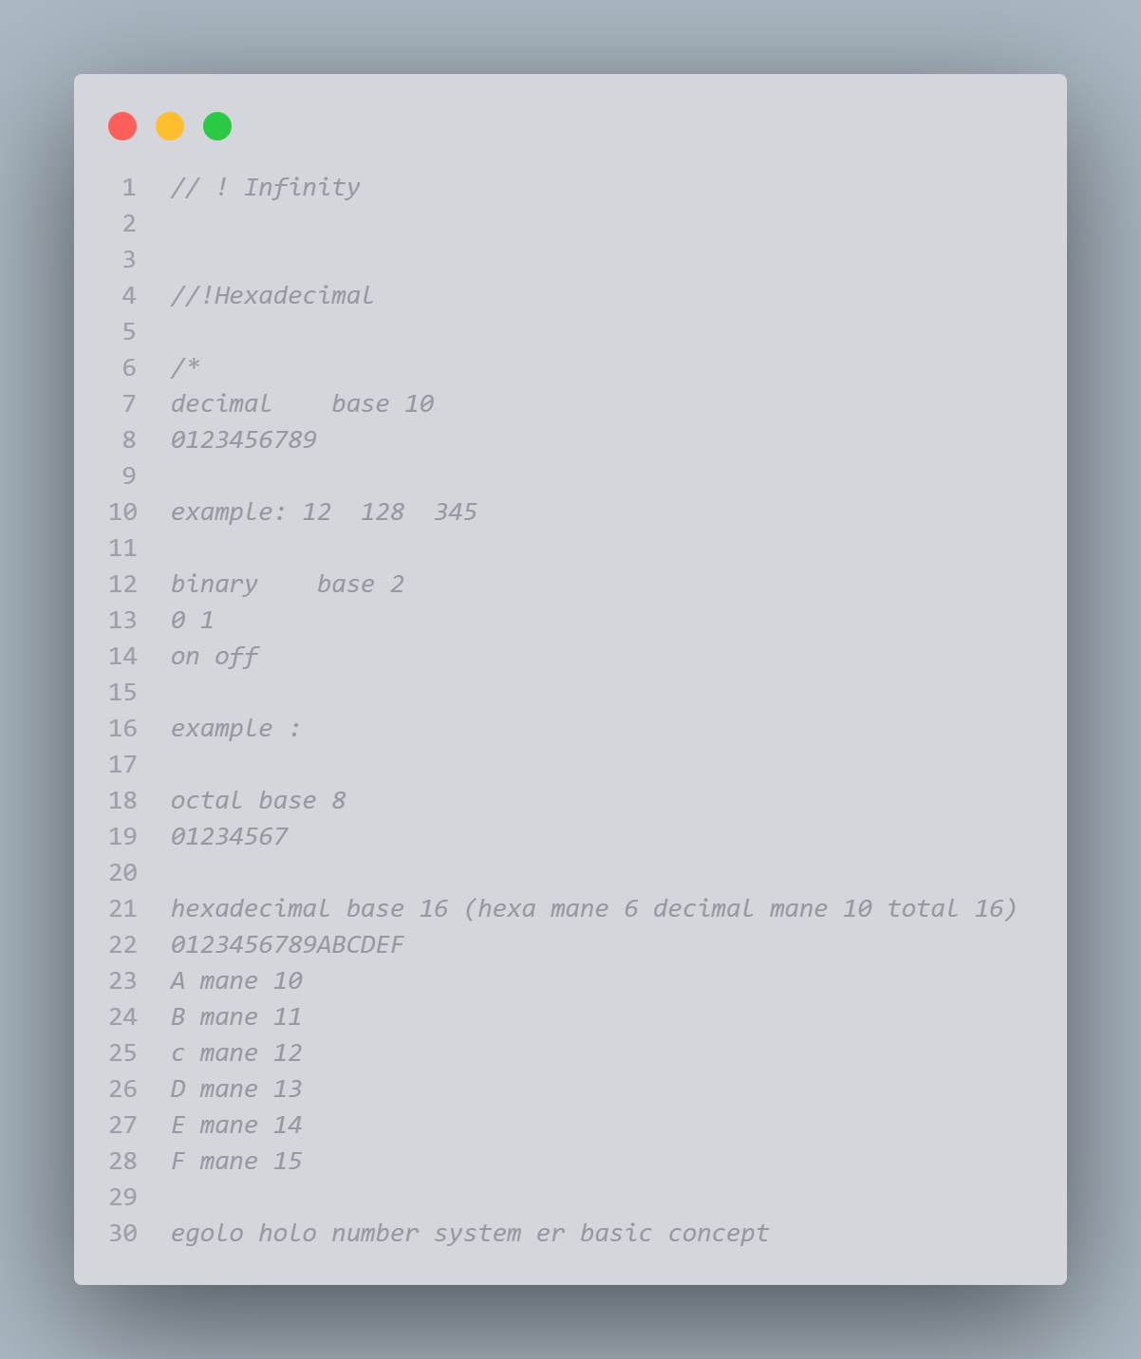

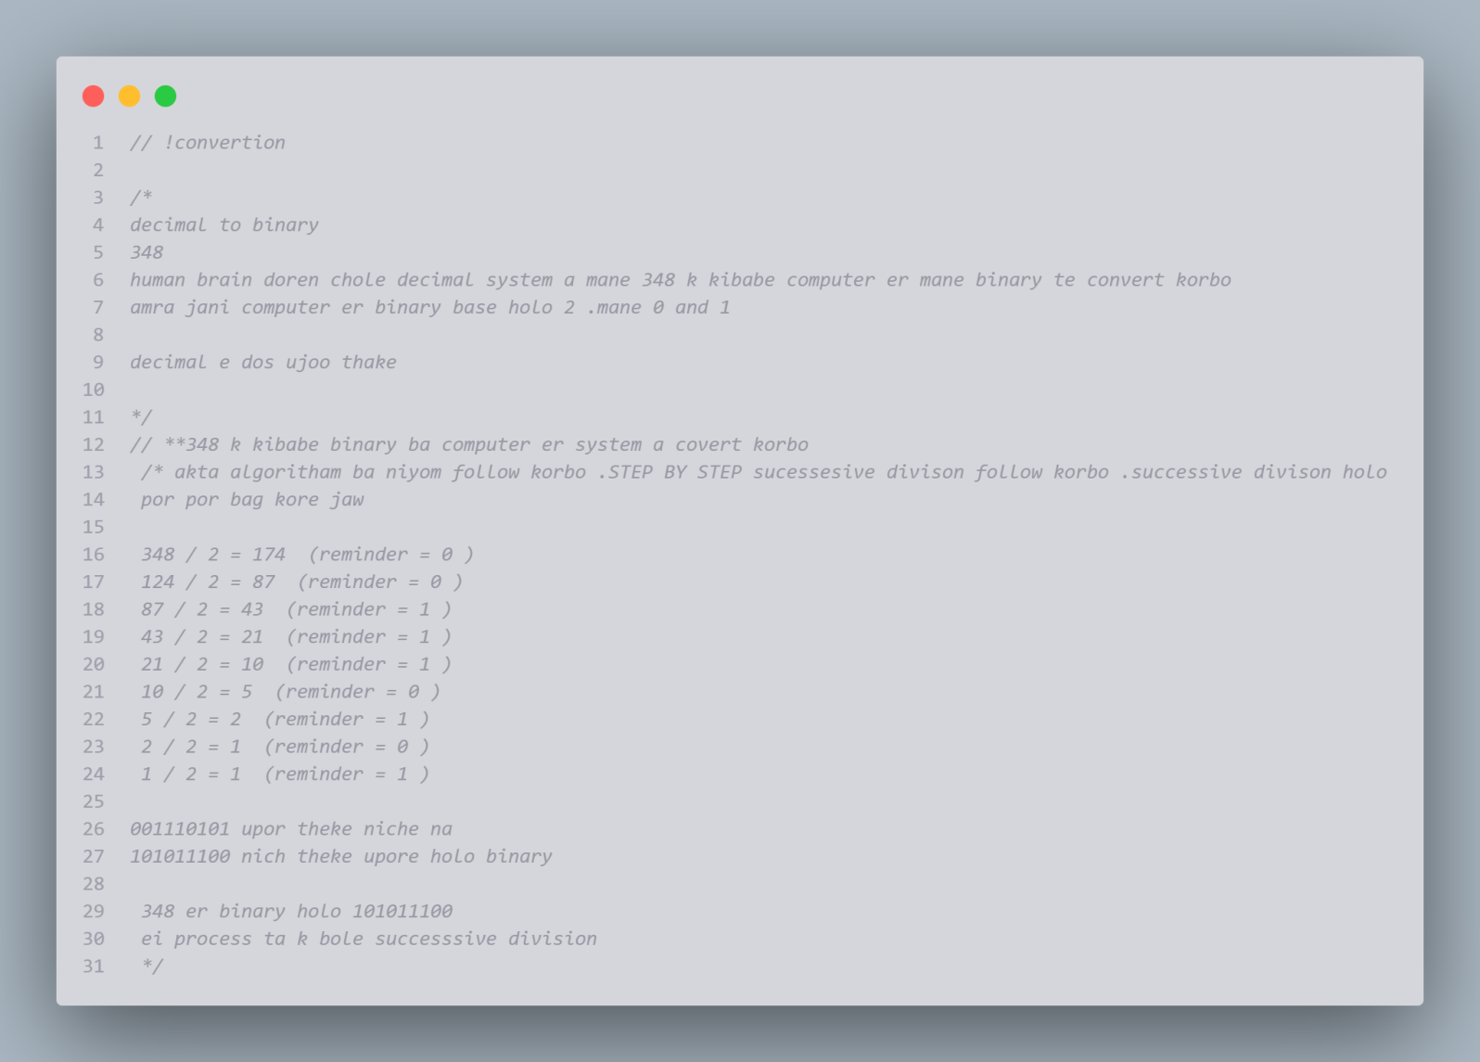

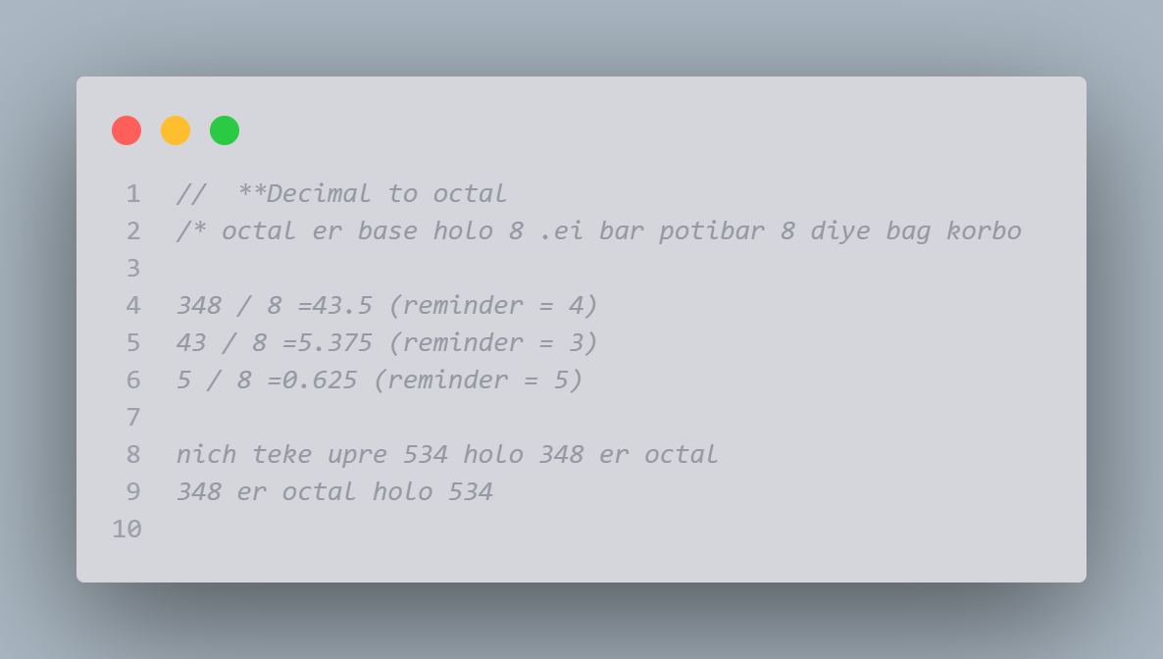

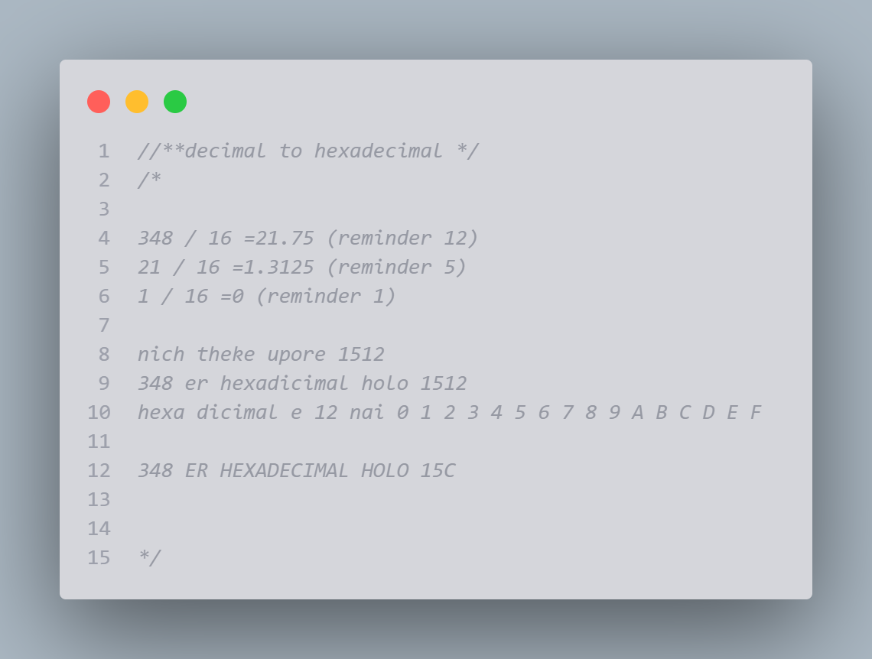

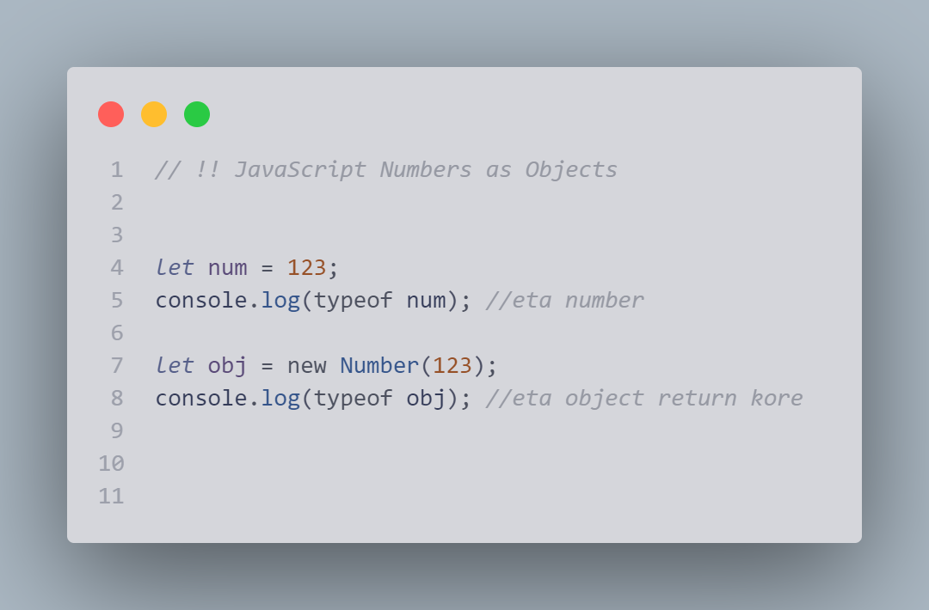

# J**avaScript Number Methods**

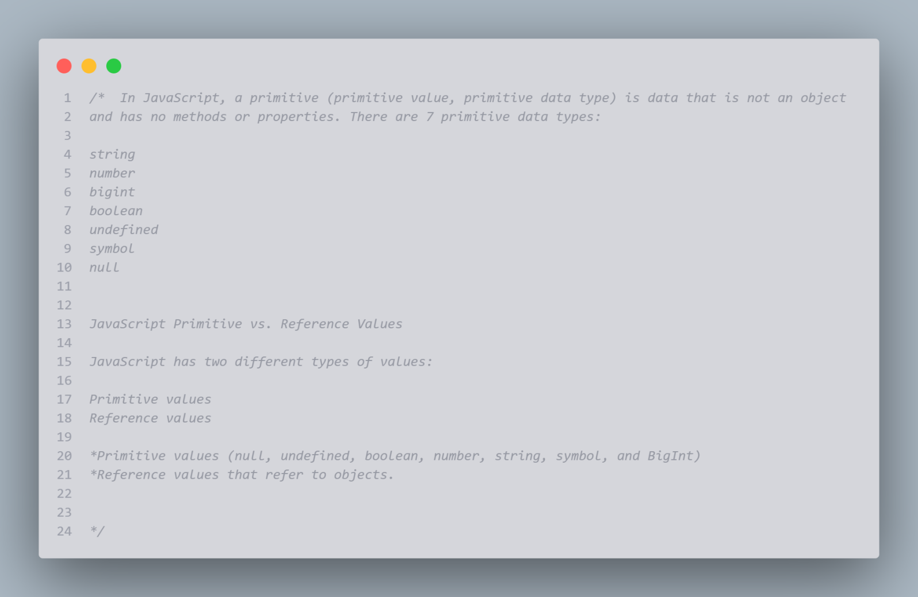

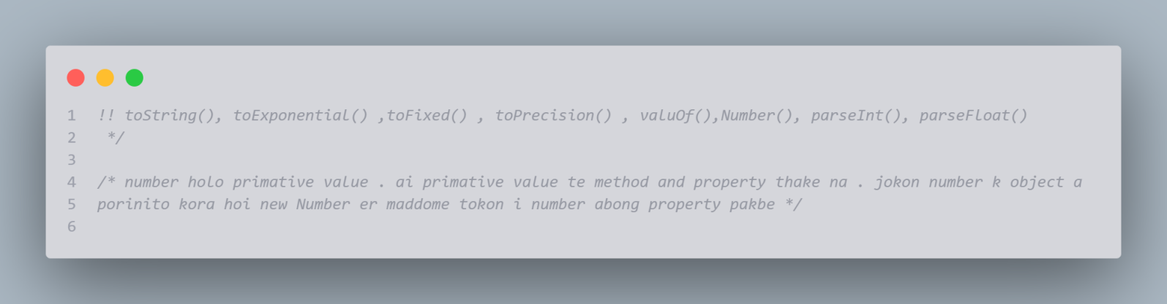

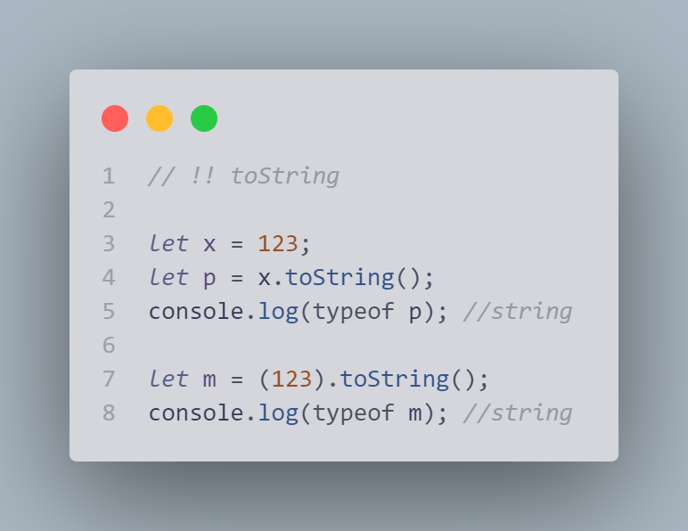

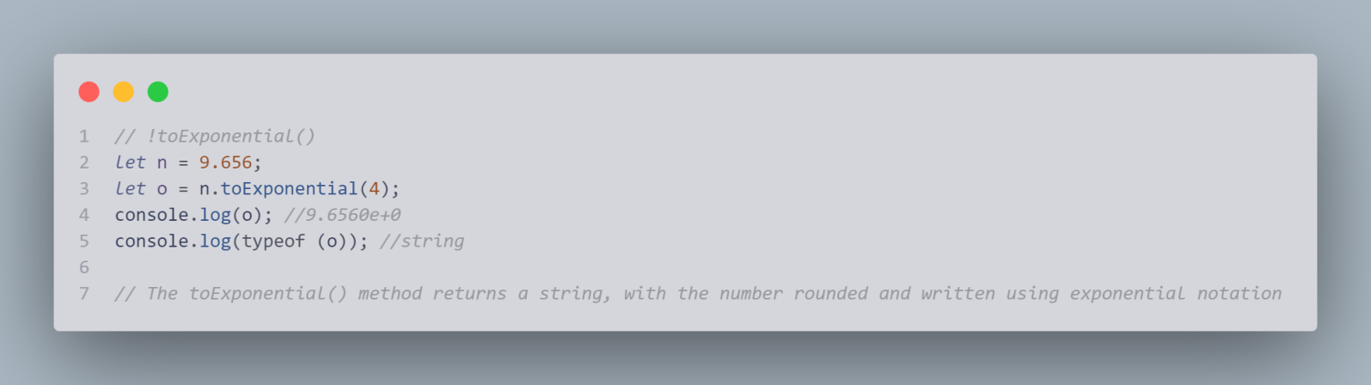

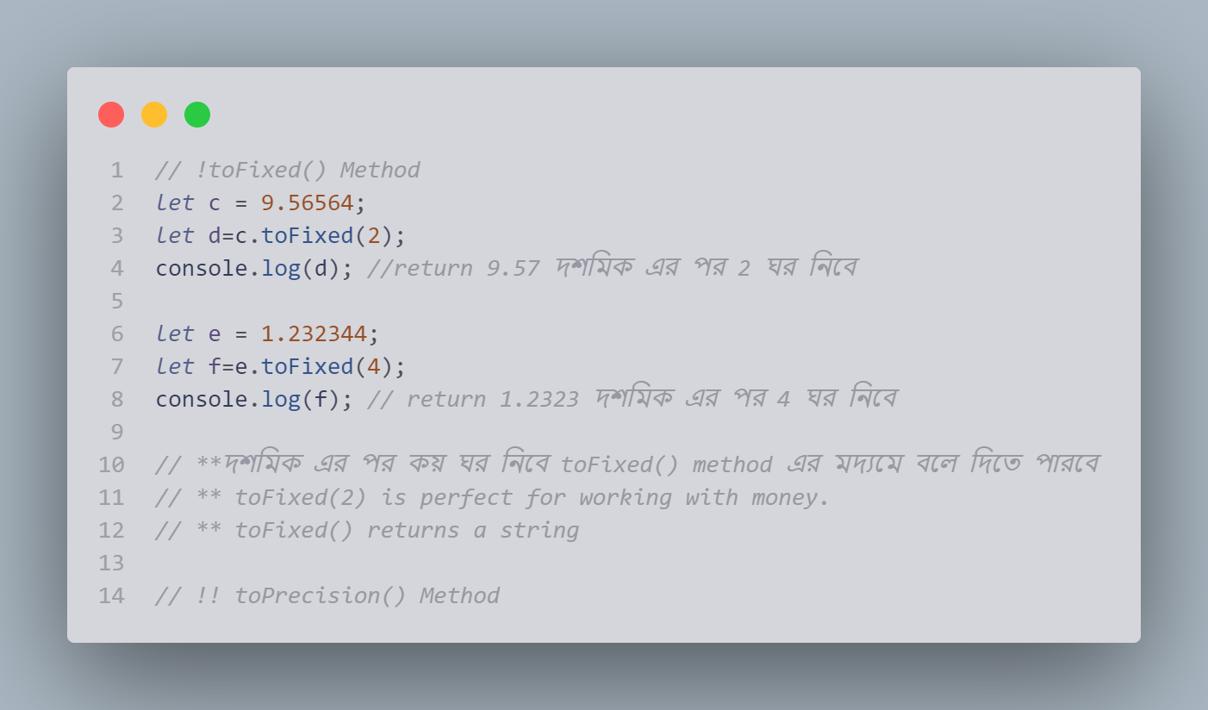

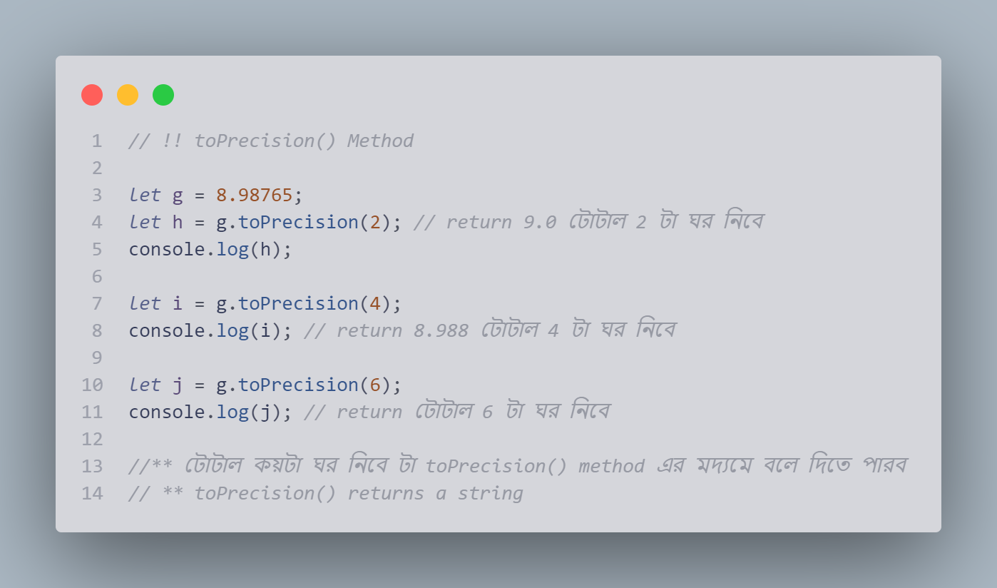

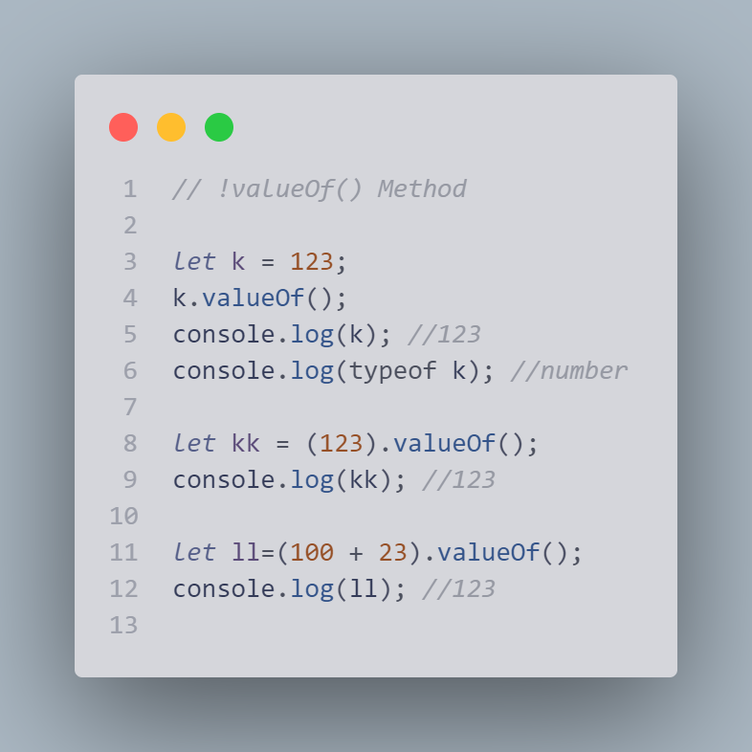

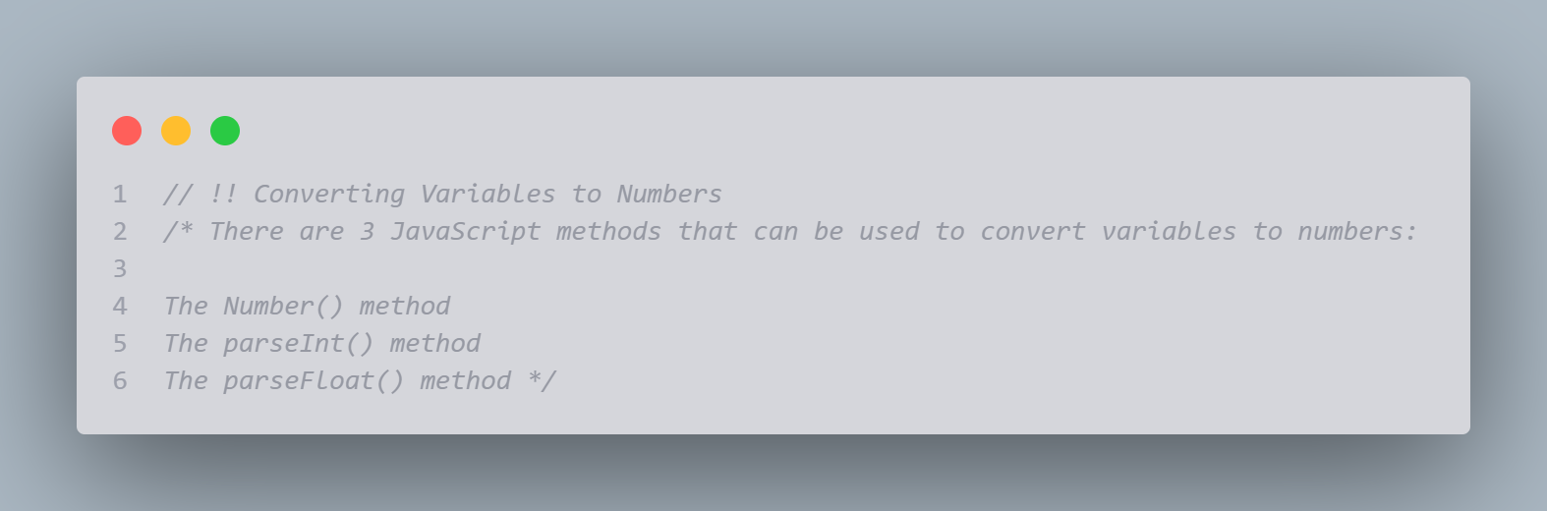

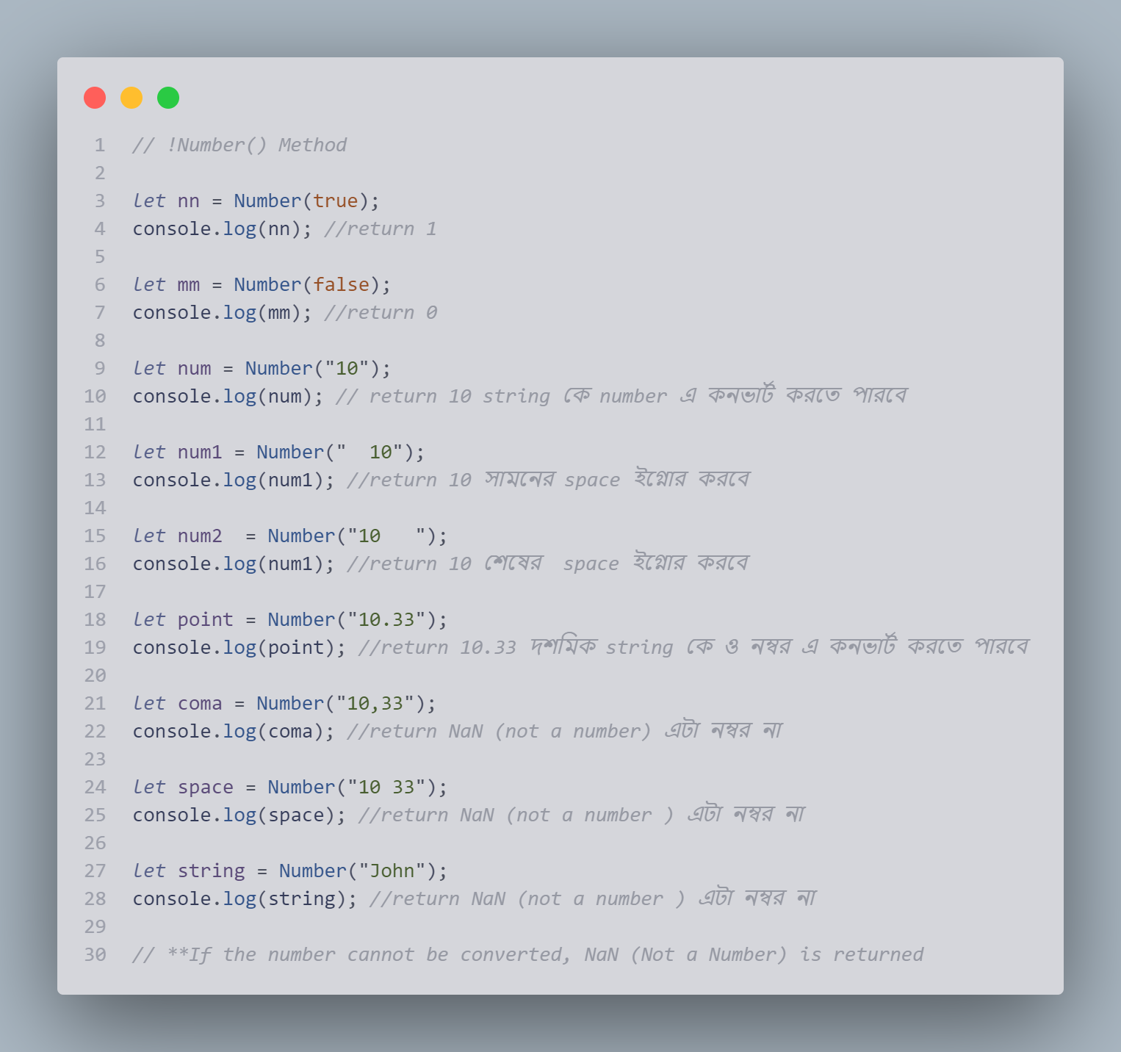

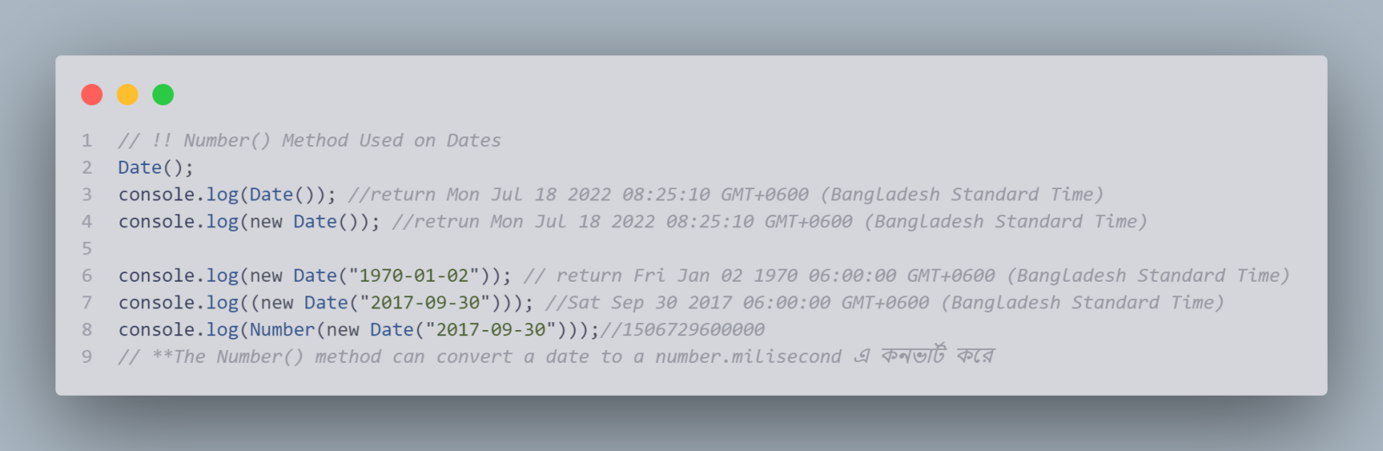

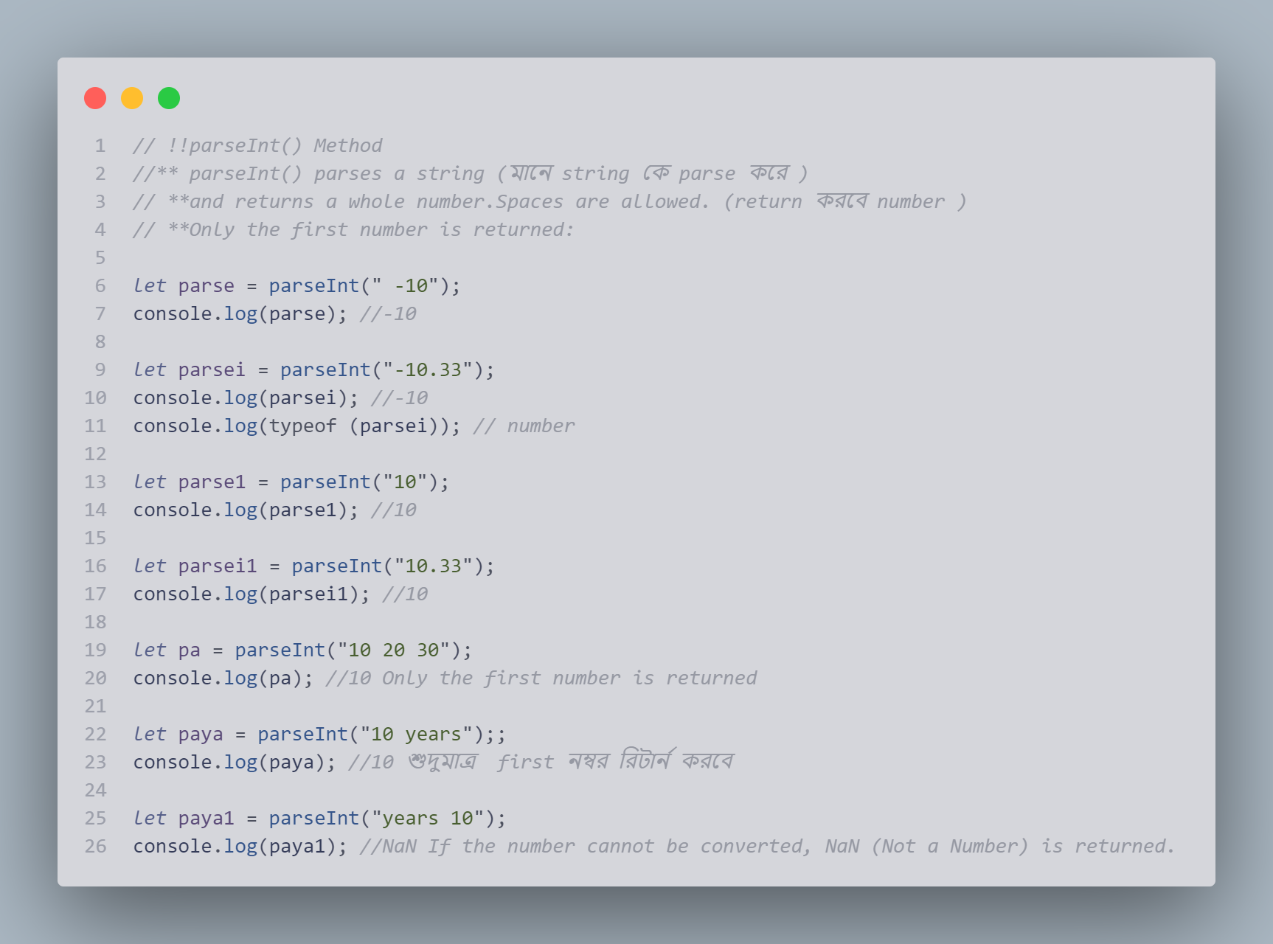

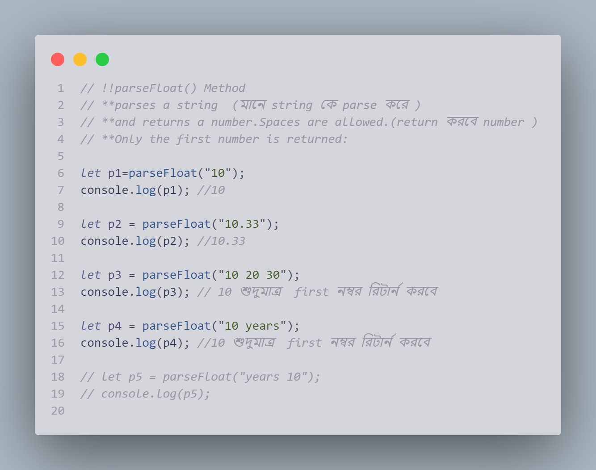

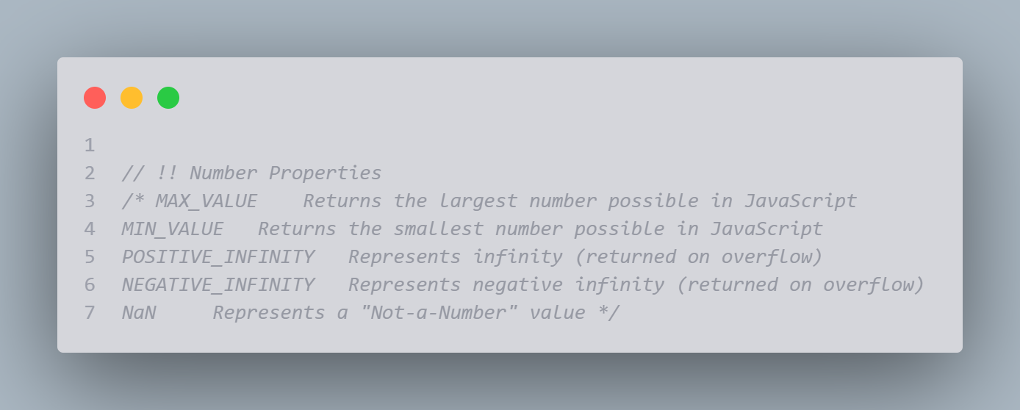

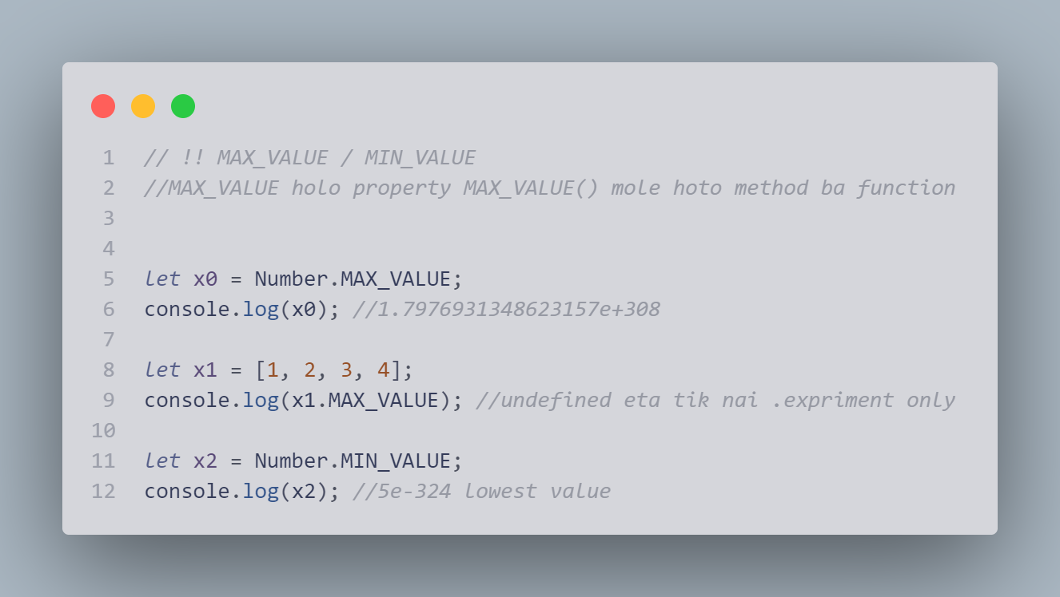

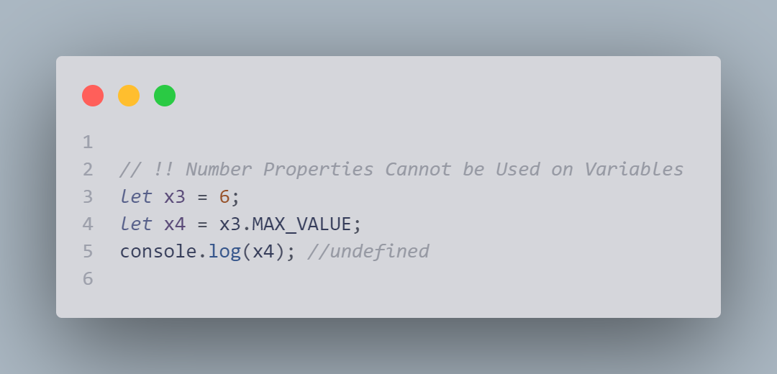

## JavaScript Arrays

**Creating array,new syntex,accessing,changing,full array access,arrays as objects,properties,length**

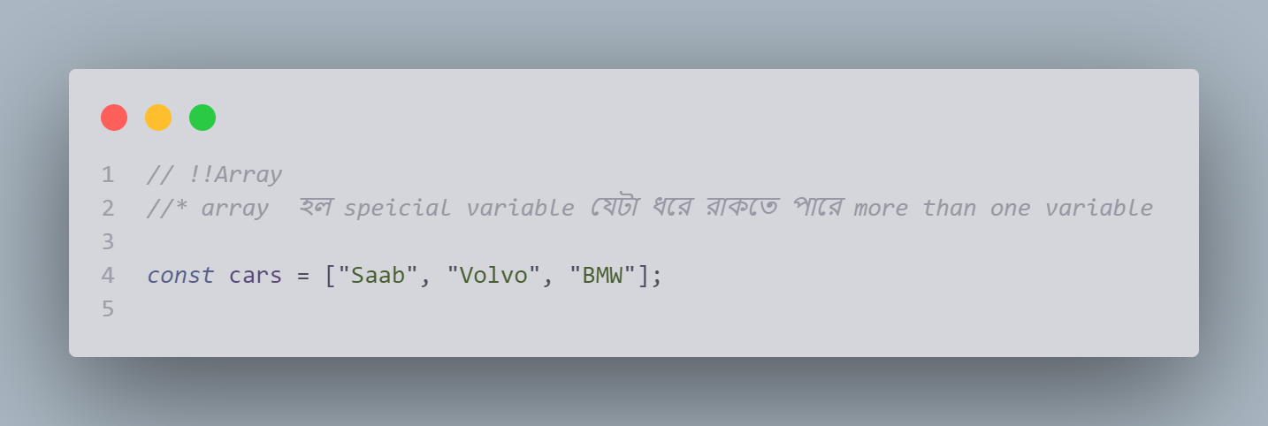

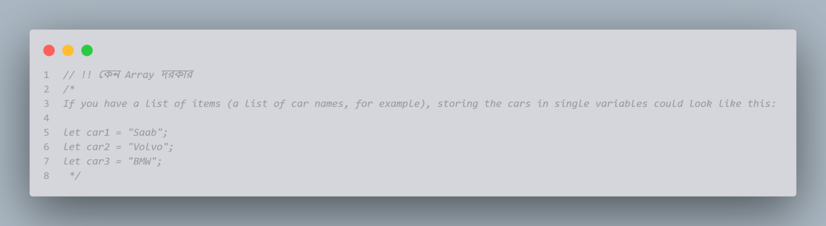

Creating an Array

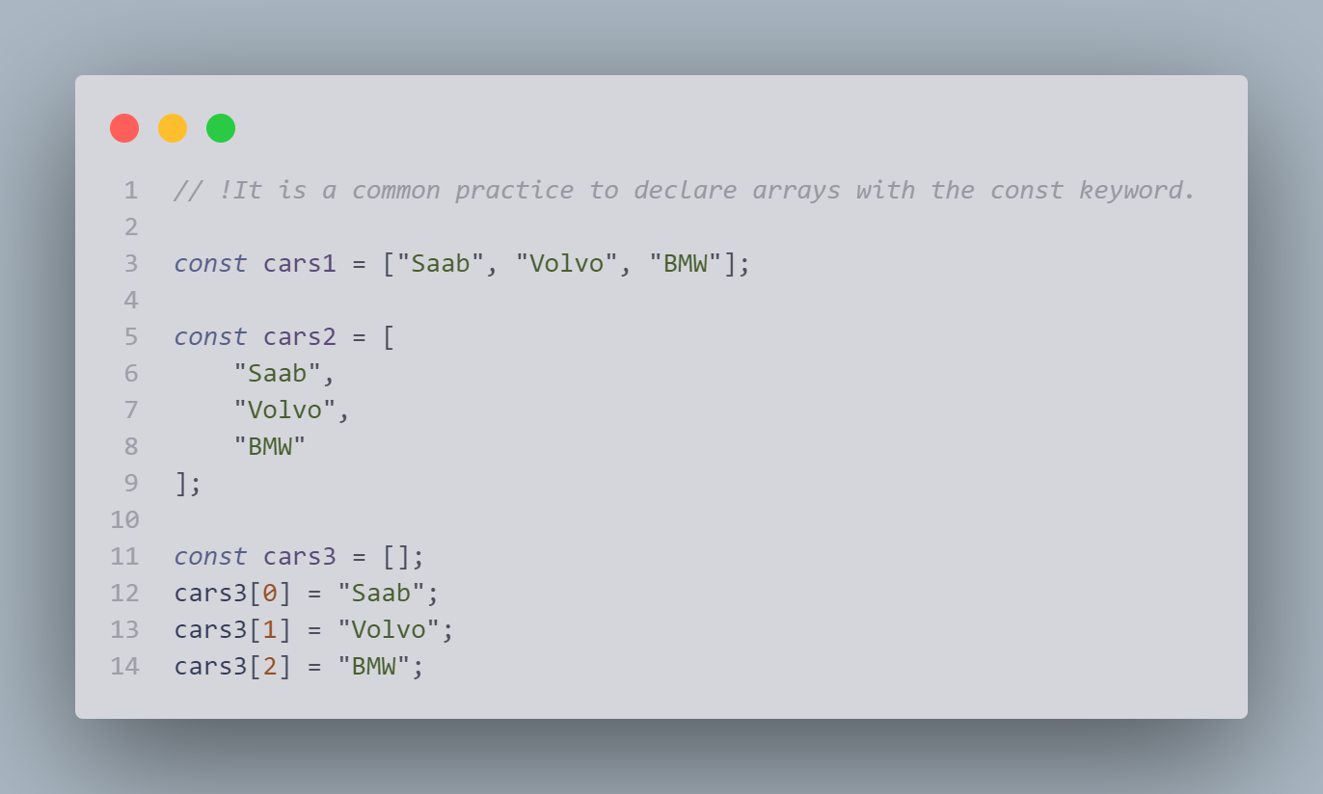

Using the JavaScript Keyword new

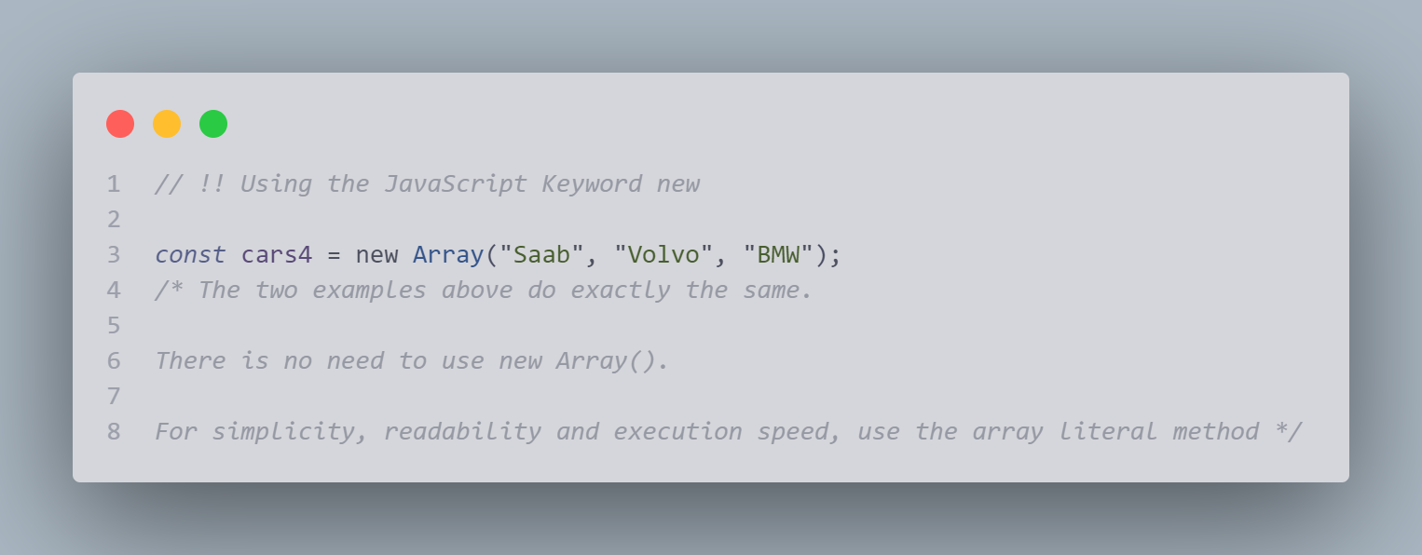

Accessing Array Elements

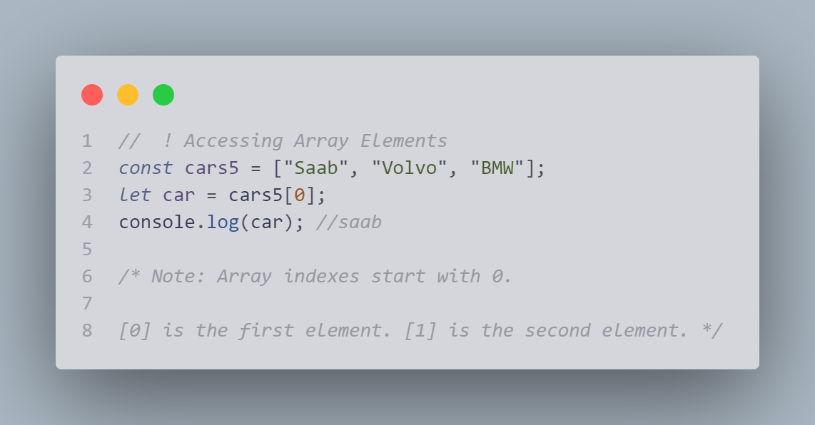

Changing an Array Element

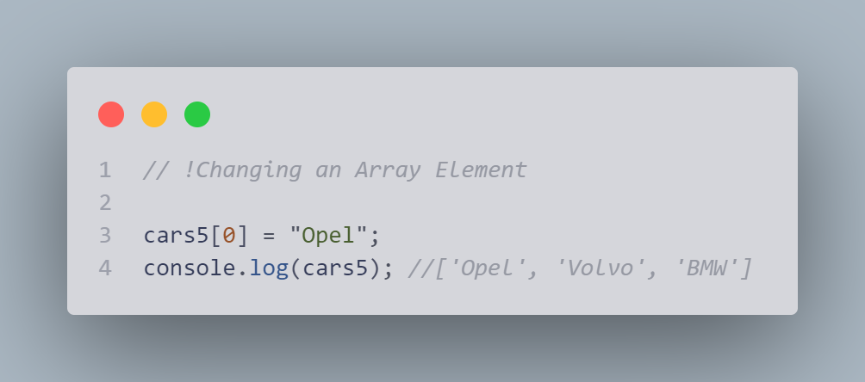

###### Access the Full Array

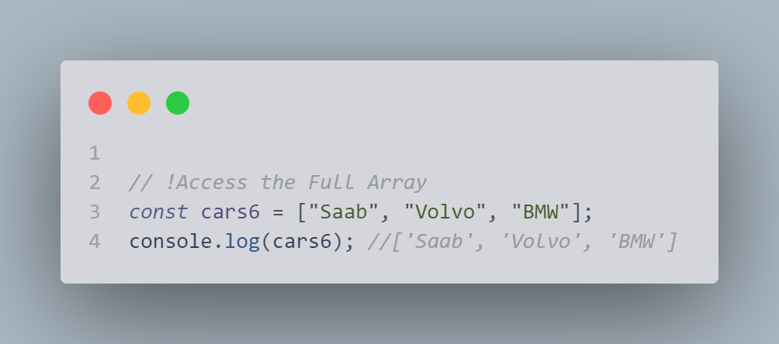

###### Arrays are Objects

##### 8

###### Array Elements Can Be Objects

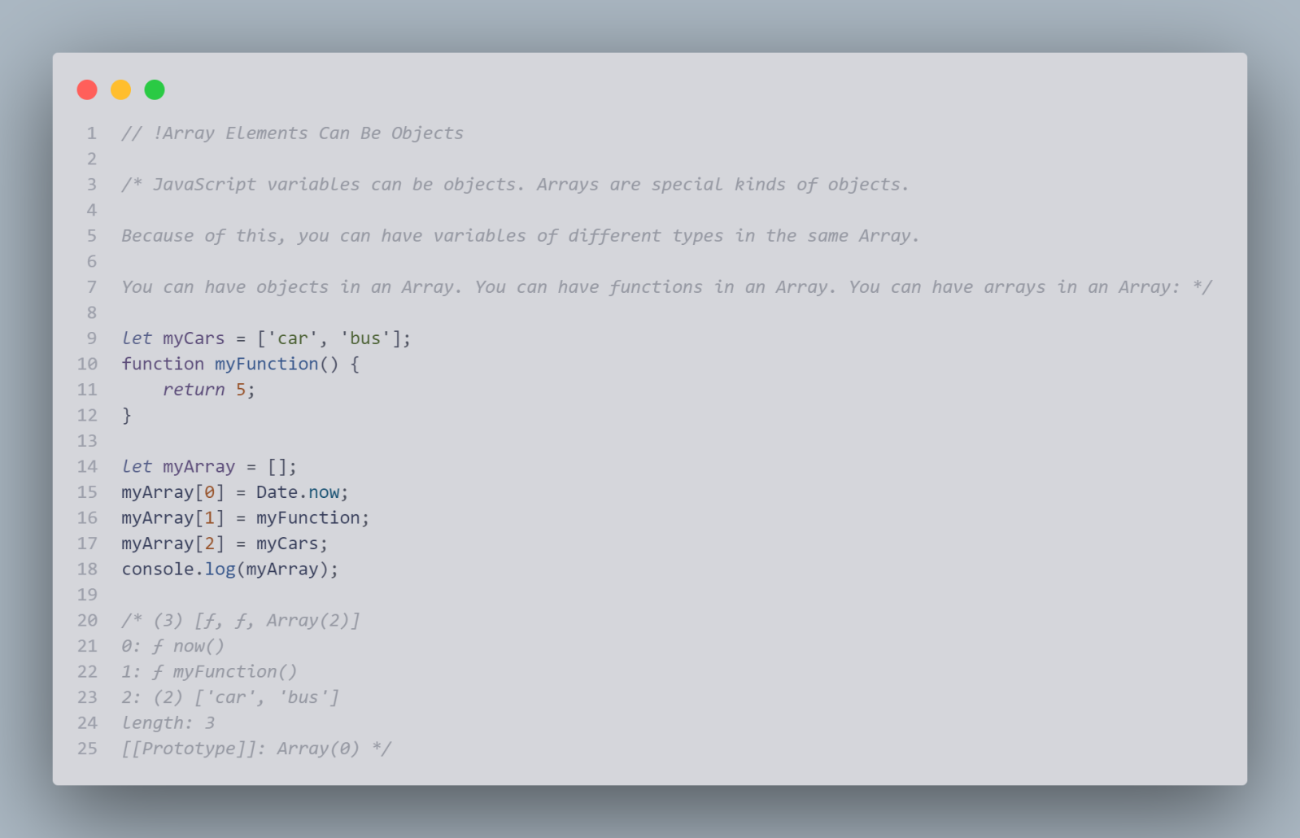

###### Array Properties and Methods

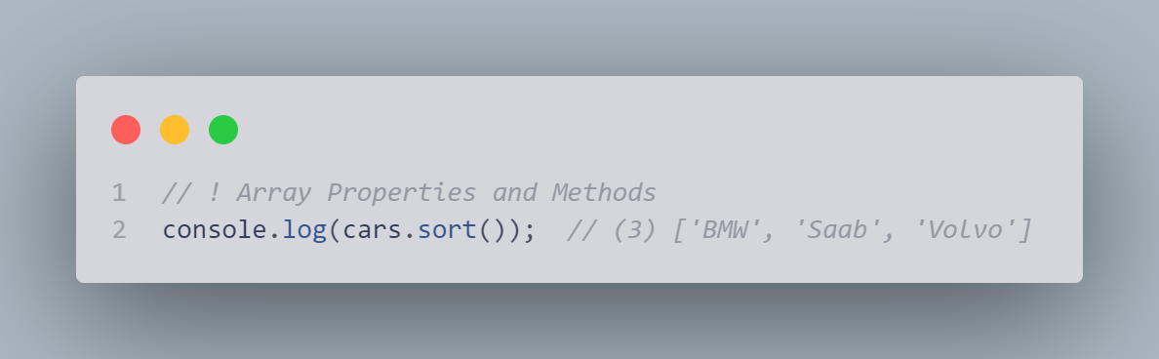

##### The length Property

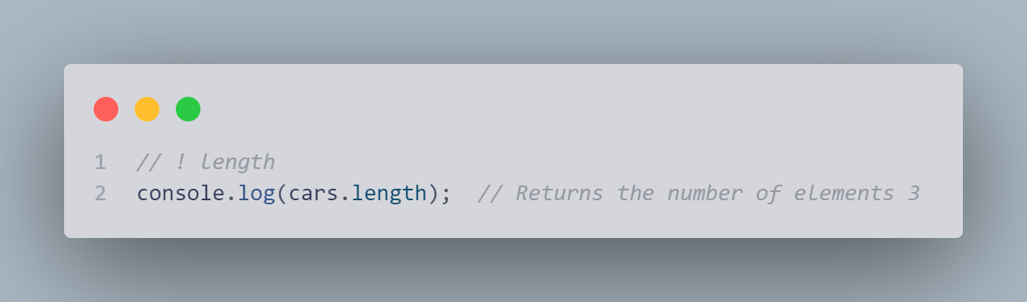

##### Accessing the First Array Element

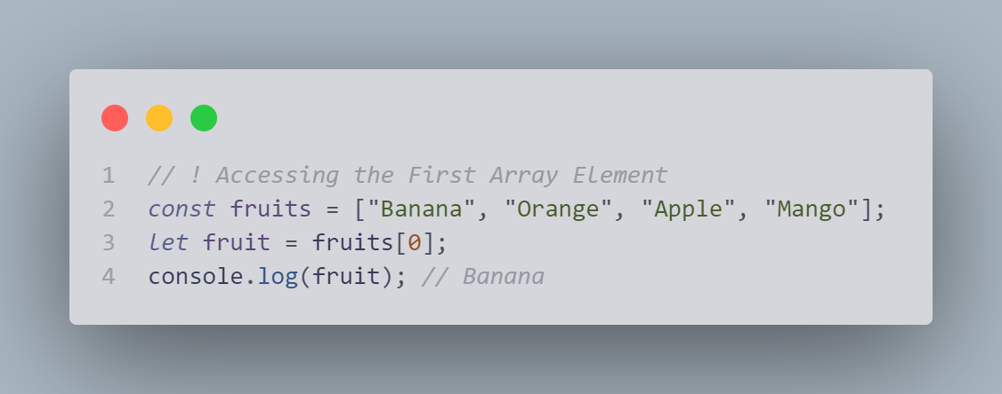

##### Accessing the Last Array Element

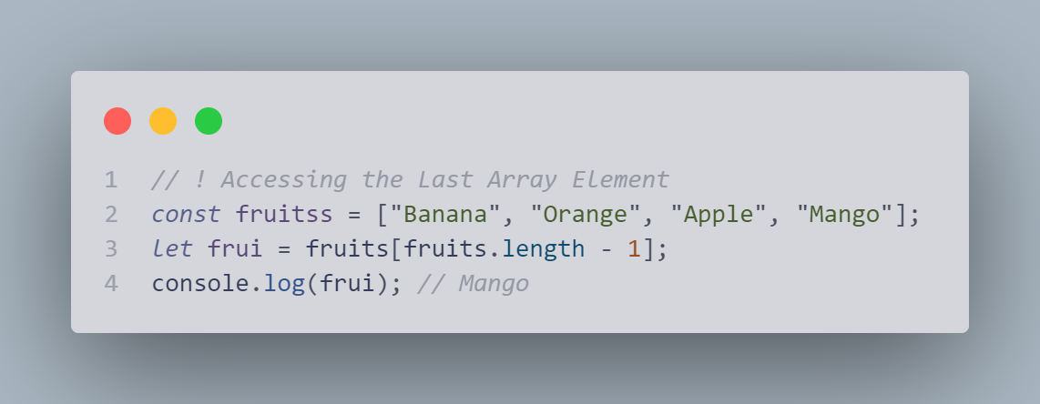

##### Looping Array Elements

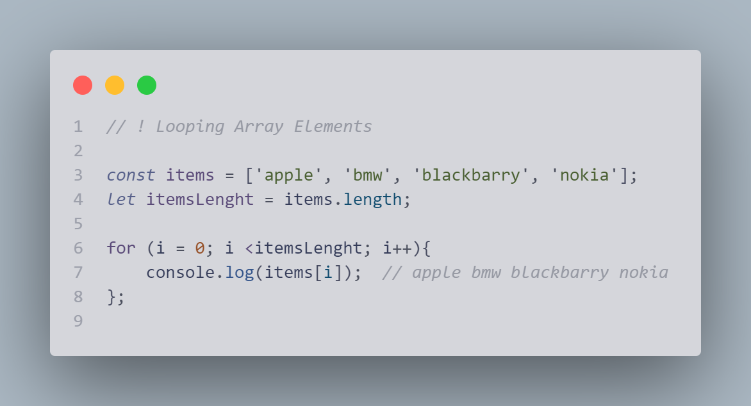

##### Array.forEach()

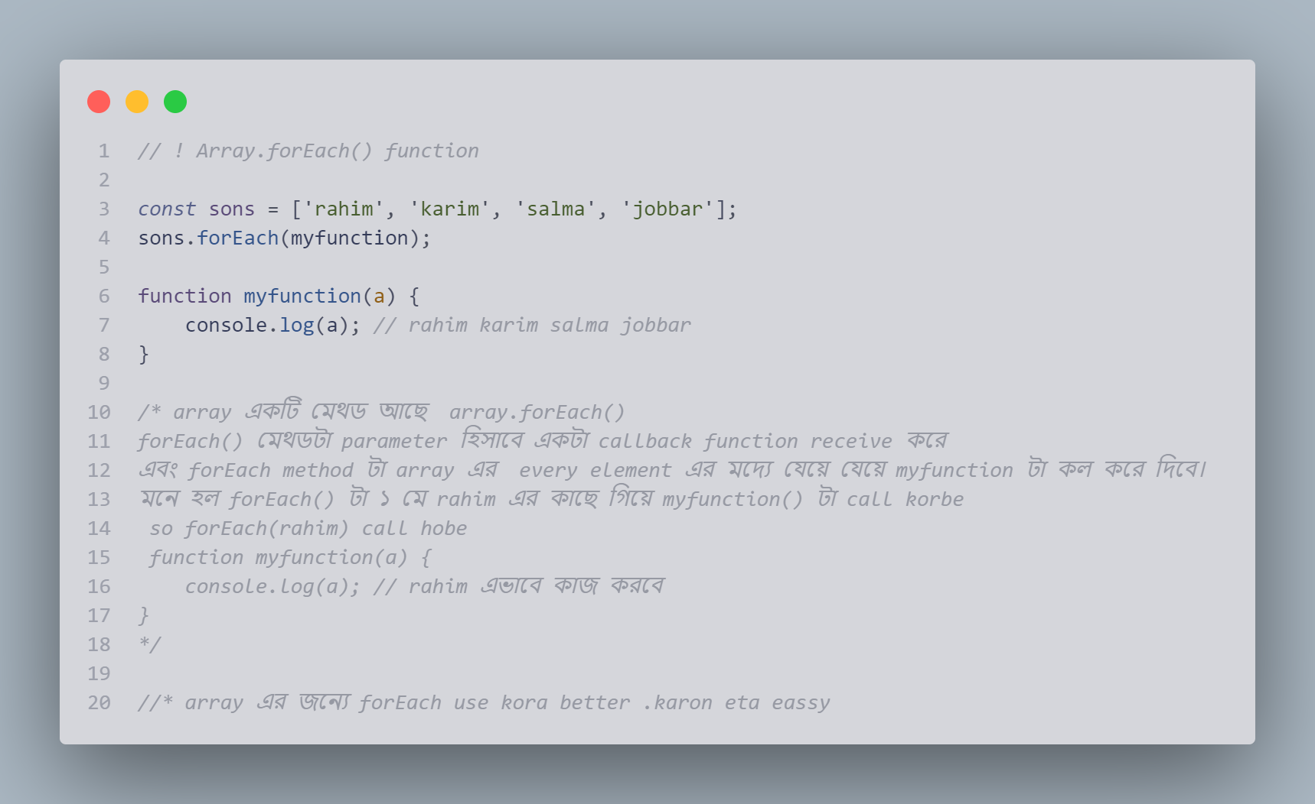

### Adding Array Elements

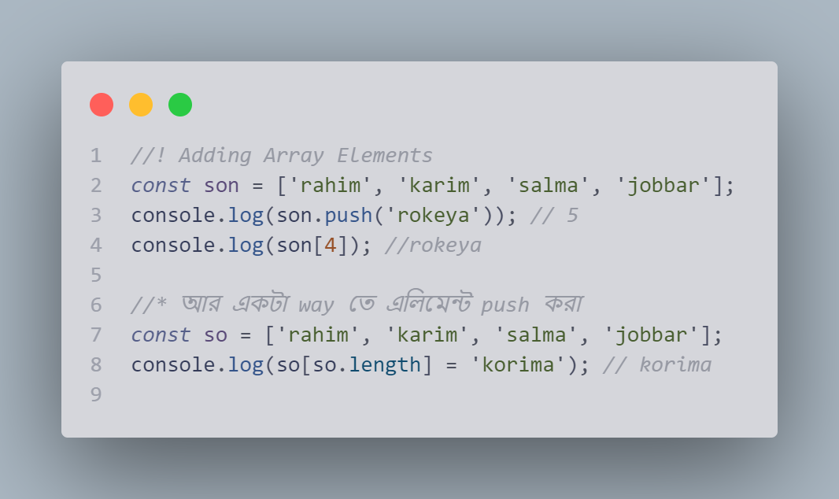

### Associative Arrays

### 18

### The Difference Between Arrays and Objects

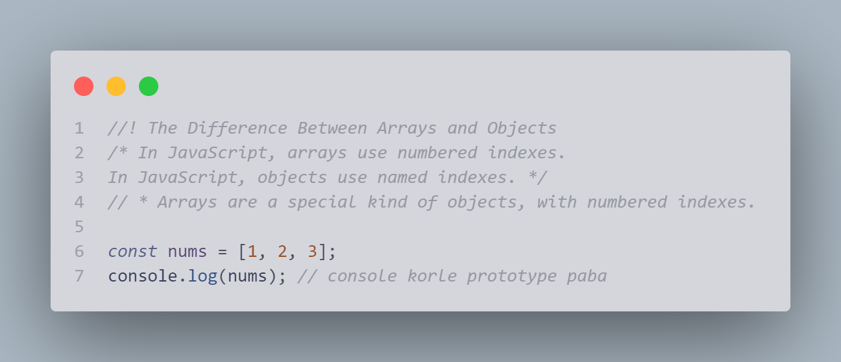

### When to Use Arrays. When to use Objects.

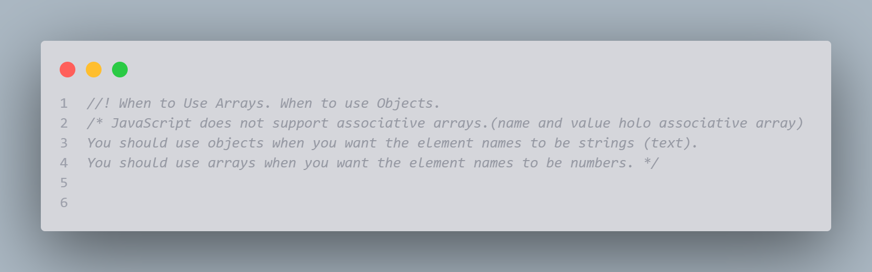

### JavaScript new Array()

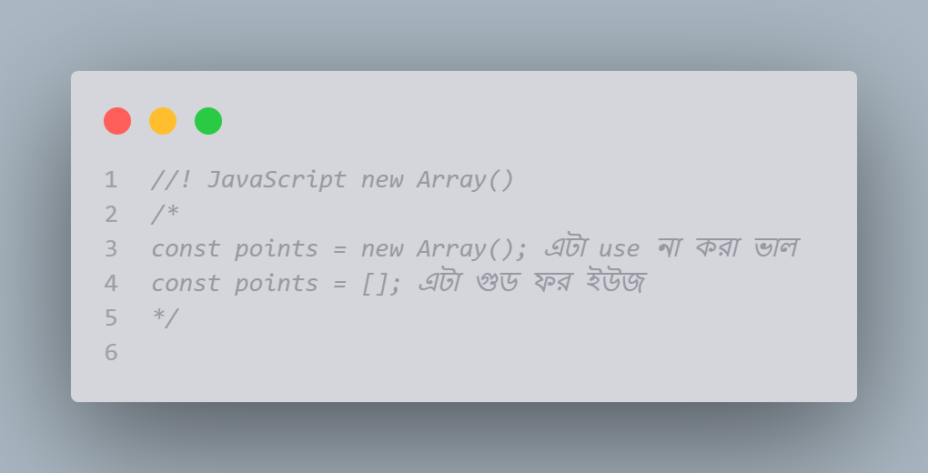

### How to Recognize an Array

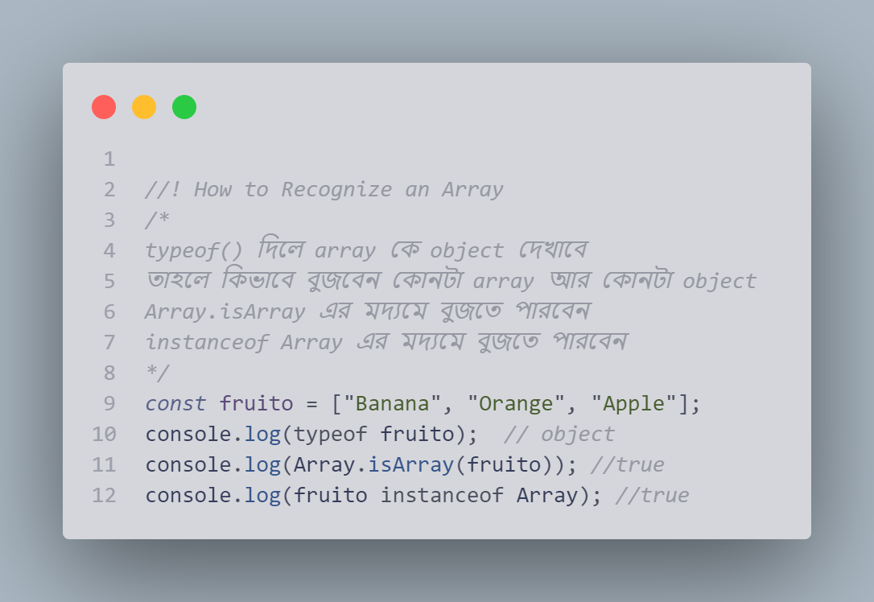

# JavaScript Array Methods

Conversion, popping, pushing, shifting, changing, deleting, splicing, merging, slicing

## Converting Arrays to Strings

The JavaScript method toString() converts an array to a string of (comma separated) array values.

*const* fruits = ["banana", "mango", "apple", "lemon"];

console.log(fruits); *// ['banana', 'mango', 'apple', 'lemon']*

console.log(fruits.toString()); *// banana,mango,apple,lemon*

**join()**

The join() method also joins all array elements into a string.

It behaves just like toString(), but in addition you can specify the separator:

*join method টা ও array কে  string এ রপান্তর করে ।*

*ডিফারেন্টটা হল separator add করতে পারবে (" * ")*

*const* fruiti = ["banana", "mango", "apple", "lemon"];

console.log(fruiti.join(" - ")); *// banana - mango - apple - lemon*

## Popping and Pushing

When you work with arrays, it is easy to remove elements and add new elements.

This is what popping and pushing is:

Popping items ****out**** of an array, or pushing items ****into**** an array.

*array নিয়ে যখন কাজ করবে তখন array তে element add অথবা remove করতে হয়*

## JavaScript Array pop()

The pop() method removes the last element from an array:

*const* fruitPop = ["banana", "mango", "apple", "lemon"];

console.log(fruitPop.pop()); *// lemon*

console.log(fruitPop); *//['banana', 'mango', 'apple']*

The pop() method returns the value that was "popped out"

console.log(fruitPop.pop()); *// lemon*

## JavaScript Array push()

The push() method adds a new element to an array (at the end):

*const* fruitPush = ["banana", "mango", "apple", "lemon"];

console.log(fruitPush.push('pineapple')); *// 5*

console.log(fruitPush); *// ['banana', 'mango', 'apple', 'lemon', 'pineapple']*

The push() method returns the new array length

console.log(fruitPush.push('pineapple')); *// 5*

## Shifting Elements

Shifting is equivalent to popping, but working on the first element instead of the last.

## JavaScript Array shift()

The shift() method removes the first array element and "shifts" all other elements to a lower index.

*const* fruitShift = ["banana", "mango", "apple", "lemon"];

console.log(fruitShift.shift()); *// banana*

console.log(fruitShift); *// ['mango', 'apple', 'lemon']*

The shift() method returns the value that was "shifted out":

console.log(fruitShift.shift()); *// banana*

## JavaScript Array unshift()

The unshift() method adds a new element to an array (at the beginning), and "unshifts" older elements:

*const* fruitUnshift = ["banana", "mango", "apple", "lemon"];

console.log(fruitUnshift.unshift("guava")); *//5*

console.log(fruitUnshift); *// ['guava', 'banana', 'mango', 'apple', 'lemon']*

The unshift() method returns the new array length.

console.log(fruitUnshift.unshift("guava")); *//5*

## Changing Elements

Array elements are accessed using their ****index number****:

Array ****indexes**** start with 0:

[0] is the first array element  
[1] is the second  
[2] is the third ...

*const* fruitcngEle = ["banana", "mango", "apple", "lemon"];

console.log(fruitcngEle[0] = "pineapple"); *//pineapple*

console.log(fruitcngEle); *//['pineapple', 'mango', 'apple', 'lemon']*

*// এখানে banana রিমুভ হয়ে গিয়েছে আর pineapple add হয়েছে*

## JavaScript Array length

The length property provides an easy way to append a new element to an array:

*const* fruit3 = ["banana", "mango", "apple", "lemon"];

console.log(fruit3[fruit3.length]="kiwi");

## JavaScript Array delete()

### Warning !

Array elements can be deleted using the JavaScript operator delete.

Using delete leaves undefined holes in the array.

Use pop() or shift() instead.

## Merging (Concatenating) Arrays

The concat() method creates a new array by merging (concatenating) existing arrays:

*const* myGirls = ["Cecilie", "Lone"];

*const* myBoys = ["Emil", "Tobias", "Linus"];

*const* myChildren = myGirls.concat(myBoys);

console.log(myChildren); *//'Cecilie', 'Lone', 'Emil', 'Tobias', 'Linus']*

The concat() method does not change the existing arrays. It always returns a new array.

The concat() method can take any number of array arguments:

### Example (Merging Three Arrays)

*// * concat() এর মদ্যমে  যতটা ইচ্ছে array concate করে*

*const* arr1 = ["Cecilie", "Lone"];

*const* arr2 = ["Emil", "Tobias", "Linus"];

*const* arr3 = ["Robin", "Morgan"];

*const* ourChildren = arr1.concat(arr2, arr3);

console.log(ourChildren);*//['Cecilie', 'Lone', 'Emil', 'Tobias', 'Linus', 'Robin', 'Morgan']*

The concat() method can also take strings as arguments:

### Example (Merging an Array with Values)

*const* arr = ["Emil", "Tobias", "Linus"];

*const* Children = arr1.concat("Peter");

console.log(Children); *//['Cecilie', 'Lone', 'Peter']*

## Splicing and Slicing Arrays

The splice() method adds new items to an array.

The slice() method slices out a piece of an array.

## JavaScript Array splice()

The splice() method can be used to add new items to an array:

*const* fruito = ["Banana", "Orange", "Apple", "Mango"];

console.log(fruito.splice(2, 0, "Lemon", "Kiwi")); *//*

console.log(fruito); *//['Banana', 'Orange', 'Lemon', 'Kiwi', 'Apple', 'Mango']*

*// ১ম পেরামিটার define the position যেকানে নুতন element add হবে*

*// ২য়  পেরামিটার define করে কথগোল element remove হবে*

*// The rest of the parameters ("Lemon" , "Kiwi") define the new elements to be added হবে*

The first parameter (2) defines the position ****where**** new elements should be ****added**** (spliced in).

The second parameter (0) defines ****how many**** elements should be ****removed****.

The rest of the parameters ("Lemon" , "Kiwi") define the new elements to be ****added****.

The splice() method returns an array with the deleted items:

*const* fruitis = ["Banana", "Orange", "Apple", "Mango"];

console.log(fruitis.splice(2, 2, "Lemon", "Kiwi")); *//['Apple', 'Mango']*

console.log(fruitis); *//['Banana', 'Orange', 'Lemon', 'Kiwi']*

## Using splice() to Remove Elements

With clever parameter setting, you can use splice() to remove elements without leaving "holes" in the array:

*const* fruitsrm = ["Banana", "Orange", "Apple", "Mango"];

console.log(fruitsrm.splice(0, 1)); *//'Banana']*

console.log(fruitsrm); *// ['Orange', 'Apple', 'Mango']*

The first parameter (0) defines the position where new elements should be ****added**** (spliced in).

The second parameter (1) defines ****how many**** elements should be ****removed****.

The rest of the parameters are omitted. No new elements will be added.

## JavaScript Array slice()

The slice() method slices out a piece of an array into a new array.

This example slices out a part of an array starting from array element 1 ("Orange"):

*const* fruitslice = ["Banana", "Orange", "Lemon", "Apple", "Mango"];

console.log(fruitslice.slice(1)); *// ['Orange', 'Lemon', 'Apple', 'Mango']*

console.log(fruitslice); *// ['Banana', 'Orange', 'Lemon', 'Apple', 'Mango']*

## Note

The slice() method creates a new array.

The slice() method does not remove any elements from the source array.

This example slices out a part of an array starting from array element 3 ("Apple"):

*// This example slices out a part of an array starting from array element 3 ("Apple"):*

*const* fruitslice2 = ["Banana", "Orange", "Lemon", "Apple", "Mango"];

console.log(fruitslice2.slice(3)); *// ['Apple', 'Mango']*

console.log(fruitslice2); *// ['Banana', 'Orange', 'Lemon', 'Apple', 'Mango']*

The slice() method can take two arguments like slice(1, 3).

The method then selects elements from the start argument, and up to (but not including) the end argument.

*// another example*

*const* fruitsli = ["Banana", "Orange", "Lemon", "Apple", "Mango"];

console.log(fruitsli.slice(1, 3)); *// ['Orange', 'Lemon'];*

console.log(fruitsli); *//['Banana', 'Orange', 'Lemon', 'Apple', 'Mango']*

If the end argument is omitted, like in the first examples, the slice() method slices out the rest of the array.

*const* fruitslian = ["Banana", "Orange", "Lemon", "Apple", "Mango"];

console.log(fruitslian.slice(2)); *// ['Lemon', 'Apple', 'Mango']*

console.log(fruitslian); *//['Banana', 'Orange', 'Lemon', 'Apple', 'Mango']*

## Automatic toString()

# JavaScript Sorting Arrays

# Sorting an Array

The sort() method sorts an array alphabetically:

*const* fruits = ["Banana", "Orange", "Apple", "Mango"];

console.log(fruits.sort()); *// ['Apple', 'Banana', 'Mango', 'Orange']*

## Reversing an Array

The reverse() method reverses the elements in an array.

You can use it to sort an array in descending order:

*const* fruitsr = ["Banana", "Orange", "Apple", "Mango"];

console.log(fruitsr.reverse()); *//['Mango', 'Apple', 'Orange', 'Banana']*

console.log(fruitsr.sort()); *//['Apple', 'Banana', 'Mango', 'Orange']*

console.log(fruitsr.reverse()); *//['Orange', 'Mango', 'Banana', 'Apple']*

## Numeric Sort

By default, the sort() function sorts values as ****strings****.

This works well for strings ("Apple" comes before "Banana").

However, if numbers are sorted as strings, "25" is bigger than "100", because "2" is bigger than "1".

Because of this, the sort() method will produce incorrect result when sorting numbers.

You can fix this by providing a ****compare function****:

*const* points = [40, 100, 1, 5, 25, 10];

console.log(points.sort()); *// [1, 10, 100, 25, 40, 5] এটা প্রবলেম*

*compare function এর মাধ্যমে এই problem এর solution করা যায়::*

*const* point = [40, 100, 1, 5, 25, 10];

console.log(point.sort(function (a, b) { *return* a - b }));

*//[1, 5, 10, 25, 40, 100]*

**Use the same trick to sort an array descending:**

*const* pointd = [40, 100, 1, 5, 25, 10];

console.log(pointd.sort(function (a, b) { *return* b - a }));

*//[100, 40, 25, 10, 5, 1]*

## The Compare Function

The purpose of the compare function is to define an alternative sort order.

The compare function should return a negative, zero, or positive value, depending on the arguments:

function(a, b){return a - b}

When the sort() function compares two values, it sends the values to the compare function, and sorts the values according to the returned (negative, zero, positive) value.

If the result is negative, a is sorted before b.

If the result is positive, b is sorted before a.

If the result is 0, no changes are done with the sort order of the two values.

****Example:****

The compare function compares all the values in the array, two values at a time (a, b).

When comparing 40 and 100, the sort() method calls the compare function(40, 100).

The function calculates 40 - 100 (a - b), and since the result is negative (-60),  the sort function will sort 40 as a value lower than 100.

You can use this code snippet to experiment with numerically and alphabetically sorting:

*const* point = [40, 100, 1, 5, 25, 10];

console.log(point.sort(function (a, b) { *return* a - b }));

*//[1, 5, 10, 25, 40, 100]*

### More explain compare function:

The "compare" function must take two arguments, often referred to as ****a**** and ****b****. Then you make the compare function return 0, greater than 0, or less than 0, based on these values, ****a**** and ****b****.

1. Return greater than 0 if ****a**** is greater than ****b****
2. Return 0 if ****a**** equals ****b****
3. Return less than 0 if ****a**** is less than ****b****

With these three return values, and only two arguments, it is possible to write a compare function that can sort any type of input data type, or complex data structures.

Then, when you call sort(), with your custom compare function, the compare function is called on pairs in your to-be-sorted list, to determine the proper ordering.

Lets walk through a simple example... Suppose you're only sorting some numbers, so we have a very simple compare function:

Function compare(a, b){return a - b}

Simply subtracting b from a will always return greater than zero if a is larger than b, 0 if they are equal, or less than zero if a is less than b. So it meets the requirements for a compare function.

Now lets suppose this is our list of numbers to sort:

*var* numbers = [1, 5, 3.14];

When you call  **numbers.sort(compare)** , internally it will actually execute:

console.log(compare(1, 5)); *// -4 , a is less than b*

console.log(compare(1, 3.14)); *// -2.14 , a is less than b*

console.log(compare(5, 3.14)); *// 1.86 , a is gater than b*

If you've ever done manual sorting or alphabetizing, you've done precisely the same thing, probably without realizing it. Even though you may have dozens or hundreds of items to compare, you're constantly comparing only two numbers (or author's last names, or whatever) at a time. Going through or short list of three numbers again, you'd start by comparing the first two numbers:

1. Is 1 greater than or less than 5? Less than, so put these two numbers in our list: 1,5
2. Is 3.14 greater than or less than 1? Greater than, so it goes after 1 in the new list
3. Is 3.14 greater than or less than 5 in our new list? Less than, so it goes before 5. Our new list is now [1,3.14,5]

## Sorting an Array in Random Order

Array এর element randomly index পজিশন change করার system :

*const* poins = [40, 100, 1, 5, 25, 10];

console.log(poins.sort(function () { *return* Math.random() }));

*// [40, 100, 1, 5, 25, 10]  এভাবে randomly change হয় না*

console.log(poins.sort(function () { *return* 0.5 - Math.random() }));

*//  [10, 5, 40, 1, 25, 100]  এটা randomly change hocce*

console.log(poins.sort(function () { *return* 0.2  - Math.random() }));

*//  [5, 10, 40, 100, 25, 1]  এটা randomly change hocce*

## The Fisher Yates Method

The above example, array.sort(), is not accurate. It will favor some numbers over the others.

The most popular correct method, is called the Fisher Yates shuffle, and was introduced in data science as early as 1938!

In JavaScript the method can be translated to this:

const points = [40, 100, 1, 5, 25, 10];  
  
for (let i = points.length -1; i > 0; i--) {  
  let j = Math.floor(Math.random() * (i+1));  
  let k = points[i];  
  points[i] = points[j];  
  points[j] = k;  
}

## Find the Highest (or Lowest) Array Value

There are no built-in functions for finding the max or min value in an array.

However, after you have sorted an array, you can use the index to obtain the highest and lowest values.

**Sorting ascending:**

*const* pointm = [40, 100, 1, 5, 25, 10];

console.log(pointm.sort(function (a, b) { *return* a - b }));

*// [1, 5, 10, 25, 40, 100]*

console.log(pointm); *// [1, 5, 10, 25, 40, 100]*

console.log(pointm[0]); *// 1 এভাবে lowest number বের করতে পারবে*

**Sorting descending:**

*const* pointmx = [40, 100, 1, 5, 25, 10];

console.log(pointmx.sort(function (a, b) { *return* b - a })); *//  [100, 40, 25, 10, 5, 1]*

console.log(pointmx); *//  [100, 40, 25, 10, 5, 1]*

console.log(pointmx[0]); *// 100 এভাবে lowest number বের করতে পারবে*

## Sorting Object Arrays

JavaScript arrays often contain objects:

*const* cars = [

    { type: "Volvo", year: 2016 },

    { type: "Saab", year: 2001 },

    { type: "BMW", year: 2010 }

];

console.log(cars.sort(function (a, b) { *return* a.year - b.year }));

*// { type: 'Saab', year: 2001 }*

*// { type: 'BMW', year: 2010 }*

*// { type: 'Volvo', year: 2016 }*

## JavaScript Sorting Arrays

### Sorting an Array

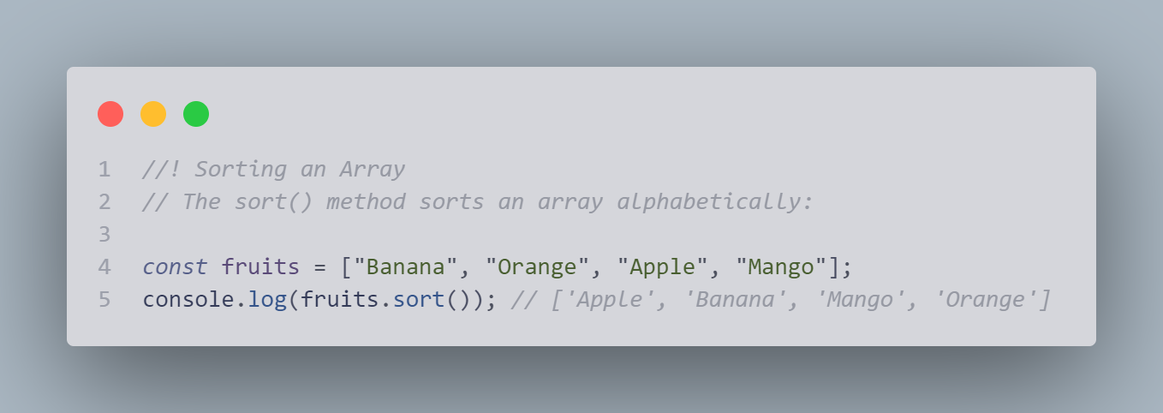

### Reversing an Array

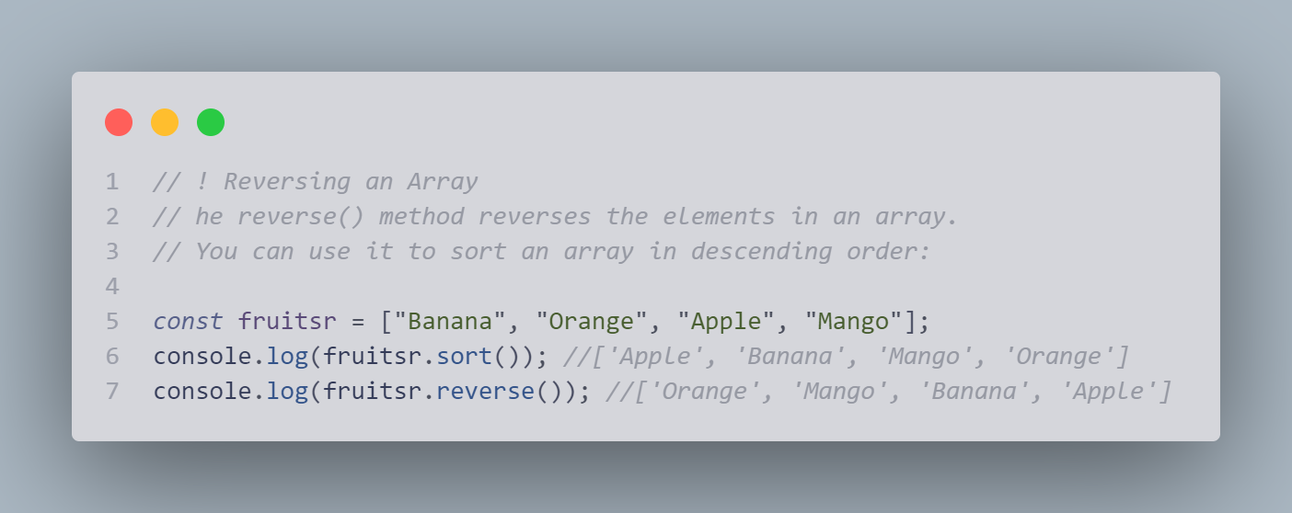

### Numeric Sort

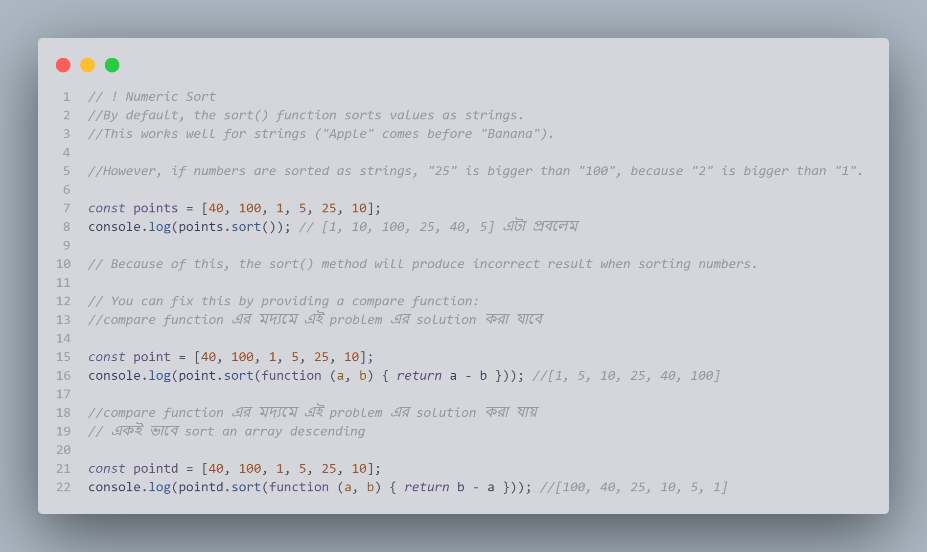

The Compare Function

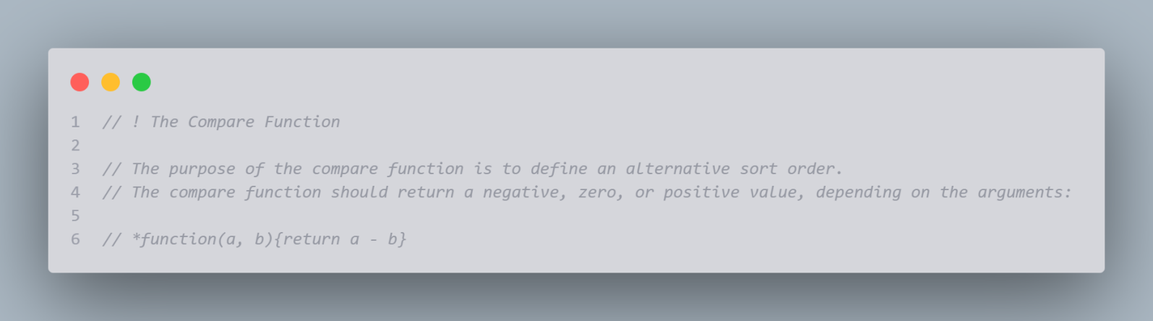

### Find the Highest (or Lowest) Array Value

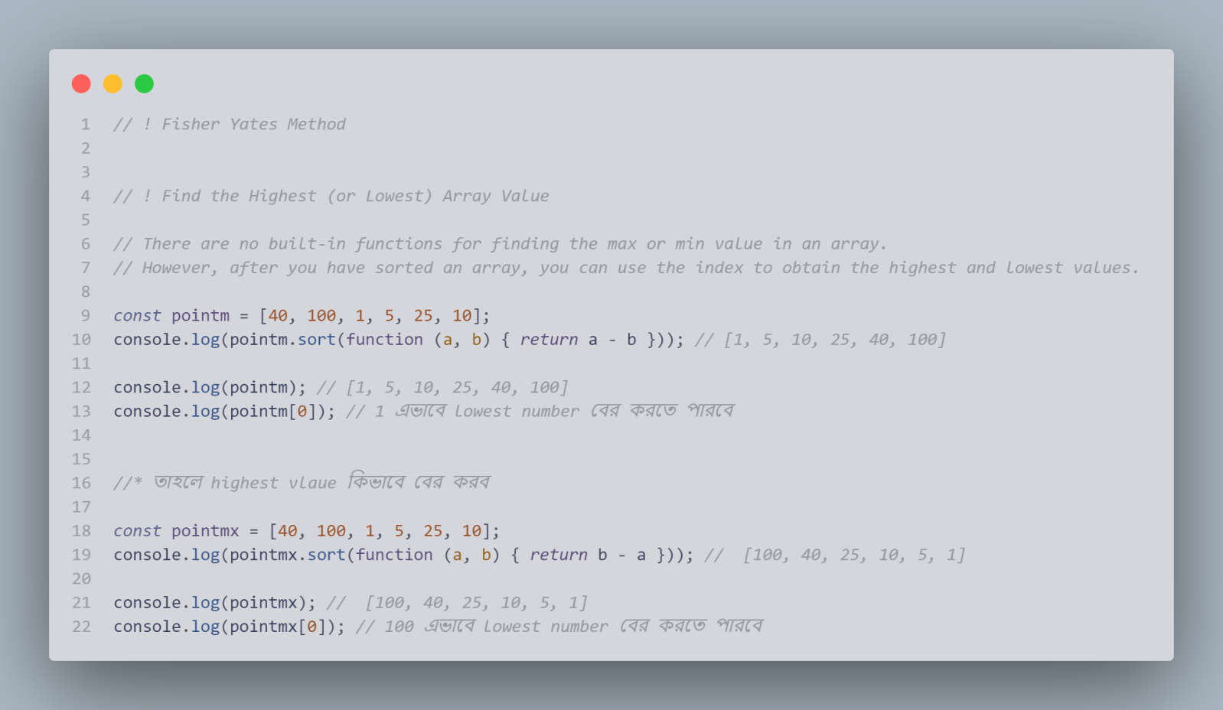

### Sorting Object Arrays

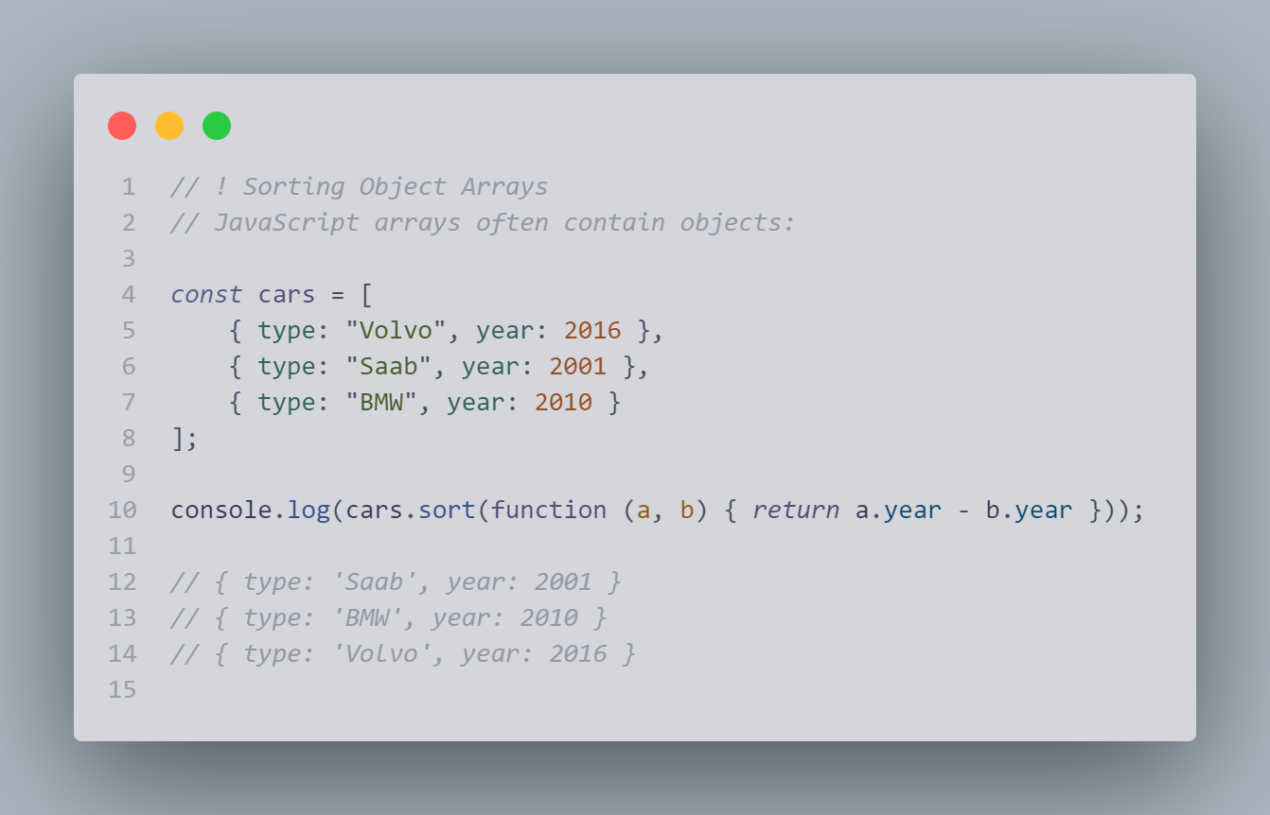

### JavaScript Array Iteration

*JavaScript Array Iteration পুনরাবৃত্তি*

forEach(), map(), filter(), reduce(), every(), some(),

 indexOf(), lastIndexOf(), includes(), find(), findIndex(),

 key()

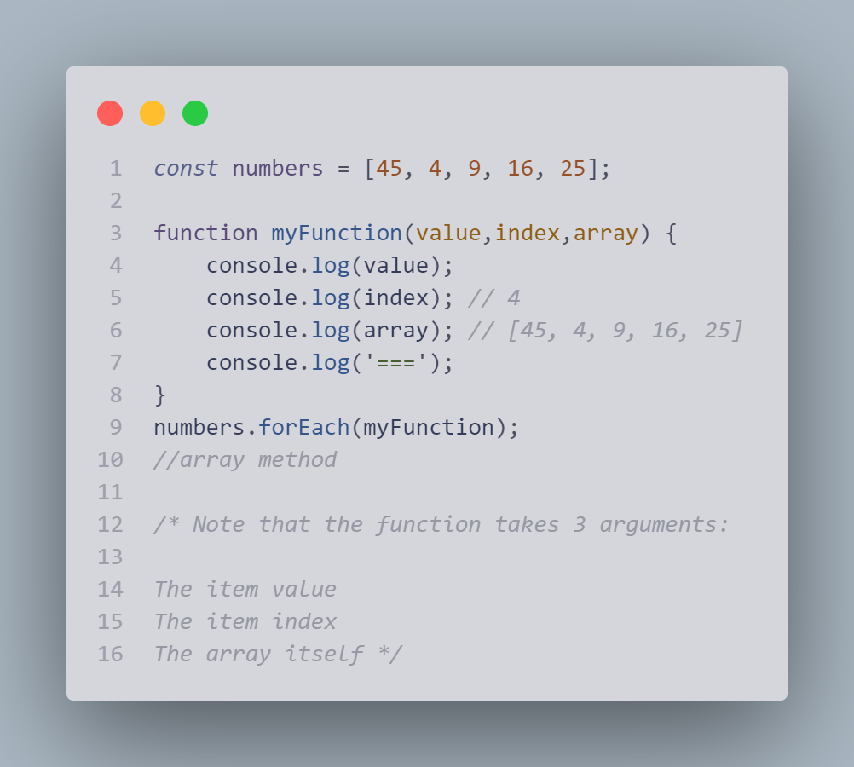

### Array.forEach()

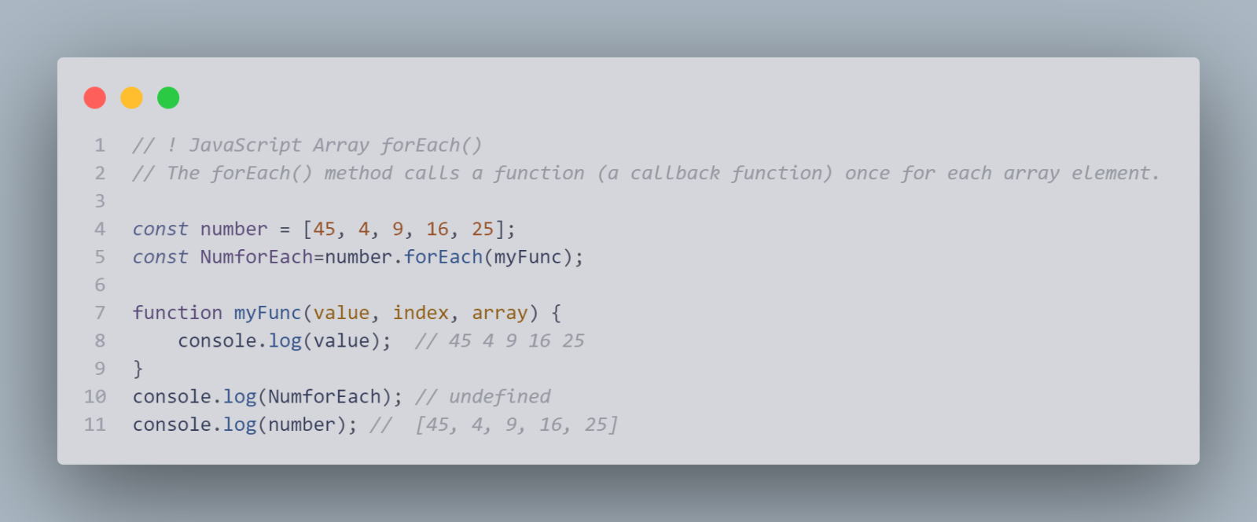

### JavaScript Array map()

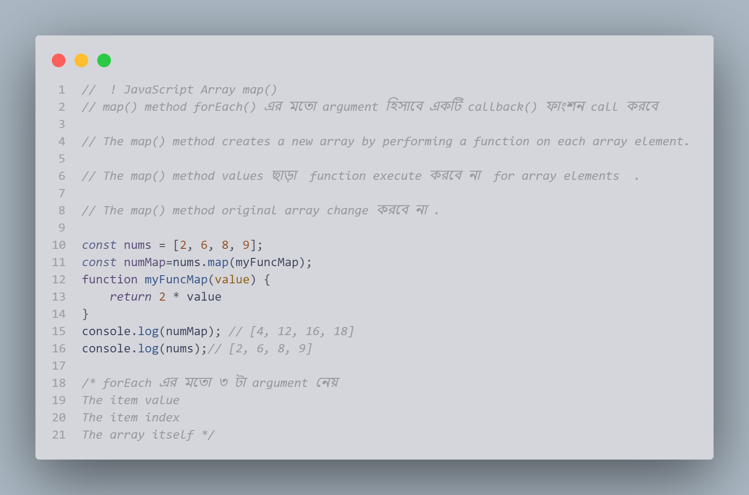

### Differences between forEach() and map() methods:

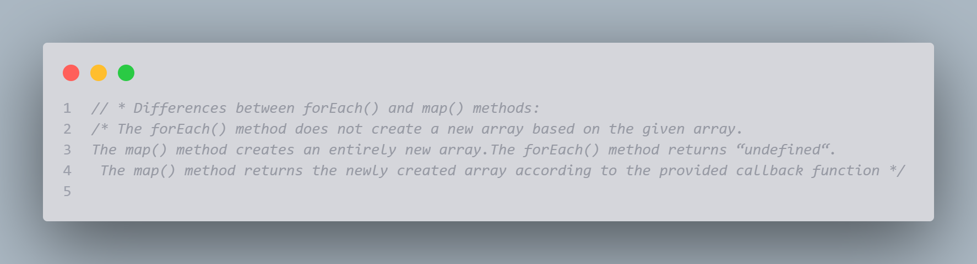

### JavaScript Array filter()

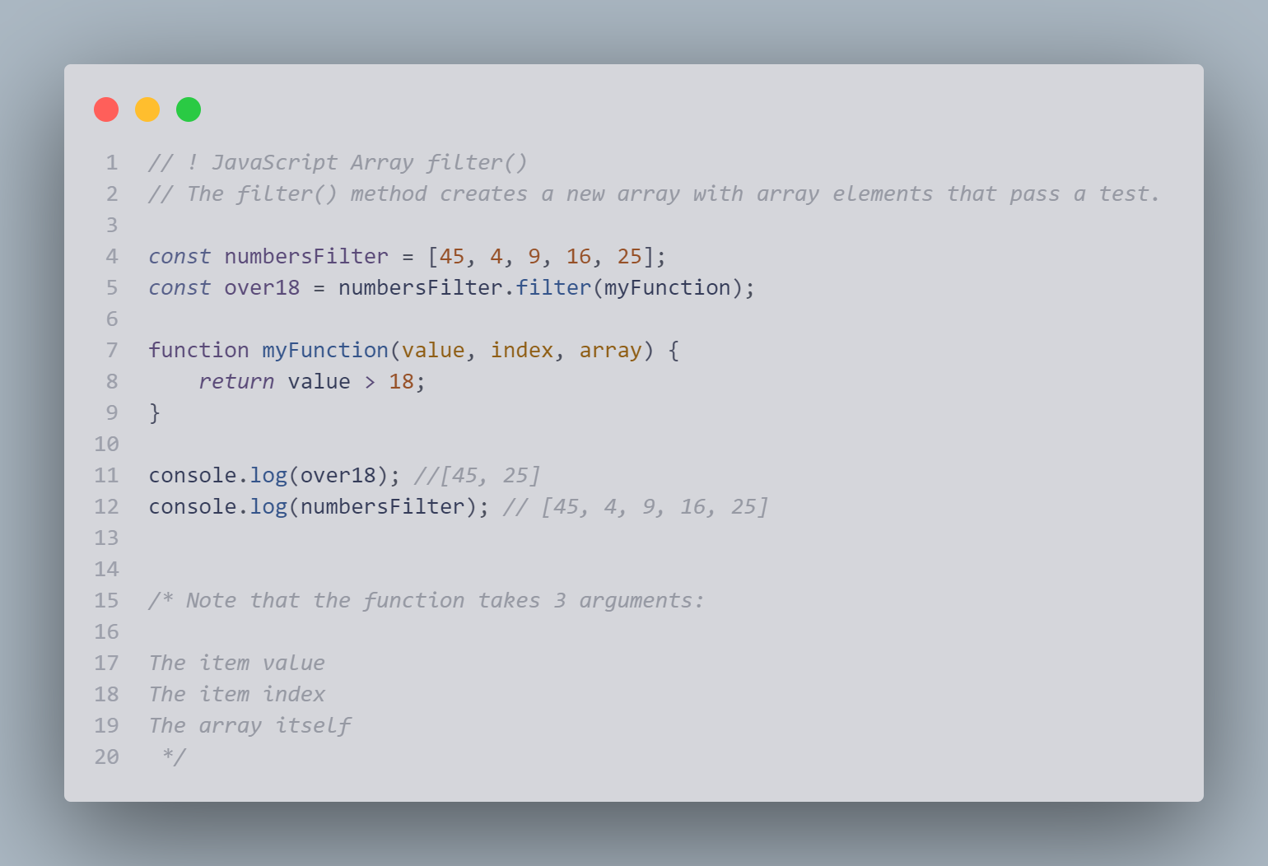

### JavaScript Array reduce()

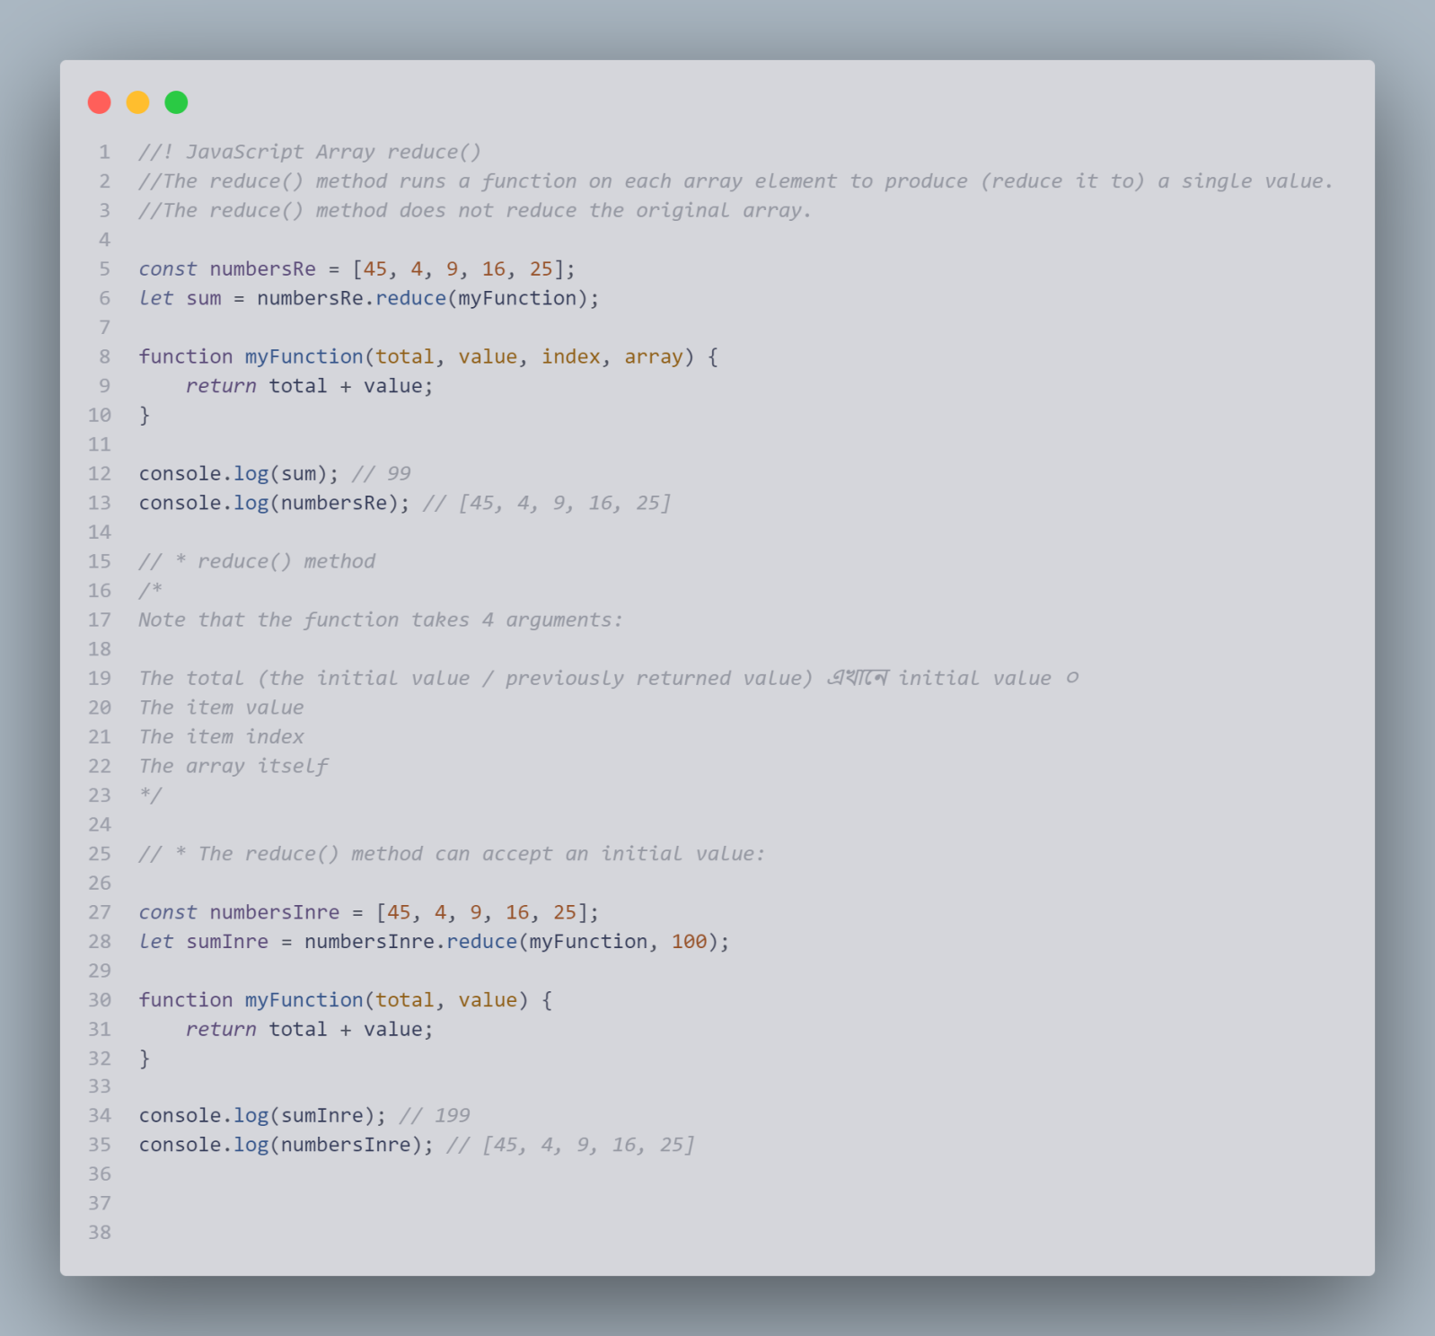

### JavaScript Array reduceRight()

### JavaScript Array every() 7

### JavaScript Array some()

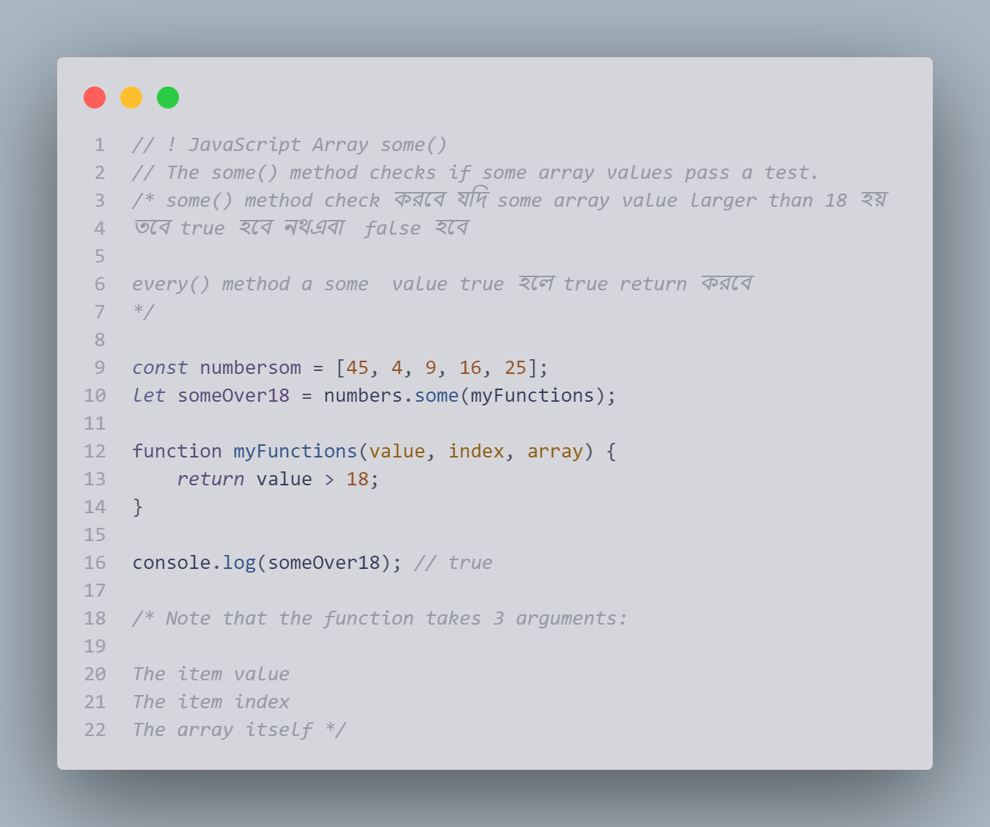

### JavaScript Array indexOf()

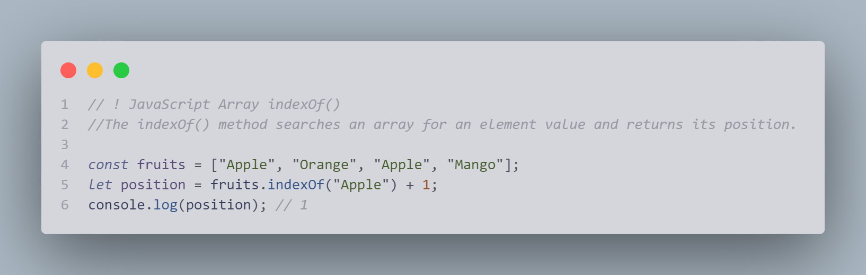

### JavaScript Array lastIndexOf()

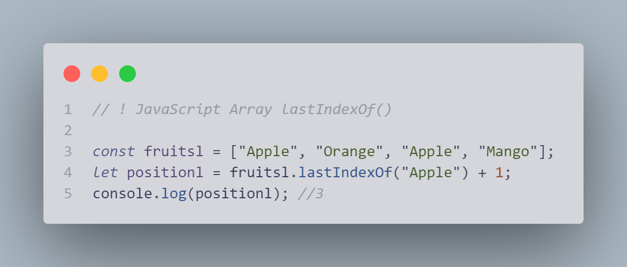

### JavaScript Array find()

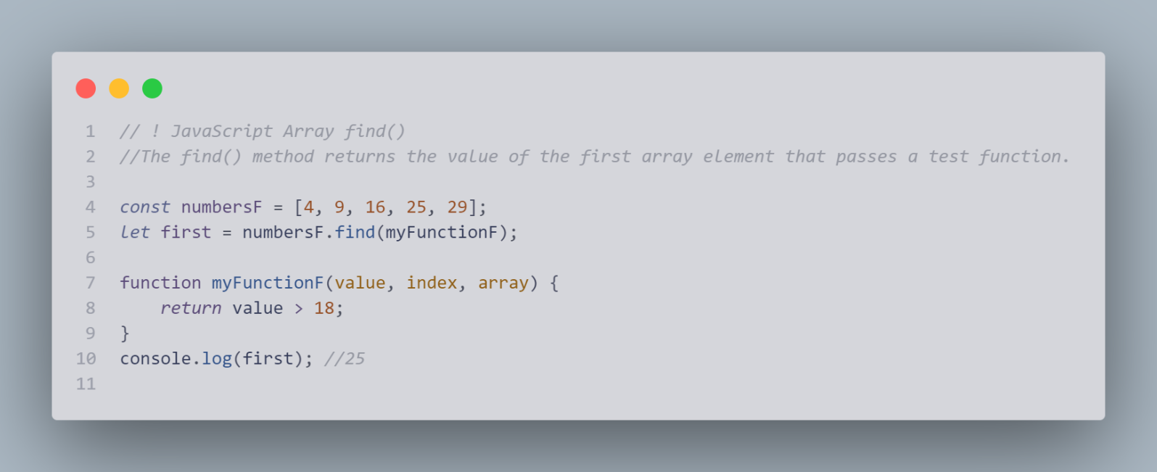

### JavaScript Array findIndex()

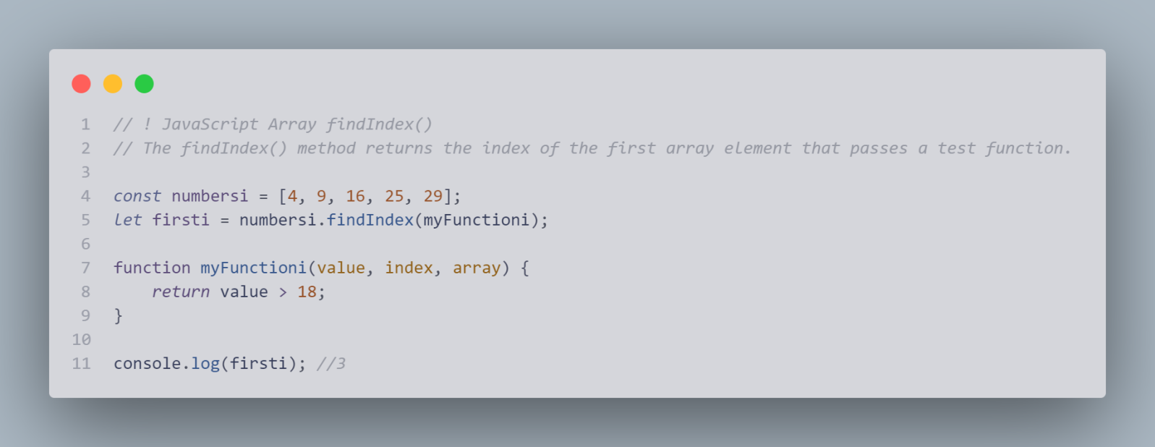

### JavaScript Array.from()

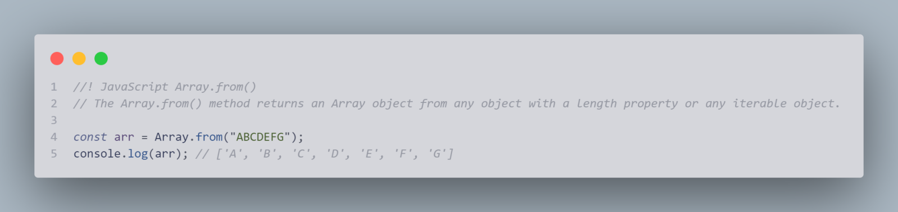

JavaScript Array Keys() Array entries()

### JavaScript Array includes()

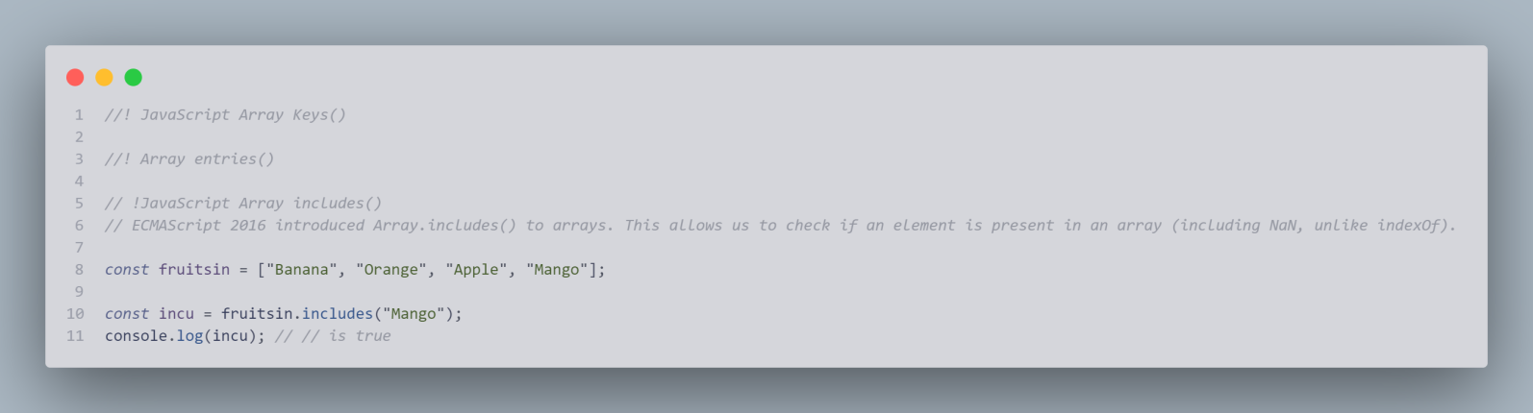

# DateObjects1

## Get Date Methods

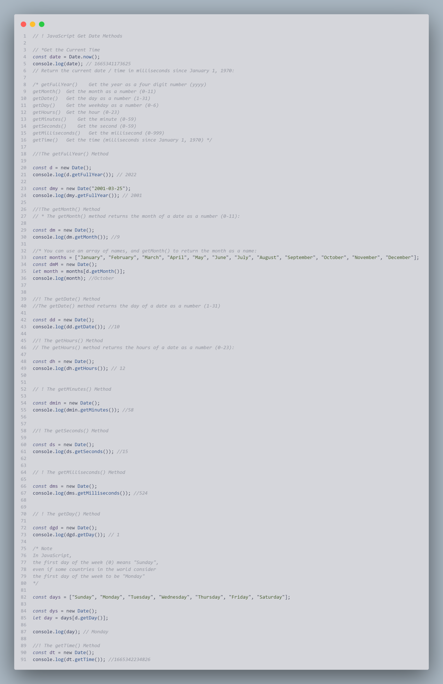

## Set Date Methods

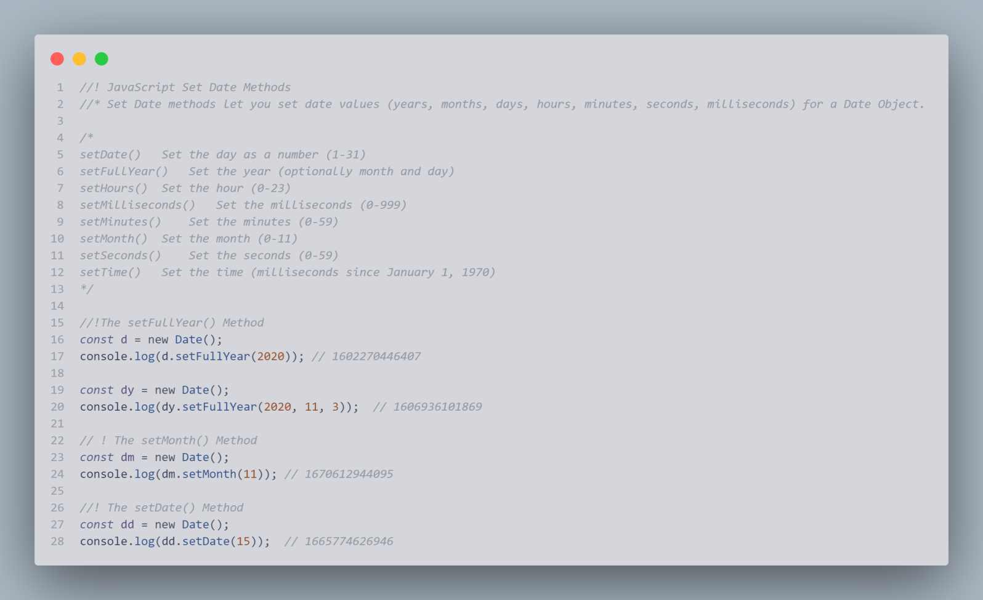

## Math Object

Math.round(), Math.ceil(), Math.floor(), Math.trunc()

Math.sign(), Math.pow(), Math.sqrt(),Math.abs(),

Math.sin(),Math.cos(),Math.min() and Math.max(),

Math.random()

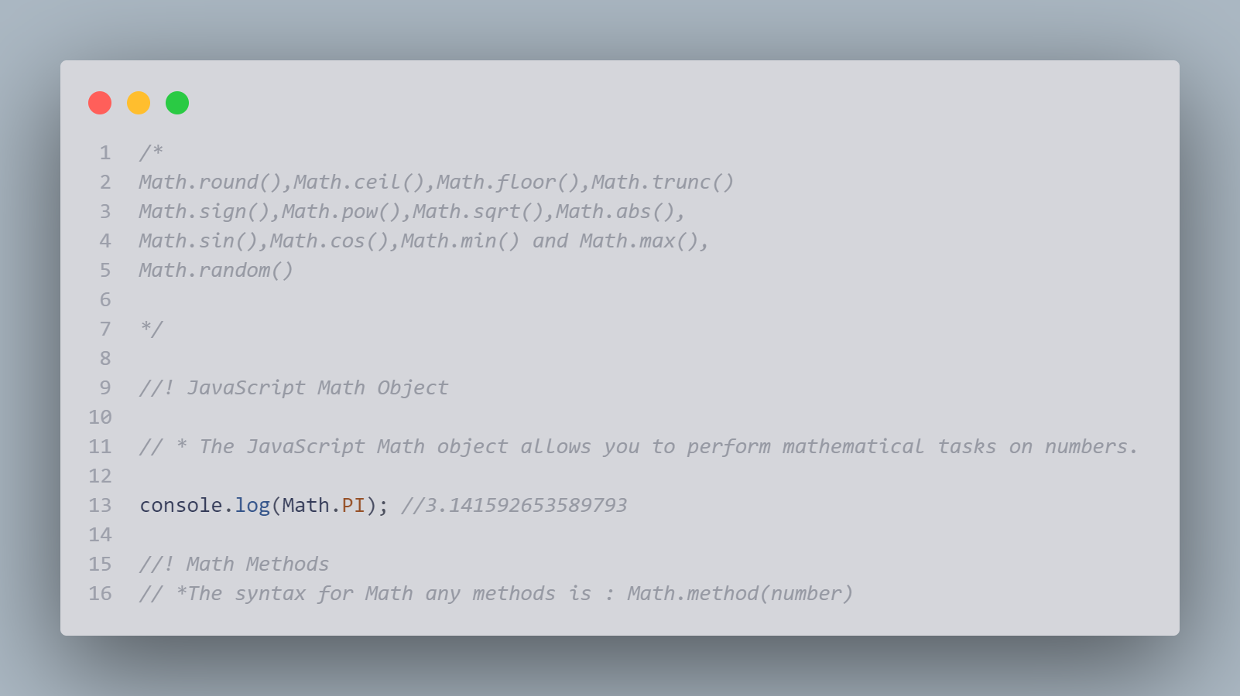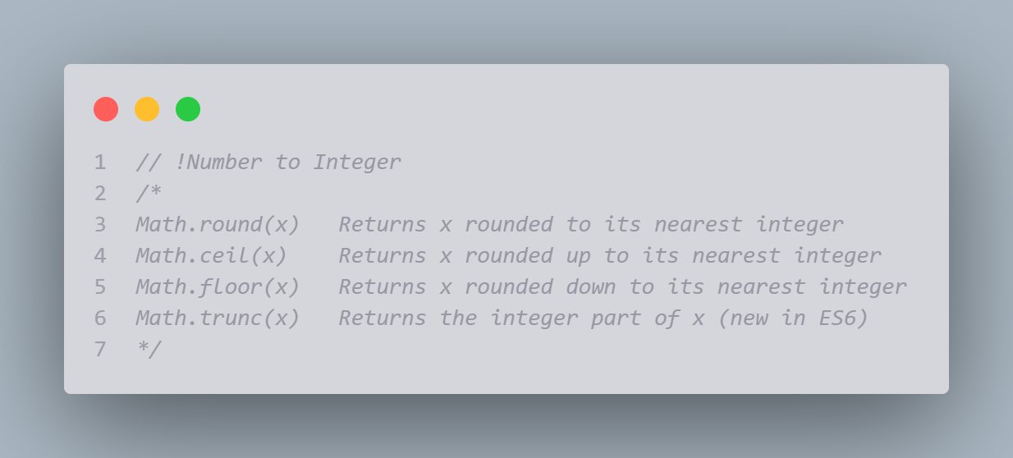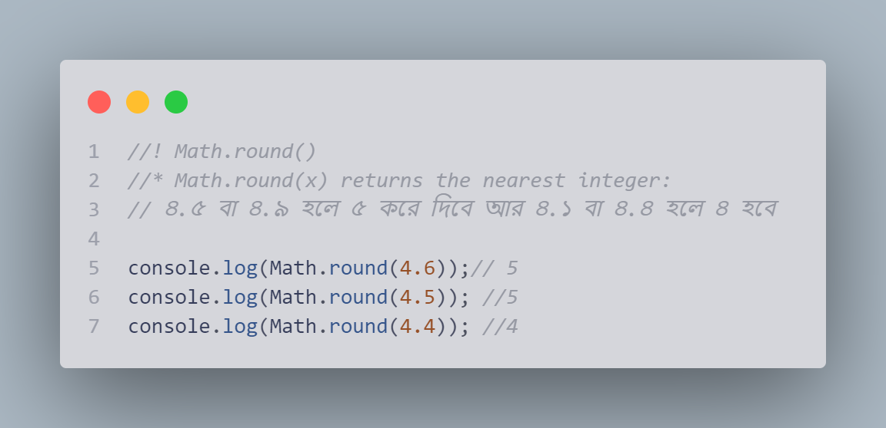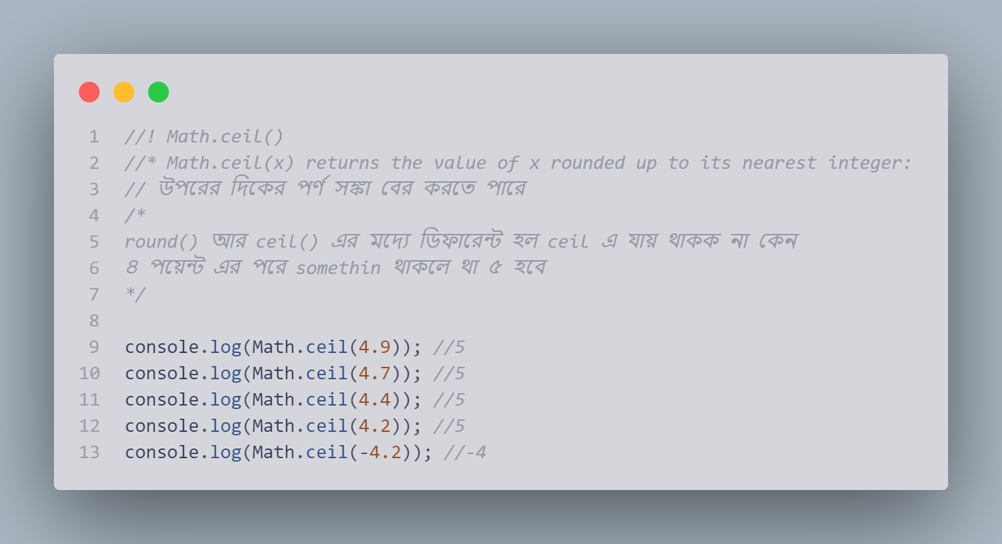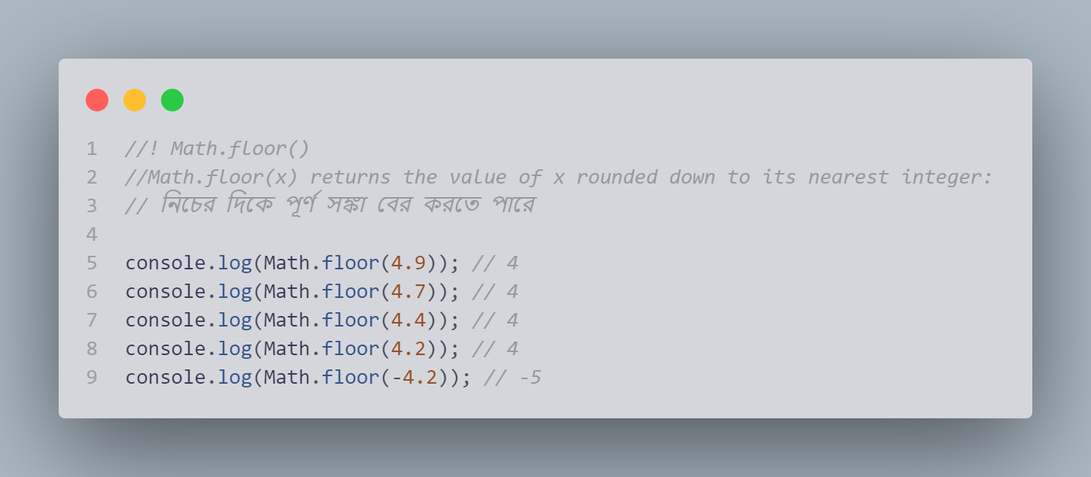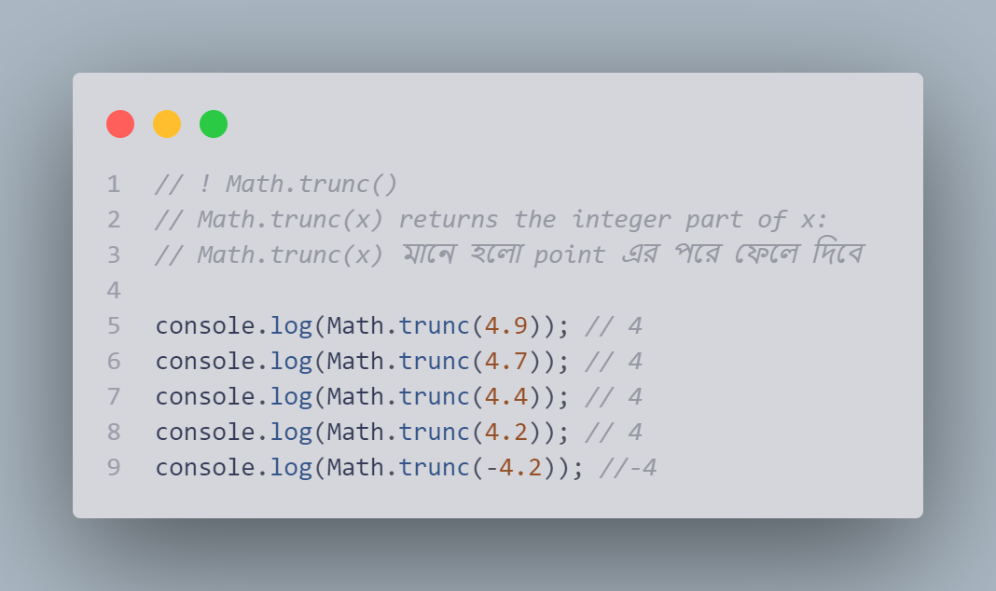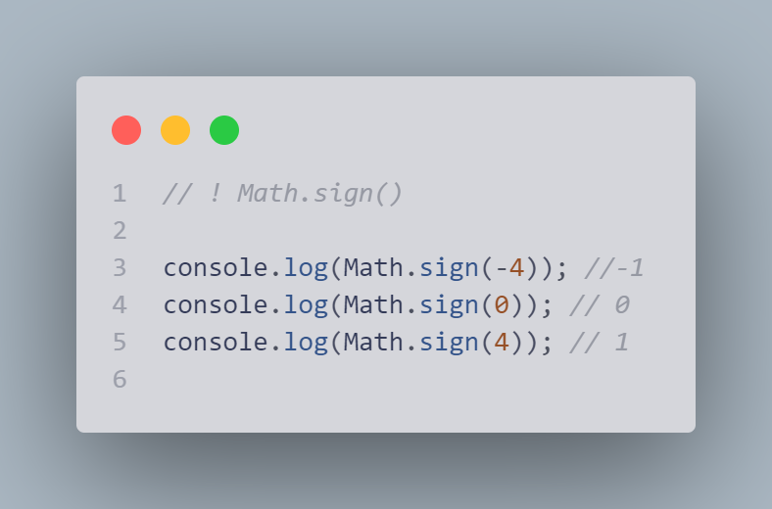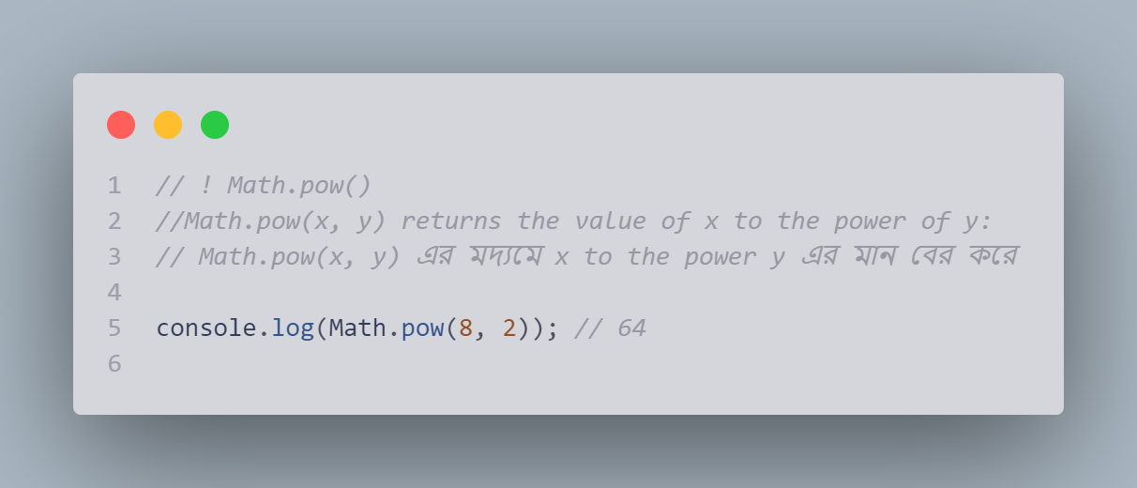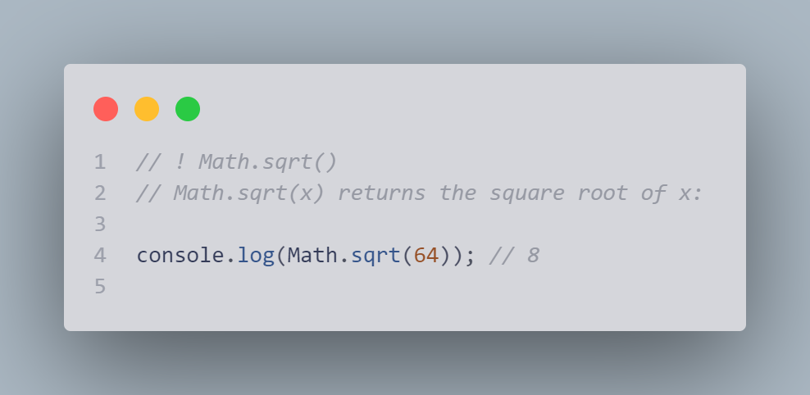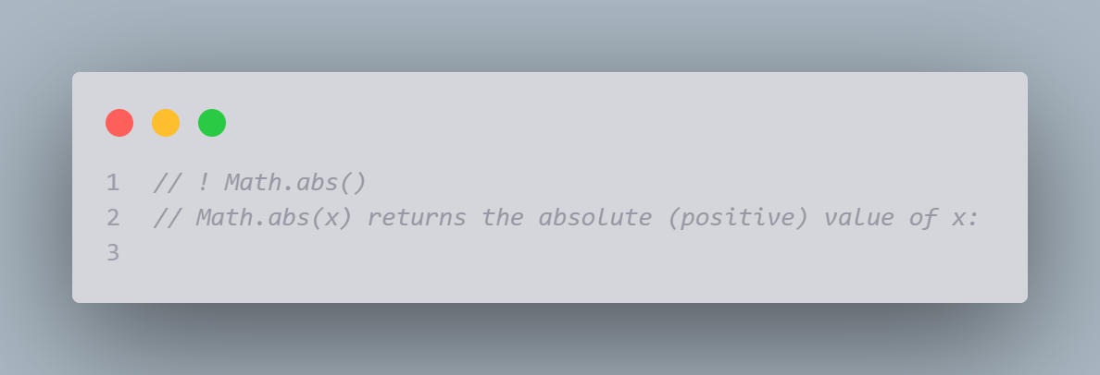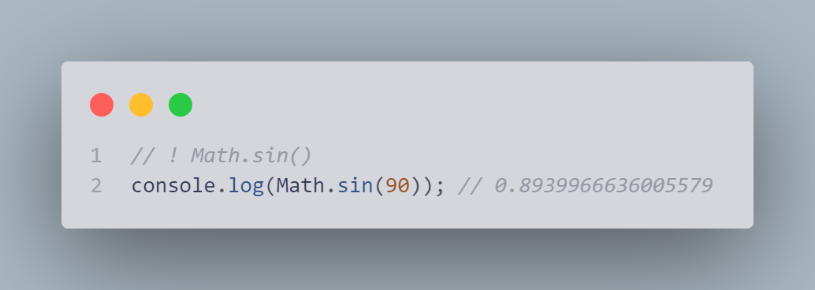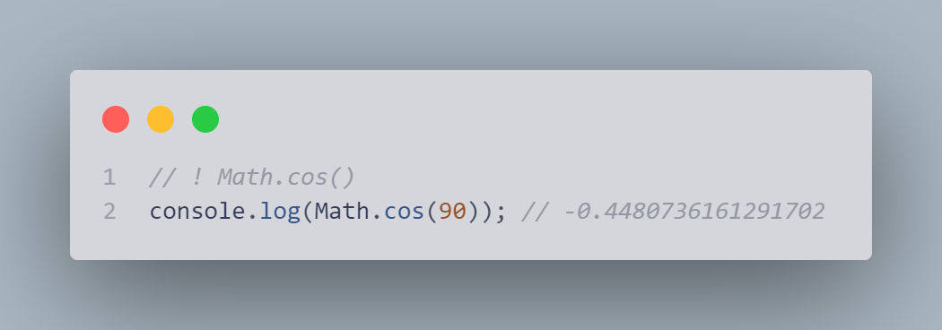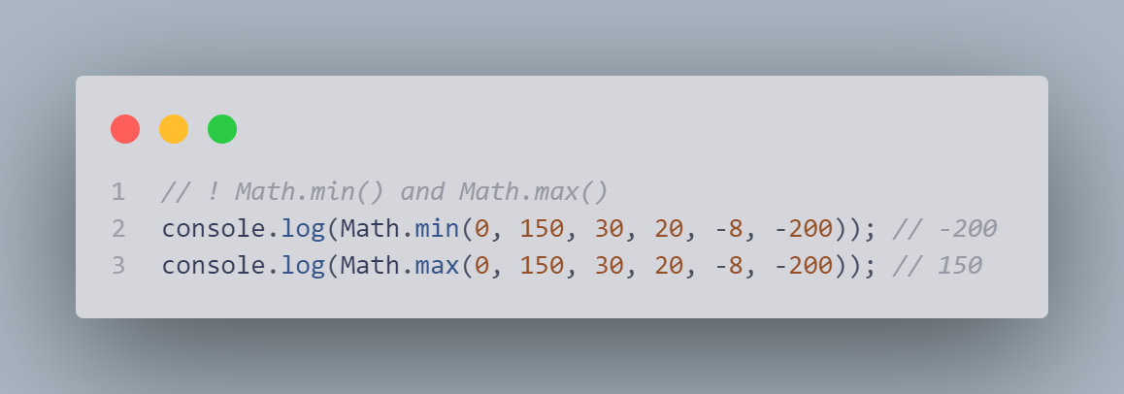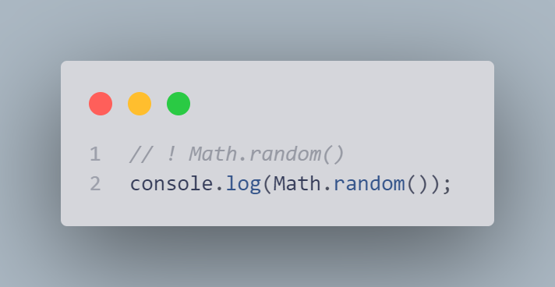

## Js random

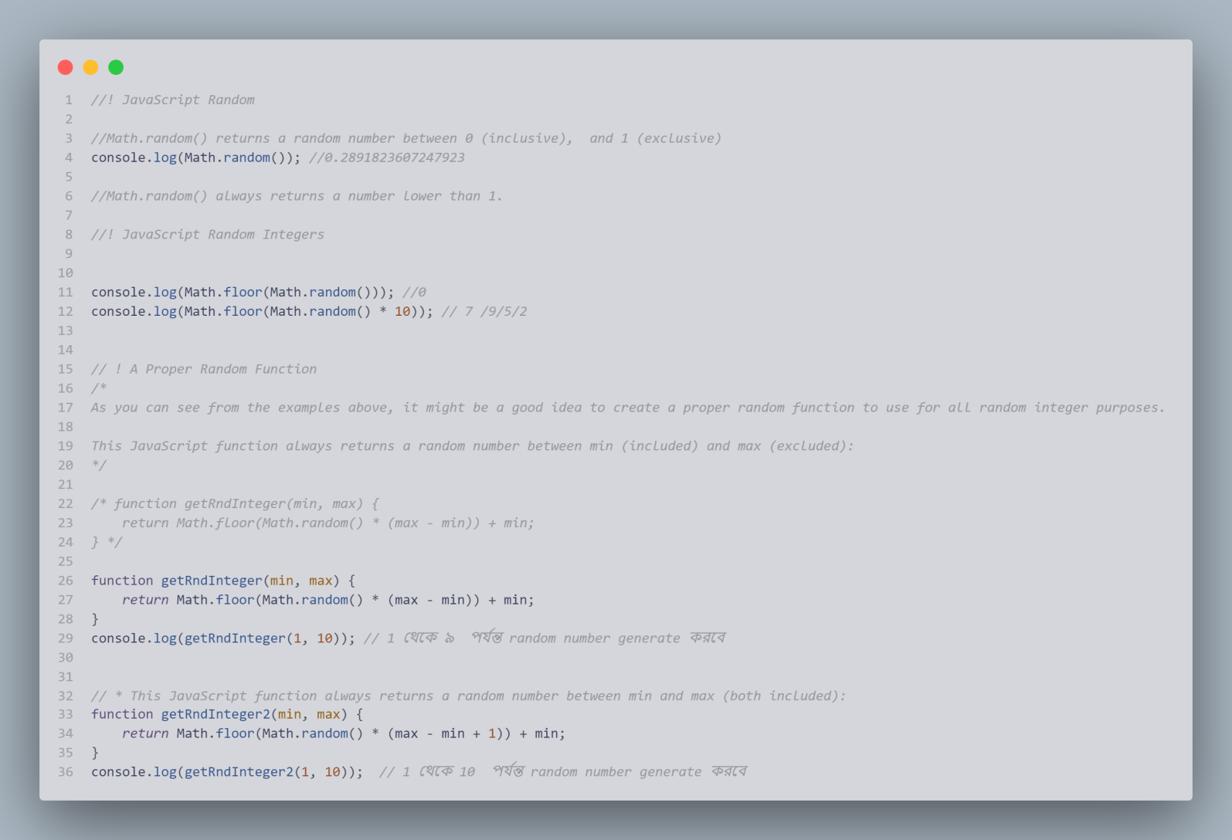

Js boleean

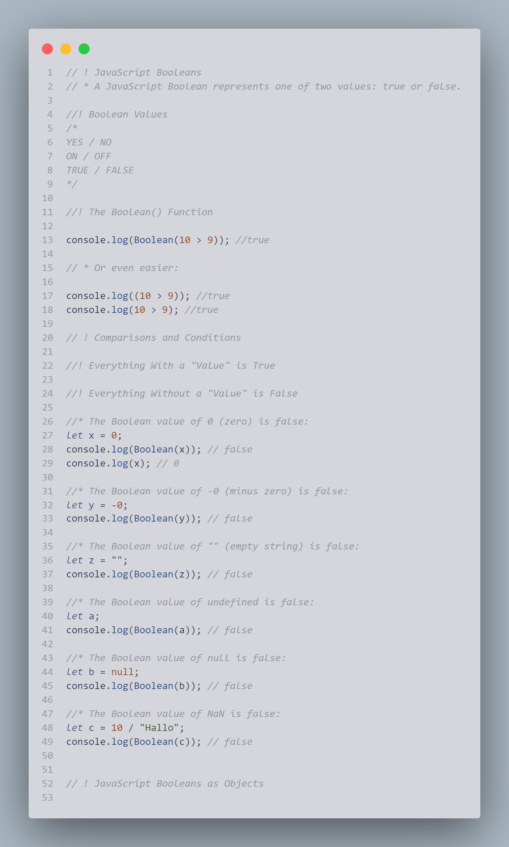

Js comparison

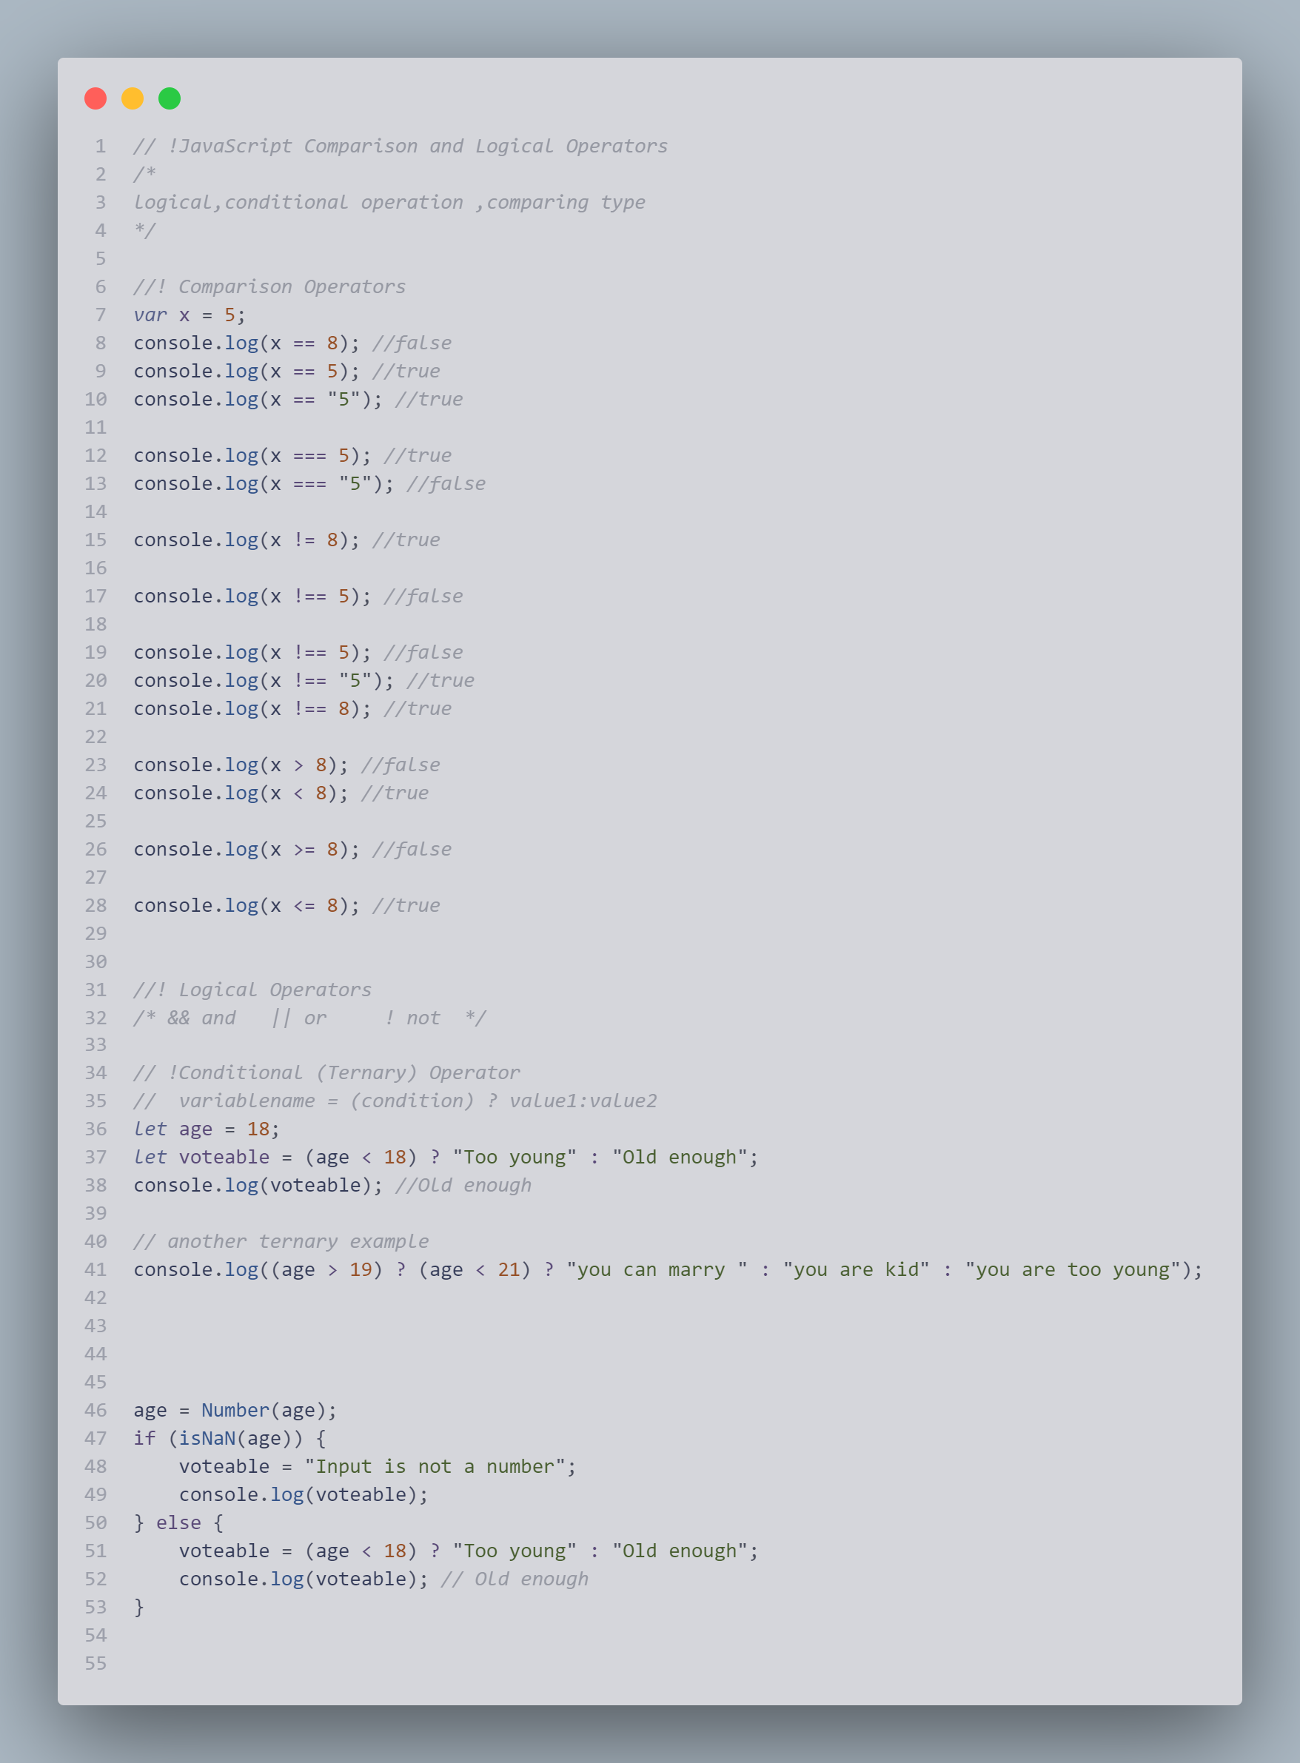

## If else switch

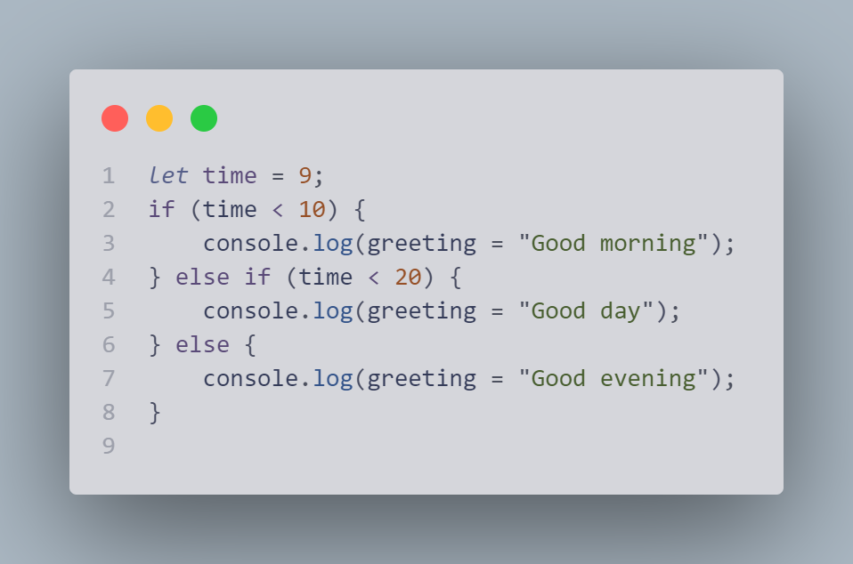

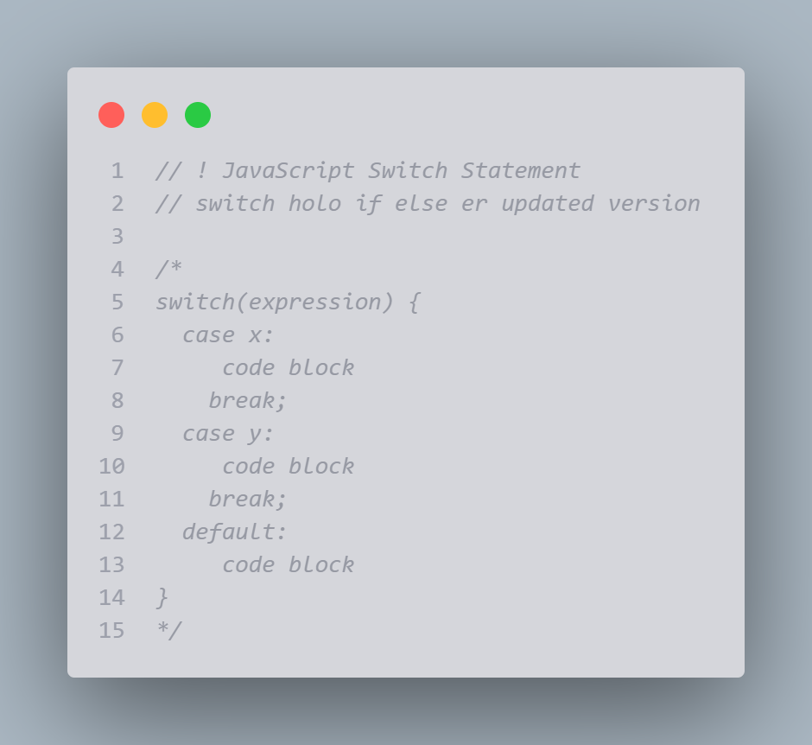

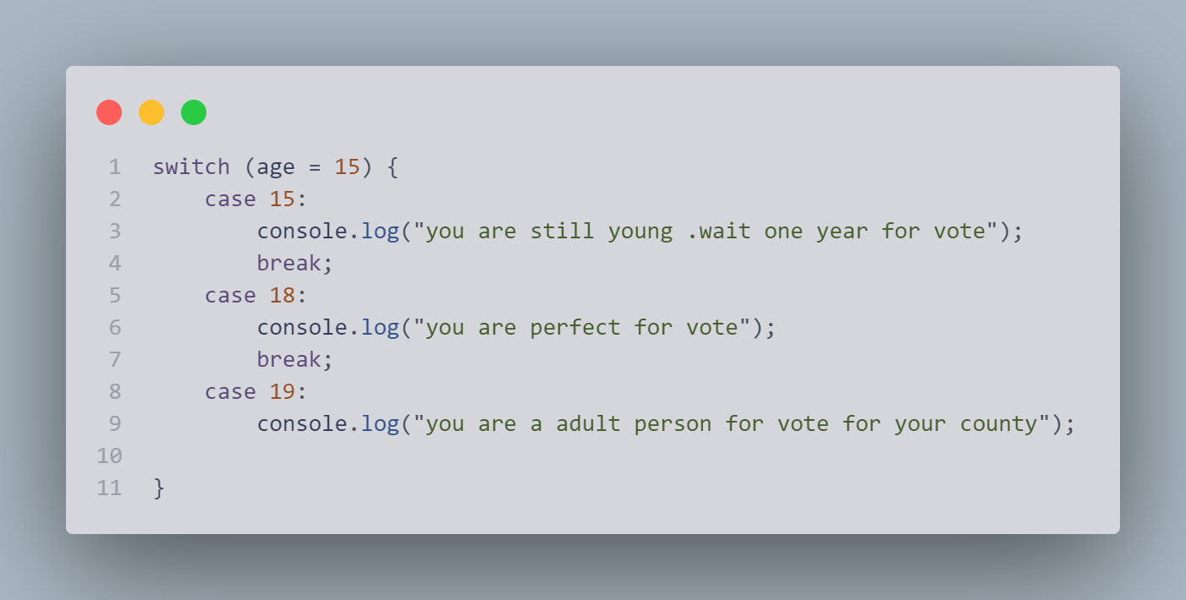

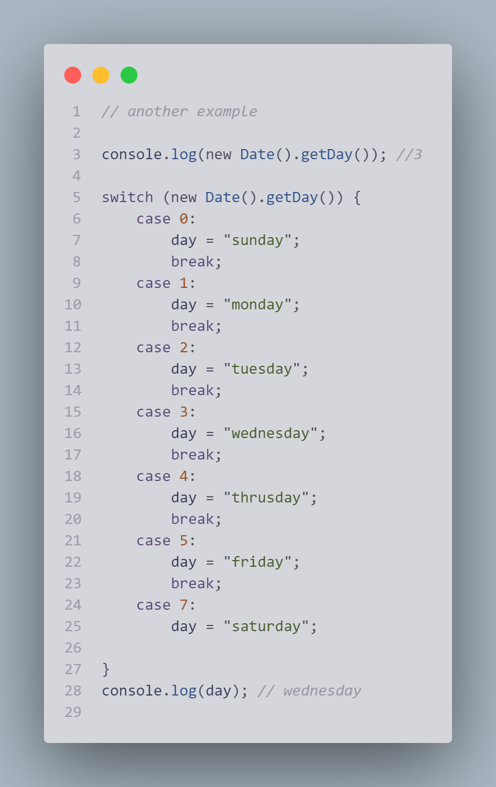

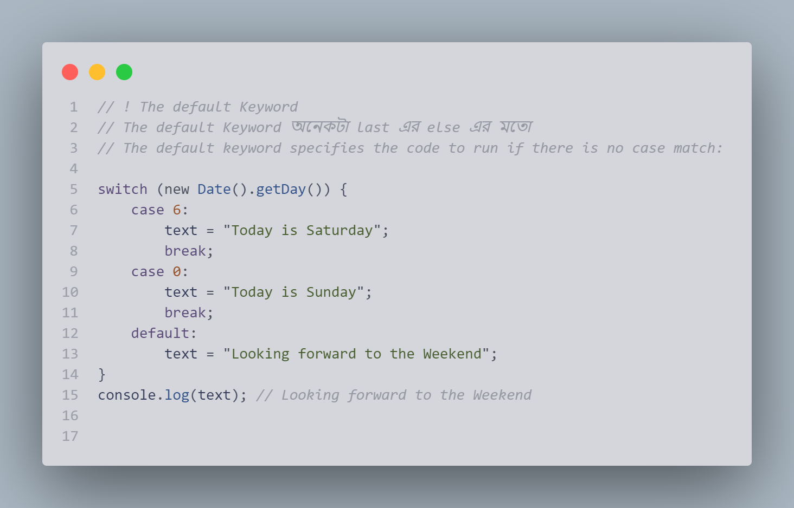

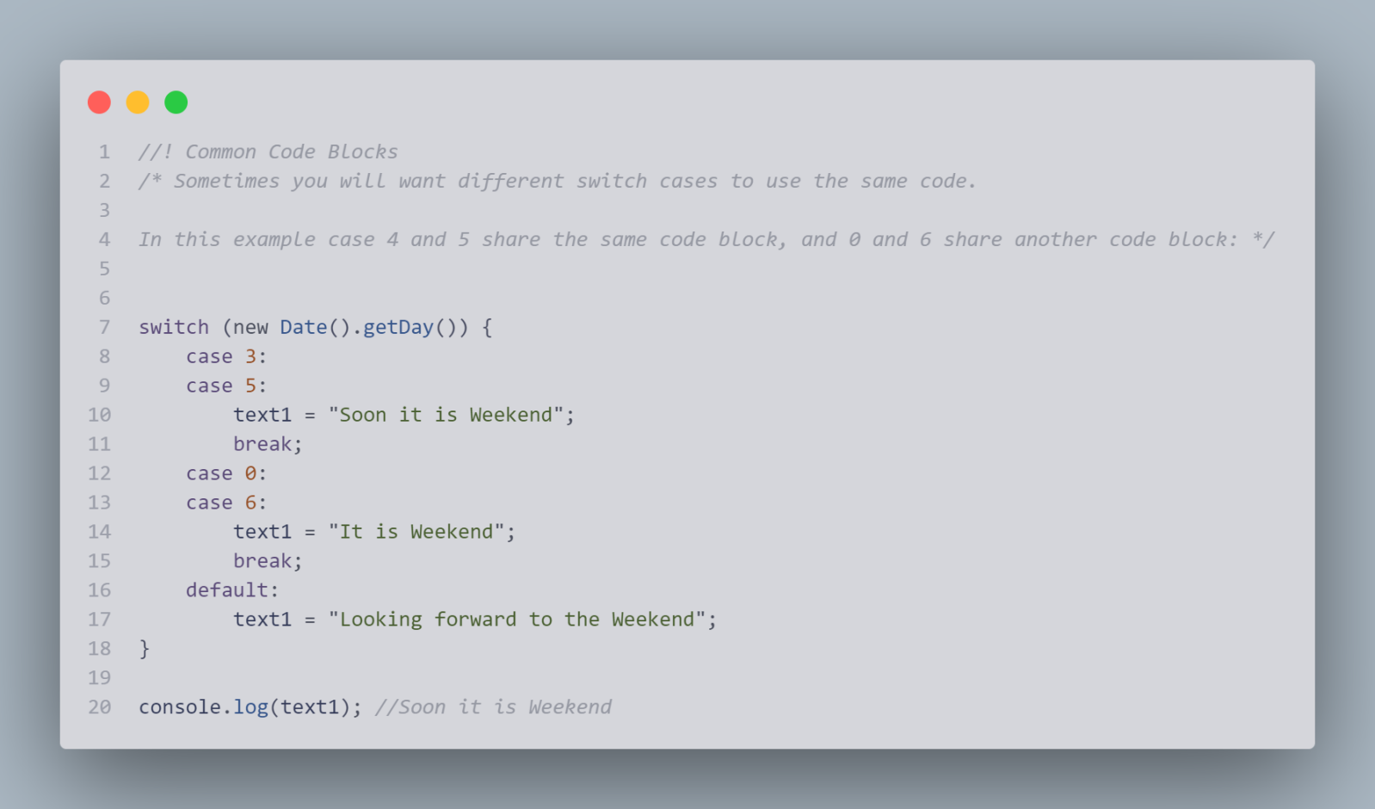

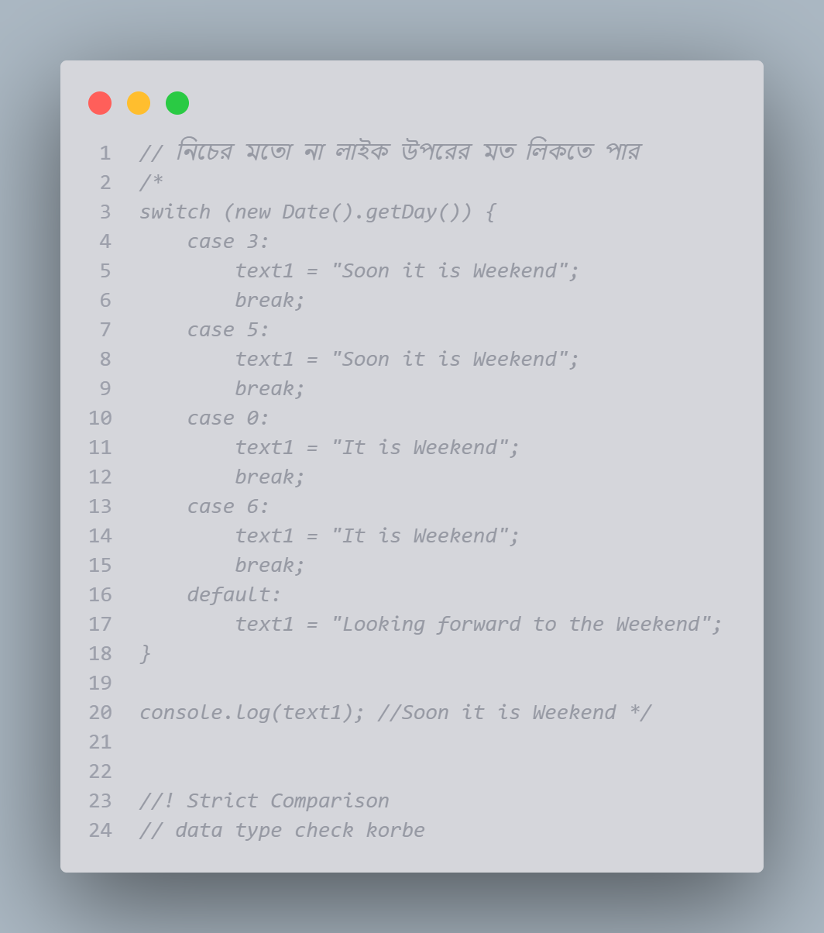

# JavaScript For Loop

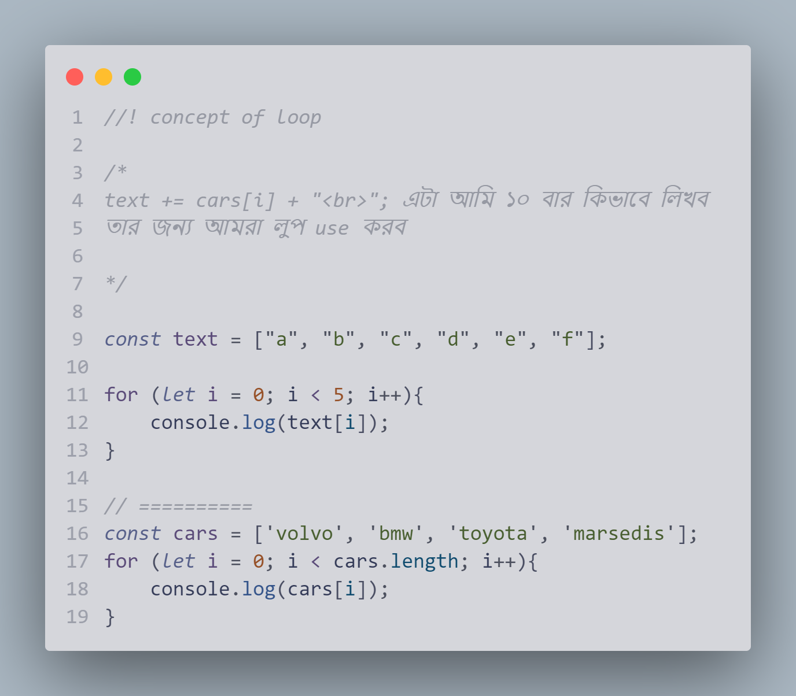

## Different Kinds of Loops

JavaScript supports different kinds of loops:

* for - loops through a block of code a number of times
* for/in - loops through the properties of an object
* for/of - loops through the values of an iterable object
* while - loops through a block of code while a specified condition is true
* do/while - also loops through a block of code while a specified condition is true

## The For Loop

The for statement creates a loop with 3 optional expressions:

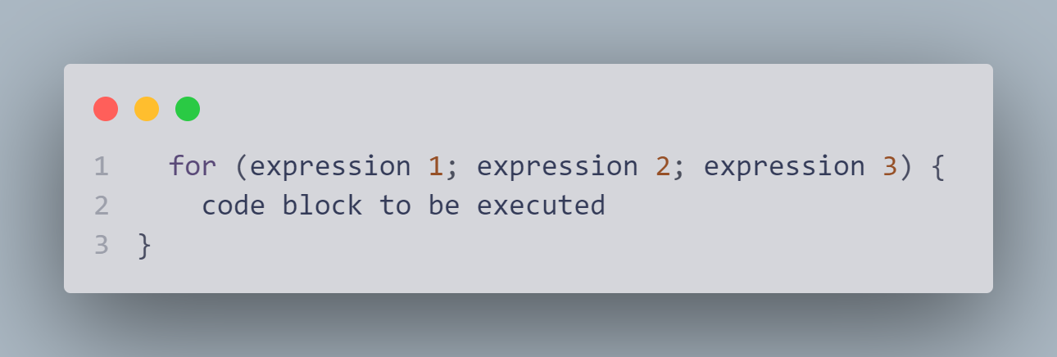

****Expression 1**** is executed (one time) before the execution of the code block.

****Expression 2**** defines the condition for executing the code block.

****Expression 3**** is executed (every time) after the code block has been executed.

Example:

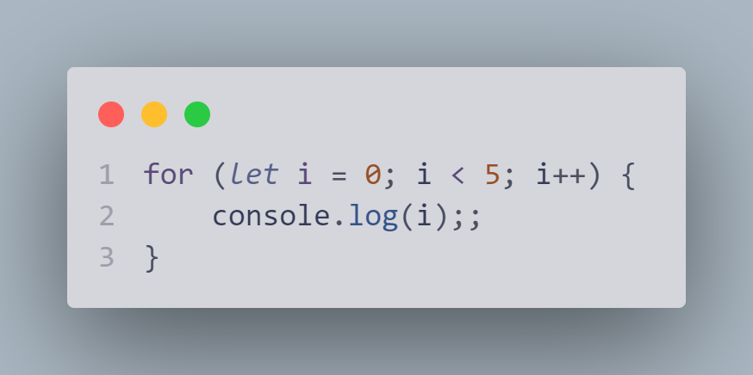

উপরের example এ :

  Expression 1 - loop শুরু হওয়ার পূর্বে variable set করা হয় (let i = 0)

  Expression 2 - এ কন্ডিশন দেয় হয়

  Expression 3 - প্রতেকবার code block executed.হওয়ার পর increment বা decrement করা হয়

## Expression 1

Normally you will use expression 1 to initialize the variable used in the loop (let i = 0).

This is not always the case. JavaScript doesn't care. Expression 1 is optional.

You can initiate many values in expression 1 (separated by comma):

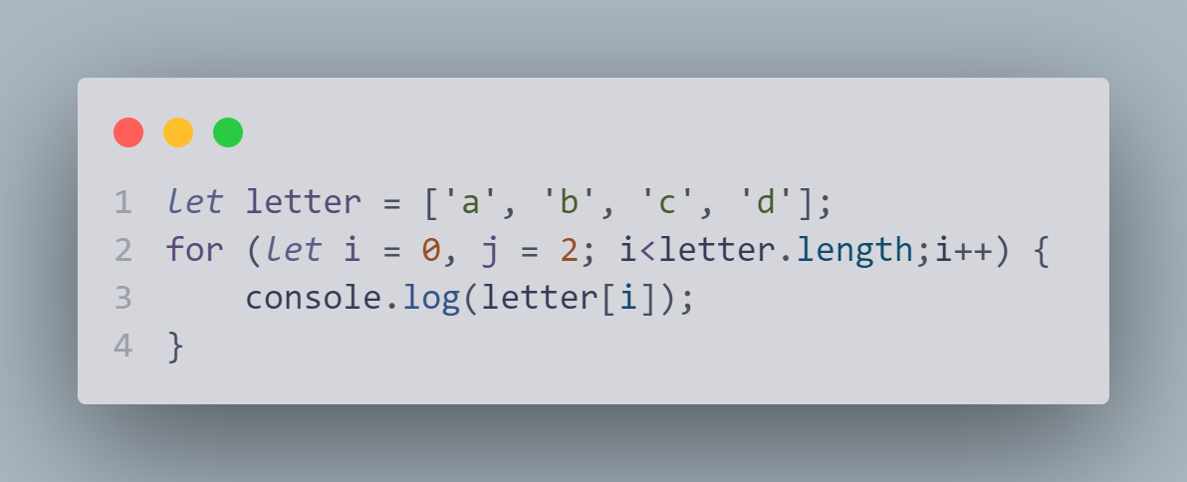

*And you can omitবর্জন করা expression 1  (like when your values are set before the loop starts):*

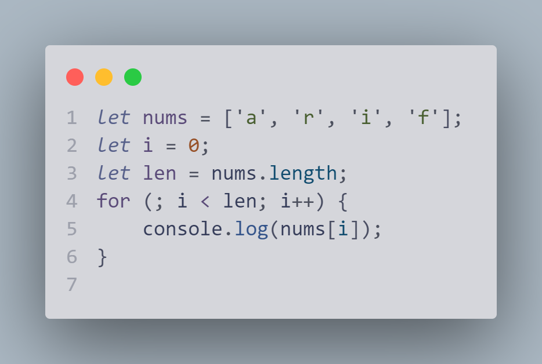

## Expression 2

*/\**

*Expression 2 is also optional.*

*If you omitবর্জন করা expression 2, you must provide a break inside the loop*

*Otherwise the loop will never end*

*\*/*

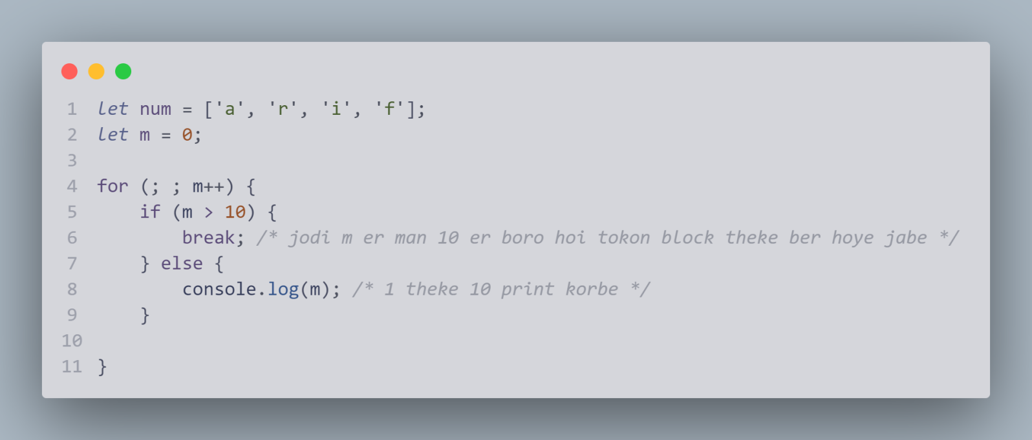

*//!  Expression 3*

*/* Expression 3 is optional.*/*

## Loop Scope

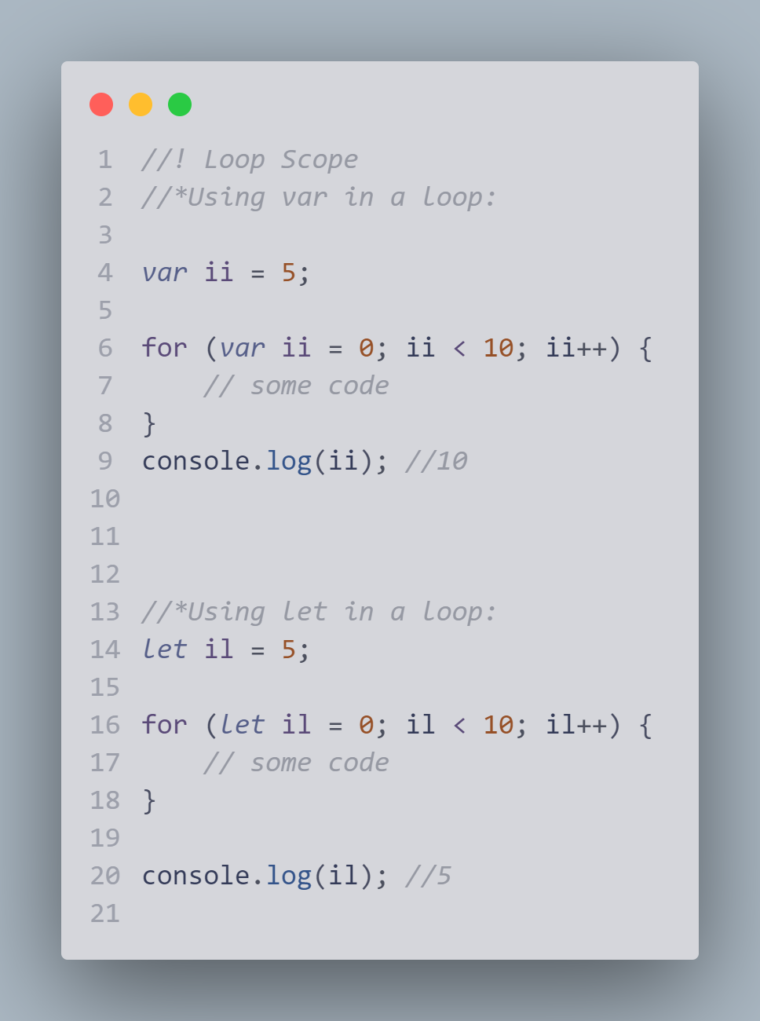

# JavaScript For In(object)

The JavaScript for in statement loops through the properties of an Object:

*for in loop object এর জন্য*

for (key in object) {  
  // *code block to be executed*  
}

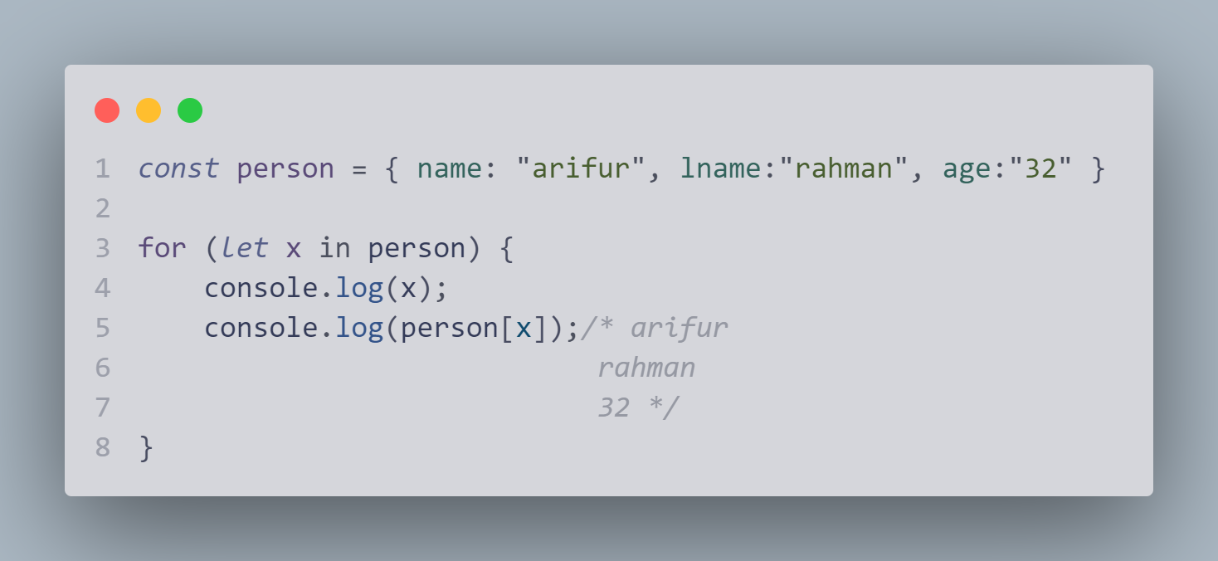

## Example Explained

* The **for in** loop iterates over a **person** object
* Each iteration returns a **key** (x)
* The key is used to access the **value** of the key
* The value of the key is **person[x]**

## For In Over Arrays

The JavaScript for in statement can also loop over the properties of an Array:

for (variable in array) {  
  code  
}

Example

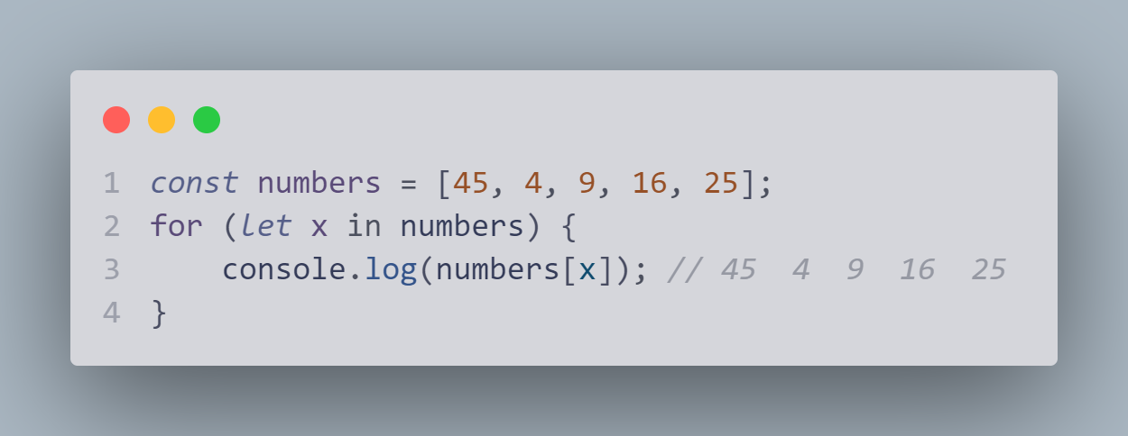

*//*Do not use for in over an Array if the index order is important.*

*//*It is better to use a for loop, a for of loop, or Array.forEach() when the order is important.*

*//***for in array te use korbe na.*

## Array.forEach()

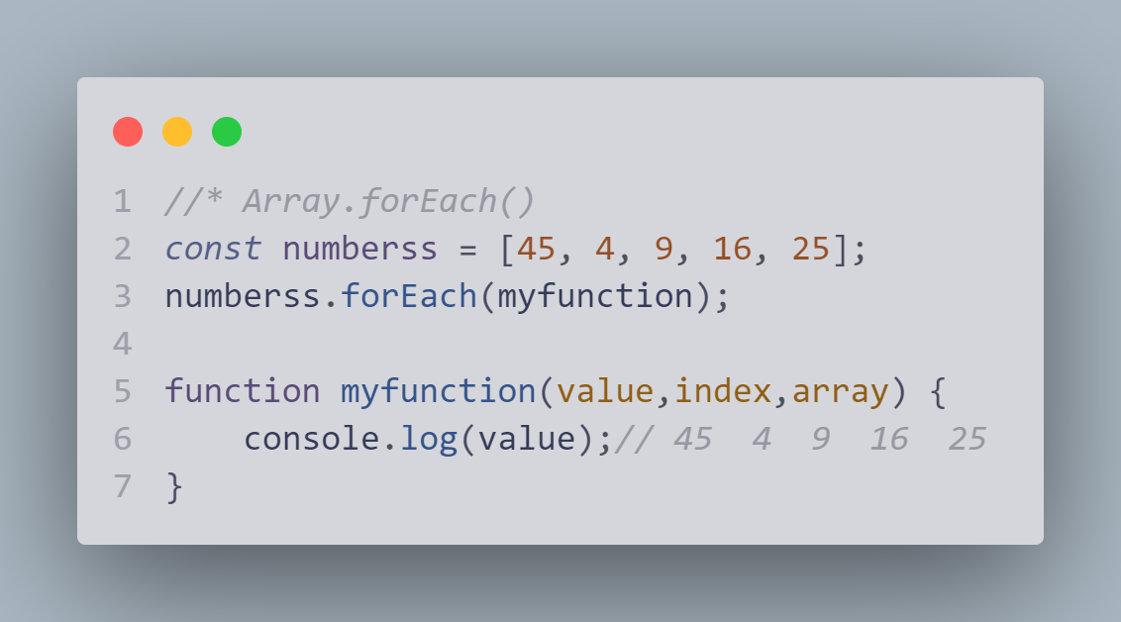

# JavaScript For Of

*for of loop in over* Arrays, Strings, Maps, NodeLists, and more

The JavaScript for of statement loops through the values of an iterable object.

It lets you loop over iterable data structures such as Arrays, Strings, Maps, NodeLists, and more:

### Syntax

for (variable of iterable) {  
  // *code block to be executed*  
}

*// object iterable na*

*// array iterable*

*//string iterable ,map and nodelist iterable*

## Looping over an string

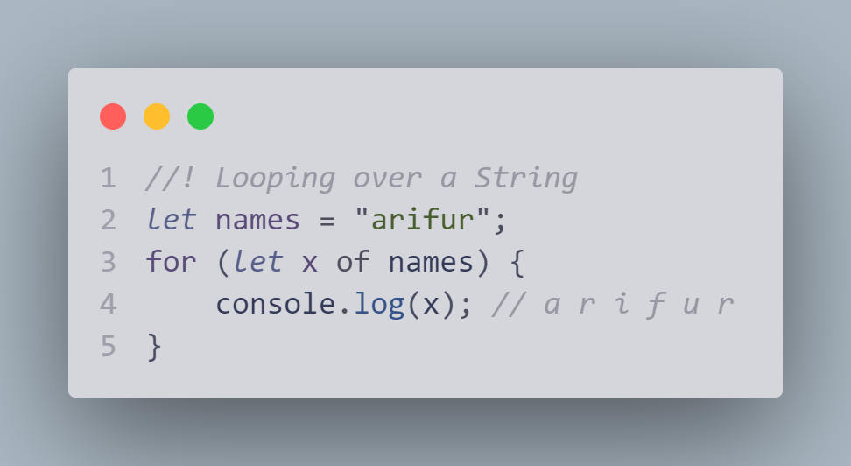

## Looping over an Array

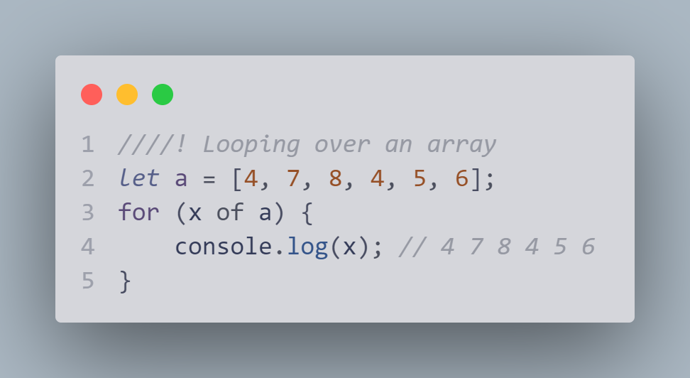

# JavaScript While Loop

*while loop আর for loop একই কাজ করে*

*// আমরা জানি for loop এর খেততরে প্রতেকটা expression হল optional*

*// while loop এর খেততরে ১ম ও last expression optional হয় তবে while loop use করবেন*

*// let i = 0;*

*// while (i < 10) {*

*//   console.log(i);*

*//   i++*

*// }*

*// যতকন i এর মান ১০ এর ছোট হবে ততক্ষণ পর্যন্ত loop চলবে*

## The Do While Loop

*//The do while loop is a variant of the while loop. This loop will execute the code block once, before checking if the condition is true, then it will repeat the loop as long as the condition is true.*

*let* j = 0;

*let* text = "";

do {

  text += "The number is " + j;

  j++;

  console.log(j);

}

while (j < 10);

console.log(`text ${j}`);

# JavaScript Break and Continue

The break statement "jumps out" of a loop.

The continue statement "jumps over" one iteration in the loop.

## The Break Statement

for (*let* i = 0; i < 10; i++){

  if (i === 3) {

    break;

  } else {

    console.log(i);

  }

};

console.log("--");

*// 0 1 2 er por block theke ber hoye jabe*

## The Continue Statement

for (*let* i = 0; i < 10; i++) {

  if (i === 3) {

    continue;

  } else {

    console.log(i);

  }

};

console.log("--");

*// 0 1 2 4 5 6 7 8 9*

*// 3 print hoi nai*

# JavaScript Iterables

*// Iterables মনে যেটার মদ্যে step বাই step যায় বা লুপ করা যায়*

*//আমরা জানি জাভাস্ক্রীপ্ট এ সবগলো object*

*// so javascript এ iterable মনে iterable object*

*// array , string সবগলো আমরা iterate করতে পরি*

*// কিন্ত অবজেক্ট কিন্ত iterable না*

*const* person = {

  fname: "arifur",

  lname:"rahman"

}

*/ অবজেক্ট কিন্ত iterable না .object a একটা একটা করে iterate করতে পরি না*

## Iterating Over an Array

*// array কিন্ত iterable*

*const* nums = [1, 2, 3, 4];

for(*const* x of nums){

  console.log(x); *// 1 2 3 4*

}

*// string ও iterable*

*let* a = "bangladesh"

for (*const* y of a) {

  console.log(y); *// b a n g l a d e s h*

}

## Iterating Over a Set

*// set হল unique collection of value;*

*// set এর কেটরে unique value থাকবে না*

*const* letters = new Set(["a", "b", "c", "a"]);

for (l of letters) {

  console.log(l); *// a b c*

}

## Iterating Over a Map

*const* fruits = new Map([

  ["apples", 500],

  ["bananas", 300],

  ["oranges", 200]

]);

for (f of fruits) {

  console.log(f);

}

# JavaScript Sets

*// ! JavaScript Sets*

*/* A JavaScript Set is a collection of unique values.*

*Each value can only occur once in a Set. */*

*// set হল unique collection of value;*

*// set এর কেটরে unique value থাকবে না*

*// set er S capital hobe*

*//* array হল collection of values আর sets হল collection of uniques values*

Set hঅল array এর মতো । but set only unique value নিবে । যেমন - a ২ টা হলে ১টা নেবে

## How to Create a Set

You can create a JavaScript Set by:

* Passing an Array to new Set()
* Create a new Set and use add() to add values
* Create a new Set and use add() to add variables

*//! How to Create a Set*

*const* alphabet = new Set(["a", "b", "c"]);

## The new Set() Method

*//! The new Set() Method*

*const* letters = new Set(["a", "b", "c"]);

*//* Create a Set and add values:*

*// Create a Set*

*const* letter = new Set();

*// Add Values to the Set*

letter.add("a");

letter.add("b");

letter.add("c");

console.log(letter); *// Set(3) {'a', 'b', 'c'}*

## The add() Method

*//!The add() Method*

letter.add("f");

letter.add("g");

console.log(letter); *//Set(5) {'a', 'b', 'c', 'f', 'g'}*

## The forEach() Method

*//!The forEach() Method*

*const* num = new Set([1, 2, 3, 4]);

console.log(num);

num.forEach(myFunction);

function myFunction(i) {

    console.log(i); *// 1 2 3 4*

}

## The values() Method

*//! The values() Method*

*const* val=new Set(['a','b','c'])

console.log(letters.values());*// SetIterator {'a', 'b', 'c'}*

*//* Now you can use the Iterator object to access the elements:*

*// List all Elements*

*const* val2 = new Set([1, 2, 3, 4, 5]);

for (*const* x of val2.values()) {

    console.log(x); *// 1 2 3 4 5*

}

# JavaScript Maps

*// object*

*const* persons = {

    fname: "arifur",

    lname: "rhaman",

}

*/* ekane object এর key ta always string hoi."" na dile o eta string .karon eta onno kono data type hoi na*

*fname holo key r "arifur" holo value*

*r map er kettre key any data hoi*

*\*/*

*//! JavaScript Maps*

*/\**

*A Map holds key-value pairs where the keys can be any datatype.*

*A Map remembers the original insertion order of the keys.*

*map e key and value thake*

*\*/*

## Essential Map Methods

*// ! Essential Map Methods*

*/\**

*new map()  set() get()  delete()  has()  forEach() entries()  size*

*\*/*

## How to Create a Map

You can create a JavaScript Map by:

* Passing an Array to new Map()
* Create a Map and use Map.set()

*const* fruits = new Map([

    ["apple", 500],

    ["mango",300],

    ["orange", 200],

]);

## The new Map() Method

*new Map er modde একবারে key and value set kora jai*

*/*map এ  key ta আমরা any data type dite pari.*

*kinto object এ ketrre আমরা string ছাড়া  অন্য কোন data টাইপ use করতে পারব না*

*এটাই হল object এর সাথে map এর different ।*

*এই কারণে map এসেছে*

*\*/*

*const* school = new Map([

    [4000, 5000],

    ['gamia', 5000],

    ['civil', 5000],

    ['ronkeli', 5000],

])

console.log(school); *// Map(4) {4000 => 5000, 'gamia' => 5000, 'civil' => 5000, 'ronkeli' => 5000}*

## The set() Method

*const* cars = new Map();

cars.set('volvo', 2015);

cars.set('toyota', 2025);

cars.set('bmw', 2045);

console.log(cars); *//  Map(3) {'volvo' => 2015, 'toyota' => 2025, 'bmw' => 2045}*

*//! The set() method can also be used to change existing Map values:*

*// value change korte set() use hoi*

cars.set('bmw', 2005);

console.log(cars);*// Map(3) {'volvo' => 2015, 'toyota' => 2025, 'bmw' => 2005}*

## The get() Method

*//*The get() method gets the value of a key in a Map:*

*// get() er maddome key এর value পাওয়া যায়*

*const* student = new Map([

    ['rahim', 21],

    ['josim', 20],

    ['korim', 22],

    ['rahma', 19],

]);

console.log(student); *// Map(4) {'rahim' => 21, 'josim' => 20, 'korim' => 22, 'rahma' => 19}*

console.log(student.get('rahim')); *//21*

## The size Property

console.log(student.size); *// 4*

## The delete() Method

The delete() method removes a Map element:

console.log(student.delete('rahim'));

console.log(student); *//Map(3) {'josim' => 20, 'korim' => 22, 'rahma' => 19}*

## The has() Method

The has() method returns true if a key exists in a Map:

console.log(student.has("josim")); *//true*

console.log(student.has("rahim")); *//false*

## JavaScript Objects vs Maps

|  |  |  |
| --- | --- | --- |
|  | **Object** | **Map** |
| **Iterable** | Not directly iterable | Directly iterable |
| **Size** | Do not have a size property | Have a size property |
| **Key Types** | Keys must be Strings (or Symbols) | Keys can be any datatype |
| **Key Order** | Keys are not well ordered | Keys are ordered by insertion |
| **Defaults** | Have default keys | Do not have default keys |

## The forEach() Method

The forEach() method calls a function for each key/value pair in a Map:

*const* schools = new Map([

    ['gamia', 1991],

    ['ms', 1951],

    ['scholarshome', 2000],

    ['modonMohon', 1901],

]);

console.log(schools); *//Map(4) {'gamia' => 1991, 'ms' => 1951, 'scholarshome' => 2000, 'modonMohon' => 1901}*

schools.forEach(myFunction);

function myFunction(value , key) {

    console.log(value); *// 1991 1951 2000 1901*

    console.log(key); *// gamis ms schorshome modonMohan*

}

## The entries() Method

The entries() method returns an iterator object with the [key, values] in a Map:

*const* childrens = new Map([

    ['shahin', 24],

    ['ibrahim', 14],

    ['jolfiquer', 10],

    ['jasmin', 4],

]);

console.log(childrens); *// Map(4) {'shahin' => 24, 'ibrahim' => 14, 'jolfiquer' => 10, 'jasmin' => 4}*

console.log(childrens.entries()); *// MapIterator {'shahin' => 24, 'ibrahim' => 14, 'jolfiquer' => 10, 'jasmin' => 4}*

for (*const* x of childrens.entries()) {

    console.log(x);

}

*/\**

*['shahin', 24]*

*['ibrahim', 14]*

*['jolfiquer', 10]*

*['jasmin', 4]*

*\*/*

# JavaScript typeof

*// * javascript a ৫ ধরনের data type আছে যা value contain করতে পারে*

* string
* number
* boolean
* object
* function

There are 6 types of objects:

* Object
* Date
* Array
* String
* Number
* Boolean

*// *  2 ধরনের data type আছে যা value contain করতে পারে*

* null
* undefined

## The typeof Operator

*// typeof holo operator*

*// typeof operaretor er maddome data টা কি type এর তা বের করতে পারে*

console.log(typeof "jhon"); *// string*

console.log(typeof 12); *//Number*

console.log(typeof NaN); *// number*

console.log(typeof true); *// boolean*

console.log(typeof ['a','b','c',2]); *// object*

console.log(typeof {name:'arifur',lname:'rahman'}); *// object*

console.log(typeof new Date()); *// object*

console.log(typeof function(){}); *// function*

console.log(typeof cars); *// undefine*

console.log(typeof null); *// object*

## Primitive Data

*// primitive data holo jegolor single data value thake.kono property o method takbe name*

*/\**

* string
* number
* boolean
* undefined

## Complex Data

*/\**

*function*

*object*

*\*/*

*//The typeof operator returns "object" for objects, arrays, and null.*

*//The typeof operator does not return "object" for functions.*

*/* function এর জন্যে typeof function return করবে function .*

*karon javascript function কে function data type হিসাবে count করে*

*array এর জন্যে typeof array return করবে object.*

*karon javascript array  কে object  data type হিসাবে count করে*

*\*/*

## The Data Type of typeof

console.log(typeof { fname: 'arifur', lname: 'rahman' }); *// object*

*// typeof এর মদ্যে typeof দিলে কি হয় : object কে ও string দেখাবে কারণ object word টা হল string*

console.log(typeof typeof { fname: 'arifur', lname: 'rahman' }); *// string*

## 

## Constructor

***constructor কেন দরকার***

*var* student1 = {

    name: "arifur",

    age: 30,

    lang: ["bangali", "english", "hindi"],

}

*var* student2 = {

    name: "shahin",

    age: 30,

    lang: ["bangali", "malaya", "hindi"],

}

*var* student3 = {

    name: "rahim",

    age: 29,

    lang: ["bangali", "hibro", "hindi"],

}

*/*  student এর details এভাবে single object এর মদ্যমে লিখলে অনেক বড় হয়ে যাবে*

*এই problem এর solution হল constructor*

*\*/*

*//! constructor*

*/* constructor দিয়ে আমরা একটা template create করব।*

*আর এই template দিয়ে আমরা multiple object create করতে পারব ।*

*\*/*

function Student(name, age, lang) {

    this.name = name;

    this.age = age;

    this.lang = lang;

}

*var* student1 = new Student('arifur', 31, ['bangla','english']);

console.log(student1); *// student {name: 'arifur', age: 31, lang: Array(2)}*

console.log(typeof student1); *// object*

*// another*

*var* student1 = new Student('shahin', 31, ['bangla', 'malaya']);

console.log(student1); *// student {name: 'shahin', age: 31, lang: Array(2)}*

console.log(typeof student1); *// object*

*/* constructor হল যে function টা কোন  একটা  জিনিস create করে তাকে constructor বলে ।*

*কোন function কে বড় হাতের লিখলে তা constructor function । যেমন*

*function String();*

*function Student();*

*\*/*

## The constructor Property

*//The constructor property returns করে constructor function সব JavaScript variables এর জন্যে .*

console.log("jhon".constructor); *// ƒ String() { [native code] }*

console.log((9).constructor);  *// ƒ Number() { [native code] }*

console.log(false.constructor); *// ƒ Boolean() { [native code] }*

console.log([1, 2, 4].constructor); *// ƒ Array() { [native code] }*

console.log({ fname: "arifur", lname: "rahman" }.constructor); *// ƒ Object() { [native code] }*

console.log(new Date().constructor); *// ƒ Date() { [native code] }*

console.log(function () { }.constructor); *//ƒ Function() { [native code] }*

## Undefined

let car;    // Value is undefined, type is undefined

Any variable can be emptied, by setting the value to undefined. The type will also be undefined.

car = undefined;    *// Value is undefined, type is undefined*

*/* ধর car এর মদ্যে বড় কোন অবজেক্ট আছে ।*

*এখন you want empty the car variable.*

*than just assain undefine in car.*

*তাহলে car এর মদ্যে ja আছে চলে যাবে আর undefine দেখাবে*

*\*/*

## Empty Values

*undefine আর empty value '' এক না*

*let* i = '';

console.log(i); *// কিছুই show করে না // The value is "", the typeof is "string"*

## Null

In JavaScript null is "nothing". It is supposed to be something that doesn't exist.

Unfortunately, in JavaScript, the data type of null is an object.

let person = {firstName:"John", lastName:"Doe", age:50, eyeColor:"blue"};  
person = null;    // Now value is null, but type is still an object

## Difference Between Undefined and Null

undefined and null are equal in value but different in type:

console.log(typeof undefine); *// undefine*

console.log(typeof null); *// object*

console.log(null === undefined); *// false*

console.log(null == undefined); *// true*

# JavaScript Type Conversion

* Converting Strings to Numbers
* Converting Numbers to Strings
* Converting Dates to Numbers
* Converting Numbers to Dates
* Converting Booleans to Numbers
* Converting Numbers to Booleans

## JavaScript Type Conversion

*আমরা চাইলে ১টা datatype থেকে অন্য data type এ convert হতে পরি*

*১. JavaScript function use করে*

*2.Automatically by JavaScript itself*

## Converting Strings to Numbers

The global method Number() converts a variable (or a value) into a number.

A numeric string (like "3.14") converts to a number (like 3.14).

An empty string (like "") converts to 0.

A non numeric string (like "John") converts to NaN (Not a Number).

console.log(Number('3.2')); *// 3.2*

console.log(Number(" ")); *// 0*

console.log(Number("")); *// 0*

*// * These will not convert:*

console.log(Number('11 18')); *// NaN*

console.log(Number("jhon")); *// NaN*

## Number Methods

|  |  |
| --- | --- |
| **Method** | **Description** |
| Number() | Returns a number, converted from its argument |
|  |  |
| parseFloat() | Parses a string and returns a floating point number |
| parseInt() | Parses a string and returns an integer |

## The Unary(unary মনে +) + Operator

## Converting Numbers to Strings

The global method String() can convert numbers to strings.

It can be used on any type of numbers, literals, variables, or expressions:

*let* x = 2;

console.log(String(x)); *//2*

console.log(String(123)); *//123*

console.log(String(120-23)); *//97*

The Number method toString() does the same.

console.log(x.toString()); *// 2*

console.log((123).toString()); *// 123*

console.log((99 + 1).toString()); *// 100*

## More Methods

|  |  |
| --- | --- |
| **Method** | **Description** |
| toExponential() | Returns a string, with a number rounded and written using exponential notation. |
| toFixed() | Returns a string, with a number rounded and written with a specified number of decimals. |
| toPrecision() | Returns a string, with a number written with a specified length |

## Converting Dates to Numbers

The global method Number() can be used to convert dates to numbers.

*const* d = new Date();

console.log(Number(d)); *// 1666373677315*

## Converting Dates to Strings

*const* dat = new Date();

console.log(String(dat)); *//Fri Oct 21 2022 23:35:53 GMT+0600 (Bangladesh Standard Time)*

## Converting Booleans to Numbers

console.log(String(true)); *//true*

console.log(String(false)); *//false*

## Converting Booleans to Strings

console.log(true.toString()); *//true*

console.log(false.toString()); *//false*

## Automatic Type Conversion

console.log(5 + null); *// 5*

console.log("6" + null); *// 6null*

console.log("3" + 4); *// 34*

console.log("7" - 4); *// 3*

console.log("7" * 4); *//28*

console.log("7" * "4"); *// 28*

## Automatic String Conversion

## JavaScript Type Conversion Table

# JavaScript Regular Expressions

## Regular Expression কি ?

*/\**

*javascript এ regular Expression কে বেশি complex মনে করা হয় than other language।*

*sequence of characters that forms a search pattern.*

*যখন তুমি একটা text থেকে data search করবে । তখন তুমি search pattern ইউজ করতে পার ।*

*A regular expression can be a single character, or a more complicated pattern.*

*text search অথবা text repplace এর জন্যে Regular expressions use হয়*

*Syntax:*

*pattern/modifiers;*

*let* x = "hello bangladesh"

*// console.log(x./ bangladesh /); এভাবে হবে না ।*

*// solution : string method : search()  repalce() বা match() use করতে হবে*

console.log(x.search('bangladesh')); *// 6 no. index এ bangladesh আছে*

console.log(x);

console.log(x.search(/bangladesh/)); *// 6*

console.log(x.search(/bangladesh/i)); *// 6*

# String Methods use করে

*/\**

*In JavaScript, regular expressions are often used with the two string methods: search() and replace()*

*search() method use করা হয় search করার জন্যে । এবং return করে postion of the match*

*replace() method use করা হয় replace এর জন্যে এবং retun modified string*

*\*/*

# search() string method use করে -

*//The search() method searches a string for a specified value and returns the position of the match:*

*let* sentence = "i love Bangladesh";

console.log(sentence.search('love')); *// 2 no position*

Regular Expression এর সাতে String search() use করে

*let* text = "i love Bangladesh";

console.log(text.search(/love/)); *// 2 no position*

console.log(text.search(/bangladesh/i)); *// 7 no position এখানে i হল modifier*

console.log(text.search(/bangladesh/)); *// i মনে case insensitive so -1 will return*

# Using String replace() With a String

The replace() method replaces a specified value with another value in a string:

*let* stringSentence = "i live in Dhaka";

console.log(stringSentence.replace('Dhaka', 'sylhet')); *// i live in sylhet*

# Use String replace() With a Regular Expression

Use a case insensitive regular expression to replace Microsoft with W3Schools in a string:

*let* stringtext= "i live in Dhaka";

console.log(stringtext.replace(/Dhaka/i, 'sylhet')); *// i live in sylhet*

## Regular Expression Modifiers

****Modifiers**** can be used to perform case-insensitive more global searches:

|  |  |
| --- | --- |
| **Modifier** | **Description** |
| i | Perform case-insensitive matching |
| g | Perform a global match (find all matches rather than stopping after the first match) |
| m | Perform multiline matching |

### i case insensitive :

*let* txt = "i love Bangladesh.In 1971 Bangladesh independence";

console.log(txt.search(/bangladesh/)); *//-1 কারণ Bangladesh বড় হাতের*

console.log(txt.search(/bangladesh/i)); *// 18*

console.log(txt.search(/bangladesh/ig)); *//18 g not work properly*

### g global:

*// match() array return korbe. g হল global কয়টা word আছে তা বের করবে*

console.log(txt.match(/bangladesh/ig)); *// ['Bangladesh', 'Bangladesh']*

### 

### m multiline :

*let* txt2 = `this is bangladesh.

i love my country bangladesh`;

console.log(txt2);

console.log(txt2.match(/bangladesh/m)); *// 8*

console.log(txt2.match(/^this/m)); *// 0*

*// ^ হল starting*

*// php তে preg_match() method use hoi.js a match() method use hoi*

## Regular Expression Patterns

[] bracket হল range of character এর জন্যে

|  |  |
| --- | --- |
| **Expression** | **Description** |
| [abc] | Find any of the characters between the brackets |
| [0-9] | Find any of the digits between the brackets |
| (x|y) | Find any of the alternatives separated with | |

[abc] bracket এর ভেতরের chetecter বের করতে :

*let* text3 = 'hello bangladesh! people of bangladesh everyone so polite and hospitality';

console.log(text3.match(/[h]/i)); *// 'h' index 6*

console.log(text3.match(/[h]/ig)); *// ['h', 'h', 'h', 'h']*

 [0-9]

*let* numText = '123456789';

console.log(numText.match(/[1-5]/)); *//'1', index: 0,*

console.log(numText.match(/[1-5]/g)); *// ['1', '2', '3', '4', '5']*

*/* let num = 123456789;*

*console.log(num.match(/[1-5]/g));*

*কাজ করবে না । কারণ সদুমাত্র string এ কাজ করবে*

*\*/*

##### (x|y)   কয়টা green blue আছে তা array আকারে বের করে দিবে :

*let* txt4 = "re, green, red, green, gren, gr, blue, yellow";

console.log(txt4.match(/(green|blue)/g)); *// ['green', 'green', 'blue']*

###### Metacharacters are characters with a special meaning:

|  |  |
| --- | --- |
| **Metacharacter** | **Description** |
| \d | Find a digit |
| \s | Find a whitespace character |
| \b | Find a match at the beginning of a word like this: \bWORD, or at the end of a word like this: WORD\b |
| \uxxxx | Find the Unicode |

### \d  Find a digit :

*let* digit = "Give 100%!";

console.log(digit.match(/\d/g)); *// (3) ['1', '0', '0']*

### \s Find a whitespace character :

*let* text6 = "Is this all there is?";

console.log(text6.match(/\s/g)); *//(4) [' ', ' ', ' ', ' ']*

### \b  Find a match at the beginning of a word like this: \bWORD :

*let* text7 = "HELLO, LOOK AT YOU!?";

console.log(text7.search(/\bLO/)); *// 7*

### \b  Find a match at the end of a word like this: \bWORD :

*let* text8 = "HELLO, LOOK AT YOU!?";

console.log(text8.search(/LO\b/)); *// 3*

### Quantifiers define quantities:

|  |  |
| --- | --- |
| **Quantifier** | **Description** |
| n+ | Matches any string that contains at least one n |
| n* | Matches any string that contains zero or more occurrences of n |
| n? | Matches any string that contains zero or one occurrences of n |

###### n+      Do a global search for at least one "n" in a string:

*let* tex7 = "Hellooo World! Hello W3Schools!";

console.log(tex7.match(/o+/)); *//'ooo', index: 4*

console.log(tex7.match(/w+/i)); *//'W', index: 8,*

###### n*   Do a global search for an "l", followed by zero or more "o" characters:

*let* tex8 = "Hellooo World! Hello W3Schools!";

console.log(tex8.match(/lo*/g)); *//['l', 'looo', 'l', 'l', 'lo', 'l']*

console.log(tex8.match(/he*/g)); *// ['h']*

###### n?   Do a global search for a "1", followed by zero or one "0" characters:

*let* texNum = "1,100 or 1000";

console.log(texNum.match(/1000?/g)); *// (2) ['100', '1000']*

console.log(texNum.match(/100?/g)); *// (2) ['100', '100']*

console.log(texNum.match(/10?/g)); *// (3) ['1','10','1000']*

## Using the RegExp Object

## Using test()

The test() method is a RegExp expression method.

It searches a string for a pattern, and returns true or false, depending on the result.

The following example searches a string for the character "e":

*const* pattern = /e/;

*const* pa=pattern.test("The best things in life are free!");

console.log(pa); *//true*

You don't have to put the regular expression in a variable first. The two lines above can be shortened to one:

*const* pa2 = /e/.test("The best things in life are free!");

console.log(pa2); *// true*

## Using exec()

The exec() method is a RegExp expression method.

It searches a string for a specified pattern, and returns the found text as an object.

If no match is found, it returns an empty *(null)* object.

The following example searches a string for the character "e":

*const* p3 = /e/.exec("The best things in life are free!");

console.log(p3); *//e', index: 2,*

### JavaScript Operator Precedence

|  |  |  |  |
| --- | --- | --- | --- |
| Operator Precedence Values Expressions in parentheses are computed **before** the rest of the expression Function are executed **before** the result is used in the rest of the expression | | | |
| Val | Operator | Description | Example |
| 18 | ( ) | [Expression Grouping](https://www.w3schools.com/js/tryit.asp?filename=tryjs_arithmetic_precedence2" \t "https://www.w3schools.com/js/_blank) | (100 + 50) * 3 |
| 17 | . | [Member Of](https://www.w3schools.com/js/tryit.asp?filename=tryjs_oper_member_of" \t "https://www.w3schools.com/js/_blank) | person.name |
| 17 | [] | [Member Of](https://www.w3schools.com/js/tryit.asp?filename=tryjs_oper_member_of2" \t "https://www.w3schools.com/js/_blank) | person["name"] |
| 17 | ?. | [Optional Chaining](https://www.w3schools.com/js/tryit.asp?filename=tryjs_oper_optional_chaining" \t "https://www.w3schools.com/js/_blank) [ES2020](https://www.w3schools.com/js/js_2019.asp) | x ?. y |
| 17 | () | [Function Call](https://www.w3schools.com/js/tryit.asp?filename=tryjs_functions" \t "https://www.w3schools.com/js/_blank) | myFunction() |
| 17 | new | [New with Arguments](https://www.w3schools.com/js/tryit.asp?filename=tryjs_date_new_arguments" \t "https://www.w3schools.com/js/_blank) | new Date("June 5,2022") |
| 16 | new | [New without Arguments](https://www.w3schools.com/js/tryit.asp?filename=tryjs_date_current" \t "https://www.w3schools.com/js/_blank) | new Date() |
|  |  |  |  |
| Increment Operators Posfix increments are executed **before** prefix increments | | | |
| 15 | ++ | [Postfix Increment](https://www.w3schools.com/js/tryit.asp?filename=tryjs_oper_incr2" \t "https://www.w3schools.com/js/_blank) | i++ |
| 15 | -- | [Postfix Decrement](https://www.w3schools.com/js/tryit.asp?filename=tryjs_oper_decr2" \t "https://www.w3schools.com/js/_blank) | i-- |
| 14 | ++ | [Prefix Increment](https://www.w3schools.com/js/tryit.asp?filename=tryjs_oper_incr" \t "https://www.w3schools.com/js/_blank) | ++i |
| 14 | -- | [Prefix Decrement](https://www.w3schools.com/js/tryit.asp?filename=tryjs_oper_decr" \t "https://www.w3schools.com/js/_blank) | --i |
|  |  |  |  |
| NOT Operators | | | |
| 14 | ! | [Logical NOT](https://www.w3schools.com/js/tryit.asp?filename=tryjs_oper_not" \t "https://www.w3schools.com/js/_blank) | !(x==y) |
| 14 | ~ | [Bitwise NOT](https://www.w3schools.com/js/tryit.asp?filename=tryjs_bitwise_not" \t "https://www.w3schools.com/js/_blank) | ~x |
|  |  |  |  |
| Unary Operators | | | |
| 14 | + | [Unary Plus](https://www.w3schools.com/js/tryit.asp?filename=tryjs_oper_unary_plus" \t "https://www.w3schools.com/js/_blank) | +x |
| 14 | - | [Unary Minus](https://www.w3schools.com/js/tryit.asp?filename=tryjs_oper_unary_minus" \t "https://www.w3schools.com/js/_blank) | -x |
| 14 | typeof | [Data Type](https://www.w3schools.com/js/tryit.asp?filename=tryjs_typeof_all" \t "https://www.w3schools.com/js/_blank) | typeof x |
| 14 | void | [Evaluate Void](https://www.w3schools.com/js/tryit.asp?filename=tryjs_oper_void" \t "https://www.w3schools.com/js/_blank) | void(0) |
| 14 | delete | [Property Delete](https://www.w3schools.com/js/tryit.asp?filename=tryjs_oper_delete" \t "https://www.w3schools.com/js/_blank) | delete myCar.color |
|  |  |  |  |
| Arithmetic Operators Exponentiations are executed **before** multiplications Multiplications and divisions are executed **before** additions and subtractions | | | |
| 13 | ** | [Exponentiation](https://www.w3schools.com/js/tryit.asp?filename=tryjs_arithmetric_exponent1" \t "https://www.w3schools.com/js/_blank) [ES2016](https://www.w3schools.com/js/js_2016.asp) | 10 ** 2 |
| 12 | * | [Multiplication](https://www.w3schools.com/js/tryit.asp?filename=tryjs_oper_mult" \t "https://www.w3schools.com/js/_blank) | 10 * 5 |
| 12 | / | [Division](https://www.w3schools.com/js/tryit.asp?filename=tryjs_oper_div" \t "https://www.w3schools.com/js/_blank) | 10 / 5 |
| 12 | % | [Division Remainder](https://www.w3schools.com/js/tryit.asp?filename=tryjs_oper_mod" \t "https://www.w3schools.com/js/_blank) | 10 % 5 |
| 11 | + | [Addition](https://www.w3schools.com/js/tryit.asp?filename=tryjs_oper_add" \t "https://www.w3schools.com/js/_blank) | 10 + 5 |
| 11 | - | [Subtraction](https://www.w3schools.com/js/tryit.asp?filename=tryjs_oper_sub" \t "https://www.w3schools.com/js/_blank) | 10 - 5 |
| 11 | + | [Concatenation](https://www.w3schools.com/js/tryit.asp?filename=tryjs_oper_concatenate" \t "https://www.w3schools.com/js/_blank) | "John" + "Doe" |
|  |  |  |  |
| Shift Operators | | | |
| 10 | << | [Shift Left](https://www.w3schools.com/js/tryit.asp?filename=tryjs_bitwise_left" \t "https://www.w3schools.com/js/_blank) | x << 2 |
| 10 | >> | [Shift Right (signed)](https://www.w3schools.com/js/tryit.asp?filename=tryjs_bitwise_right_sign" \t "https://www.w3schools.com/js/_blank) | x >> 2 |
| 10 | >>> | [Shift Right (unsigned)](https://www.w3schools.com/js/tryit.asp?filename=tryjs_bitwise_right" \t "https://www.w3schools.com/js/_blank) | x >>> 2 |
|  |  |  |  |
| Relational Operators | | | |
| 9 | in | [Property in Object](https://www.w3schools.com/js/tryit.asp?filename=tryjs_oper_in" \t "https://www.w3schools.com/js/_blank) | "PI" in Math |
| 9 | instanceof | [Instance of Object](https://www.w3schools.com/js/tryit.asp?filename=tryjs_oper_instanceof" \t "https://www.w3schools.com/js/_blank) | x instanceof Array |
|  |  |  |  |
| Comparison Operators | | | |
| 9 | < | [Less than](https://www.w3schools.com/js/tryit.asp?filename=tryjs_comparison9" \t "https://www.w3schools.com/js/_blank) | x < y |
| 9 | <= | [Less than or equal](https://www.w3schools.com/js/tryit.asp?filename=tryjs_comparison11" \t "https://www.w3schools.com/js/_blank) | x <= y |
| 9 | > | [Greater than](https://www.w3schools.com/js/tryit.asp?filename=tryjs_comparison8" \t "https://www.w3schools.com/js/_blank) | x > y |
| 9 | >= | [Greater than or equal](https://www.w3schools.com/js/tryit.asp?filename=tryjs_comparison10" \t "https://www.w3schools.com/js/_blank) | x >= Array |
| 8 | == | [Equal](https://www.w3schools.com/js/tryit.asp?filename=tryjs_comparison1" \t "https://www.w3schools.com/js/_blank) | x == y |
| 8 | === | [Strict equal](https://www.w3schools.com/js/tryit.asp?filename=tryjs_comparison4" \t "https://www.w3schools.com/js/_blank) | x === y |
| 8 | != | [Unequal](https://www.w3schools.com/js/tryit.asp?filename=tryjs_comparison5" \t "https://www.w3schools.com/js/_blank) | x != y |
| 8 | !== | [Strict unequal](https://www.w3schools.com/js/tryit.asp?filename=tryjs_comparison6" \t "https://www.w3schools.com/js/_blank) | x !== y |
|  |  |  |  |
| Bitwise Operators | | | |
| 7 | & | [Bitwise AND](https://www.w3schools.com/js/tryit.asp?filename=tryjs_bitwise_and" \t "https://www.w3schools.com/js/_blank) | x & y |
| 6 | ^ | [Bitwise XOR](https://www.w3schools.com/js/tryit.asp?filename=tryjs_bitwise_xor" \t "https://www.w3schools.com/js/_blank) | x ^ y |
| 5 | | | [Bitwise OR](https://www.w3schools.com/js/tryit.asp?filename=tryjs_bitwise_or" \t "https://www.w3schools.com/js/_blank) | x | y |
| Logical Operators | | | |
| 4 | && | [Logical AND](https://www.w3schools.com/js/tryit.asp?filename=tryjs_comparison_and" \t "https://www.w3schools.com/js/_blank) | x && y |
| 3 | || | [Logical OR](https://www.w3schools.com/js/tryit.asp?filename=tryjs_comparison_or" \t "https://www.w3schools.com/js/_blank) | x || y |
| 3 | ?? | [Nullish Coalescing](https://www.w3schools.com/js/tryit.asp?filename=tryjs_nullish" \t "https://www.w3schools.com/js/_blank) [ES2020](https://www.w3schools.com/js/js_2019.asp) | x ?? y |
| Conditional (ternary) Operator | | | |
| 2 | ? : | [Condition](https://www.w3schools.com/js/tryit.asp?filename=tryjs_comparison" \t "https://www.w3schools.com/js/_blank) | ? "yes" : "no" |
|  |  |  |  |
| Assignment Operators Assignments are executed **after** other operations | | | |
| 2 | = | [Simple Assignment](https://www.w3schools.com/js/tryit.asp?filename=tryjs_assign_equal" \t "https://www.w3schools.com/js/_blank) | x + y |
| 2 | : | [Colon Assignment](https://www.w3schools.com/js/tryit.asp?filename=tryjs_assign_colon" \t "https://www.w3schools.com/js/_blank) | x: 5 |
| 2 | += | [Addition Assignment](https://www.w3schools.com/js/tryit.asp?filename=tryjs_assign_plusequal" \t "https://www.w3schools.com/js/_blank) | x += y |
| 2 | -= | [Subtraction Assignment](https://www.w3schools.com/js/tryit.asp?filename=tryjs_assign_minequal" \t "https://www.w3schools.com/js/_blank) | x -= y |
| 2 | *= | [Multiplication Assignment](https://www.w3schools.com/js/tryit.asp?filename=tryjs_assign_multequal" \t "https://www.w3schools.com/js/_blank) | x *= y |
| 2 | **= | [Exponentiation Assignment](https://www.w3schools.com/js/tryit.asp?filename=tryjs_assign_exponential" \t "https://www.w3schools.com/js/_blank) | x **= y |
| 2 | /= | [Division Assignment](https://www.w3schools.com/js/tryit.asp?filename=tryjs_assign_divequal" \t "https://www.w3schools.com/js/_blank) | x /= y |
| 2 | %= | [Remainder Assignment](https://www.w3schools.com/js/tryit.asp?filename=tryjs_assign_modequal" \t "https://www.w3schools.com/js/_blank) | x %= y |
| 2 | <<= | [Left Shift Assignment](https://www.w3schools.com/js/tryit.asp?filename=tryjs_assign_left_shift" \t "https://www.w3schools.com/js/_blank) | x <<= y |
| 2 | >>= | [Right Shift Assignment](https://www.w3schools.com/js/tryit.asp?filename=tryjs_assign_right_shift" \t "https://www.w3schools.com/js/_blank) | x >>= y |
| 2 | >>>= | [Unsigned Right Shift](https://www.w3schools.com/js/tryit.asp?filename=tryjs_assign_unsigned_right_shift" \t "https://www.w3schools.com/js/_blank) | x >>>= y |
| 2 | &= | [Bitwise AND Assignment](https://www.w3schools.com/js/tryit.asp?filename=tryjs_assign_bitwise_and" \t "https://www.w3schools.com/js/_blank) | x &= y |
| 2 | |= | [Bitwise OR Assignment](https://www.w3schools.com/js/tryit.asp?filename=tryjs_assign_bitwise_or" \t "https://www.w3schools.com/js/_blank) | x |= y |
| 2 | ^= | [Bitwise XOR Assignment](https://www.w3schools.com/js/tryit.asp?filename=tryjs_assign_bitwise_xor" \t "https://www.w3schools.com/js/_blank) | x ^= y |
| 2 | &&= | [Logical AND Assignment](https://www.w3schools.com/js/tryit.asp?filename=tryjs_assign_logical_and" \t "https://www.w3schools.com/js/_blank) | x &= y |
| 2 | ||= | [Logical OR Assignment](https://www.w3schools.com/js/tryit.asp?filename=tryjs_assign_logical_or" \t "https://www.w3schools.com/js/_blank) | x ||= y |
| 2 | => | [Arrow](https://www.w3schools.com/js/tryit.asp?filename=tryjs_arrow_function4" \t "https://www.w3schools.com/js/_blank) | x => y |
| 2 | yield | Pause / Resume | yield x |
| 2 | yield* | Delegate | yield* x |
| 2 | ... | [Spread](https://www.w3schools.com/js/tryit.asp?filename=tryjs_oper_spread_array" \t "https://www.w3schools.com/js/_blank) | ... x |
| 1 | , | Comma | x , y |

# JavaScript Errors

## Throw, and Try...Catch...Finally

1. try statement এ কোড block রান হয়(to try).
2. catch statement এ try code block এ কোন error আসলে তা handle করে .
3. finally statement defines a code block to run regardless of the result.
4. throw এর মাধোমে custom error লিখা যায় ।

## Errors Will Happen!

যখন জাভাস্ক্রীপ্ট কোড execute হয় , তখন বিভিন্ন error হতে পারে

Error হতে পারে programmer এর কারণে ,error হতে পারে wrong output এর জন্যে ।

Unforeseeable বা অপ্রত্যাশিত কারেনে ও error হতে পারে ।

*// syntex*

try {

*//regular code*

} catch (err) {

*//try e kono error thakle ta catch dore felbe*

*// throw catch er modde hoe*

*// if (val < 10) throw "less than ten";*

*// catch (x) ekta parameter nibe*

} finally {

*//sob code er sese a finally hobe*

}

## Throw, and Try...Catch...Finally

*/* যখন error হবে ,javascript normally stop hobe আর error দিবে*

*এটাকে  throw an exception (throw an error) বলে*

*\*/*

*The throw statement allows you to create a custom error.*

*Technically you can throw an exception (throw an error).*

*The exception can be a JavaScript String, a Number, a Boolean or an Object: */*

<body>

    <h1>JavaScript Errors</h1>

    <input type="text" id="input">

    <button id="demo">বাটন</button>

    <p id="message"></p>

   <script src="index.js"></script>

</body>

*let* button = document.getElementById('demo');

*let* input = document.getElementById('input');

*let* message = document.getElementById('message');

button.addEventListener('click', function () {

*let* val = input.value;

    try {

        if (isNaN(val)) throw "not a Number"; *//not a Number যদি নম্বর না হয়*

        if (val < 10) throw "less than ten";

        if (val > 10) throw "greater than ten";

    } catch (err) {

        message.innerHTML = err;

    } finally {

        console.log('this is finally');

    }

});

# JavaScript Scope

Block Scope/Local Scope/Function Scope

Global JavaScript Variables/Global Scope

JavaScript Variables/Automatically Global

The Lifetime of JavaScript Variables

Function Arguments

*scope হল accessibility (visibility) of variables*

*JavaScript ৩ types এর scope আছে :*

*Block scope*

*Function scope*

*Global scope*

## Block Scope

*/\**

*২০১৫ সালের আগে javaScript এর Global Scope আর Function Scope ছিল ।*

*ES6 ২ টা নুতন keyword introduce করে : let ও const*

*let ও const এই দুটি কীওয়ার্ড জাভাস্ক্রিপ্টে block scope প্রদান করে ।*

*Variables declared inside a { } block cannot be accessed from outside the block:*

*যখন Variables declared {} block এর ভেতরের করা হয় । তখন outside {}ব্লক  থেকে ঐ variable access করা যাবে না ।*

*\*/*

{ *let* x = 5 };

*// console.log(x);*

*//Uncaught ReferenceError: x is not defined*

*//{} scoop er betore varible declare korle outside theke tar value pawa jai na*

*//* var keyword can NOT have block scope*

*//*var কীওয়ার্ডের ব্লক স্কোপ থাকতে পারে না*

{

*var* i = 2;

}

console.log(i); *// 2*

*//Variables declared inside a { } block can be accessed from outside the block.*

## Local Scope

*// Variables declared within a JavaScript function, become LOCAL to the function.*

*// যখন variable javascript function এর ভেতরে declare করা হয় । তখন তা ফাংশনে স্থানীয় হয়ে উঠে ।*

*// code here can NOT use carName*

*// console.log(carName); //Uncaught ReferenceError: carName is not defined*

function myFunction() {

*let* carName = "Volvo";

*// code here CAN use carName*

    console.log(carName); *// Volvo*

}

myFunction();

*// code here can NOT use carName*

*// console.log(carName); // Uncaught ReferenceError: carName is not defined*

*স্থানীয় ভেরিয়েবলের ফাংশন স্কোপ আছে:*

*তারা শুধুমাত্র ফাংশন মধ্যে থেকে অ্যাক্সেস করা যেতে পারে.*

*// *(Since local variables are only recognized inside their functions, variables with the same name can be used in different functions.)*

*// বিভিন্ন function এ একই নামের variable use করতে পারবেন*

function myFunction() {

*let* x = 24

    console.log(x); *//24*

}

function myFunction2() {

*let* x =24;

    console.log(x); *//24*

}

myFunction();

myFunction2();

*//Local variables are created when a function starts, and deleted when the function is completed.*

## Function Scope

*/\**

*JavaScript has function scope: Each function creates a new scope.*

*Variables defined inside a function are not accessible (visible) from outside the function.*

*Variables declared with var, let and const are quite similar when declared inside a function.*

*\*/*

*//*var*

function myFunction0() {

*var* carName = "Volvo";   *// Function Scope*

}

*//*let*

function myFunction9() {

*let* carName = "Volvo";   *// Function Scope*

}

*//* const*

function myFunction8() {

*const* carName = "Volvo";   *// Function Scope*

}

*//Variables defined inside a function are not accessible (visible) from outside the function.*

## Global JavaScript Variables

*//A variable declared outside a function, becomes GLOBAL.*

*// function এর বাহিরের variable ভেতরে access করতে পারে ,become global*

*let* carName = "Volvo";

*// code here can use carName*

function myFunction7() {

*// code here can also use carName*

    console.log(carName); *//Volvo*

}

myFunction7()

*/\**

*A global variable has Global Scope:*

*All scripts and functions on a web page can access it.*

*\*/*

## Global Scope

*/\**

*Variables declared Globally (outside any function) have Global Scope.*

*Global variables can be accessed from anywhere in a JavaScript program.*

*Variables declared with var, let and const are quite similar when declared outside a block.*

*\*/*

*var* e = 2; *// Global scope*

*let* f = 2; *// Global scope*

*let* g = 2; *// Global scope*

## JavaScript Variables

*//In JavaScript, objects and functions are also variables.*

*//* Scope determines the accessibility of variables, objects, and functions from different parts of the code.*

## Automatically Global

*/\**

*If you assign a value to a variable that has not been declared, it will automatically become a GLOBAL variable.*

*This code example will declare a global variable carName, even if the value is assigned inside a function.*

*\*/*

myFunction44();

*// code here can use carName*

console.log(carName); *// Volvo44*

function myFunction44() {

    carName = "Volvo44"; *// এখানে carName  declared করা হয় নয় । let/var/const*

}

## The Lifetime of JavaScript Variables

*/\**

*If you assign a value to a variable that has not been declared, it will automatically become a GLOBAL variable.*

*This code example will declare a global variable carName, even if the value is assigned inside a function.*

*\*/*

## Function Arguments

*// Function arguments (parameters) work as local variables inside functions.*

# JavaScript Hoisting

*//! JavaScript Hoisting(উত্তোলন/উপরের দিকে নিয়ে আসা)*

* *Hoisting হল জাভাস্ক্রিপ্টের ডিফল্ট behavior যা declarations কে উপরের দিকে নিয়ে যায়।*

* *var x ,let y ,const z হল declaration*

## JavaScript Declarations are Hoisted

* *একটি variable ব্যবহার করার পরে  declared করা যেতে পারে ।*
* *অন্য কথায়, একটি variable declared করার আগে ব্যবহার করা যেতে পারে ।*

*//Example 1 gives the same result as Example 2:*

*// example 1:*

x = 5;

console.log(x); *// 5*

*var* x;

*// example 2:*

*var* y;

y = 5;

console.log(y); *//*

*Hoisting হল javascript এর ডিফল্ট behavior যা moving all declarations to the top of the current scope(বর্তমান স্ক্রিপ্ট বা বর্তমান ফাংশনের শীর্ষে) নিয়ে যায়।*

## The let and const Keywords

*/\**

*Variables defined with let and const are hoisted to the top of the block, but not initialized.*

*Meaning: The block of code is aware of the variable, but it cannot be used until it has been declared.*

*Using a let variable before it is declared will result in a ReferenceError.*

*The variable is in a "temporal dead zone" from the start of the block until it is declared:*

*\*/*

*// example let*

*a = 5;*

*console.log(a);*

*Uncaught ReferenceError: Cannot access 'a' before initialization*

*let a;*

*// example const*

*b = 6;*

*console.log(b);*

*const b;*

*Uncaught SyntaxError: Missing initializer in const declaration*

*\*/*

### kibabe kaj kore

*var*

*x = 5;*

*console.log(x); // 5*

*var x;*

*se prothome programme ta akbar deke nei.se deke nei kothi kothi var declairation ace.*

*se asole protheme hoist kore var declairation golo upore niye jai*

*javascript যেভাবে think kore:*

*var x;*

*x=undefine; // js x e undefine assign kore;*

*x = 5;*

*console.log(x); // 5*

*\*/*

*Let*

*m = 6; // assign*

*Uncaught ReferenceError: Cannot access 'm' before initialization*

*console.log(m);*

*let m; // declare*

*//javascript যেভাবে think kore*

*let m;*

*m = undefine; // eta korbe na let e*

*se prothome programme ta akbar deke nei.se deke nei kothi kothi var declairation ace.se asole protheme hoist kore var declairation golo upore niye jai*

*let এর জন্যে x e undefine assign kore na;*

1. *১ মে let m decliare kore .*
2. *secondly m = undefine assian kore (var er ketre)*
3. *secondly m = let undefine assian korte pare na*

*var m = undefine ;javascript automaticly assain kore memory te জায়গা করে নেয় ।*

*let m = undefine ;javascript automaticly assain kore na.tai reference error dekai hoisting er সময় ।*

*// m = 6;*

*// console.log(m); // Cannot access 'm' before initialization*

*// let m;*

*const*

*m = 12;*

*console.log(m);*

*const m;*

*// Uncaught SyntaxError: Missing initializer in const declaration*

*ei error ta dekabe*

*const m;*

*m=12;*

*evabe likle o syntext error dekabe const er jonne;*

## JavaScript Initializations are Not Hoisted

*JavaScript শুধুমাত্র declarations Hoist করে / উপরে নিয়ে যায় না, initialize করে না*

*// example 1*

*var* p = 6; *// Initialize p*

*var* q = 7; *// Initialize q*

console.log(`${p + q}`); *// 13*

*// example 2*

*var* u = 6; *// Initialize u*

*// console.log(`${u + v}`); Uncaught ReferenceError: v is not defined*

*var* v = 7; *// Initialize v*

*// only declaration part টা hoist করে উপরে যাবে। inisilization টা উপরে যাবে না*

## Declare Your Variables At the Top !

*declairation golo upore likbe .etai better.*

# The JavaScript **this** Keyword

*const* person = {

    firstName: "John",

    lastName: "Doe",

    id: 5566,

    fullName: function () {

*return* this.firstName + " " + this.lastName;

    }

};

## What is **this**?

In JavaScript, the this keyword refers to an **object**.

**Which** object depends on how this is being invoked (used or called).

The this keyword refers to different objects depending on how it is used:

|  |
| --- |
| In an object method, this refers to the **object**. |
| Alone, this refers to the **global object**. |
| In a function, this refers to the **global object**. |
| In a function, in strict mode, this is undefined. |
| In an event, this refers to the **element** that received the event. |
| Methods like call(), apply(), and bind() can refer this to **any object**. |

## Note

this is not a variable. It is a keyword. You cannot change the value of this.

## **this** in a Method

When used in an object method, this refers to the **object**.

In the example on top of this page, this refers to the **person** object.

Because the **fullName** method is a method of the **person** object.

fullName : function() {  
  return **this**.firstName + " " + **this**.lastName;  
}

## **this** Alone

When used alone, this refers to the **global object**.

Because this is running in the global scope.

In a browser window the global object is [object Window]:

let x = this;

 In ****strict mode****, when used alone, this also refers to the **global object**:

"use strict";  
let x = this;

## **this** in a Function (Default)

In a function, the **global object** is the default binding for this.

In a browser window the global object is [object Window]:

function myFunction() {  
  return this;  
}

## **this** in a Function (Strict)

JavaScript ****strict mode**** does not allow default binding.

So, when used in a function, in strict mode, this is undefined.

"use strict";  
function myFunction() {  
  return this;  
}

## **this** in Event Handlers

In HTML event handlers, this refers to the HTML element that received the event:

<button onclick="this.style.display='none'">  
  Click to Remove Me!  
</button>

## Object Method Binding

In these examples, this is the **person object**:

### Example

const **person** = {  
  firstName  : "John",  
  lastName   : "Doe",  
  id         : 5566,  
  myFunction : function() {  
    return **this**;  
  }  
};

### Example

const **person** = {  
  firstName: "John",  
  lastName : "Doe",  
  id       : 5566,  
  fullName : function() {  
    return **this**.firstName + " " + **this**.lastName;  
  }  
};

1. e. **this.firstName** is the **firstName** property of **this** (the person object).

*// Example*

*const* person14 = {

    firstName: "John",

    lastName: "Doe",

    id: 5566,

    fullName: function () {

*return* this.firstName + " " + this.lastName;

    },

    getFullName: function () {

*return* this.fullName();

    }

};

console.log(person14.getFullName()); *// John Doe*

## Explicit Function Binding

The call() and apply() methods are predefined JavaScript methods.

They can both be used to call an object method with another object as argument.

call()  apply() bind()

The example below calls person1.fullName with person2 as an argument, **this** refers to person2, even if fullName is a method of person1:

*// Example*

*const* person4 = {

    fullName: function () {

*return* this.firstName + " " + this.lastName;

    },

    age:21

}

*const* person5 = {

    firstName: "John",

    lastName: "Doe",

}

console.log(person4.fullName()); *// undefined undefined*

person4.fullName.call(person5); *// Return "John Doe":*

## Function Borrowing ধার করা bind()

With the bind() method, an object can borrow a method from another object.

This example creates 2 objects (person and member).

The member object borrows the fullname method from the person object:

*const* person909 = {

    firstName: "John",

    lastName: "Doe",

    fullName: function () {

*return* this.firstName + " " + this.lastName;

    }

}

*const* member = {

    firstName: "Hege",

    lastName: "Nilsen",

}

*let* fullName909 = person909.fullName.bind(member);

console.log(fullName909()); *//Hege Nilsen*

## **This** Precedence

To determine which object this refers to; use the following precedence of order.

|  |
| --- |
|  |
| Precedence | Object |
| 1 | bind() |
| 2 | apply() and call() |
| 3 | Object method |
| 4 | Global scope |

Is this in a function being called using bind()?

Is this in a function being called using apply()?

Is this in a function being called using call()?

Is this in an object function (method)?

Is this in a function in the global scope.

# Call() apply() bind()

*this keyword টা একটা function কে different context এ reuse করতে help করে ।*

*implicit binding অন্তর্নিহিত বাঁধাই*

*explicit binding স্পষ্ট বাঁধাই*

*new binding*

*window binding*

**implicit binding**

*const* person99 = {

    name: 'sakib',

    age: 35,

    playerNamePrint: function (name) {

        console.log(this.name); *// sakib*

    }

}

person99.playerNamePrint();

*// এটাই হল implicit binding*

*// more implicit example*

*var* printPlayerFunction = function (obj) {

    obj.playerName = function () {

*return* this.name;

    }

};

*var* sakib = {

    name: 'sakib',

    age: 35

};

*var* tamim = {

    name: 'tamim',

    age: 30

};

printPlayerFunction(sakib); *// এটা ফাংশন কল করল আর  parameter হিসাবে object দিল*

printPlayerFunction(tamim);

console.log(sakib.playerName()); *// sakib*

console.log(tamim.playerName()); *// tamim*

*// another example*

*var* person111 = function (name, age) {

*return* {

        name: name,

        age: age,

        printName: function () {

            console.log(this.name); *//titi*

        }

    }

};

*var* titi = person111('titi', 35);

titi.printName();

*// another example*

*var* personX = function (name, age) {

*return* {

        name: name,

        age: age,

        printName: function () {

            console.log(this.name); *//titi*

        },

        father: {

            name: 'mr.xx',

            printName: function () {

                console.log(this.name);

            }

        }

    }

};

*var* rojo = personX('rojo', 22);

rojo.printName(); *//rojo*

rojo.father.printName();  *// mr.xx*

*//another example*

*var* rakib = {

    name: 'rakib',

    age: 36,

    printName: function () {

        console.log(this.name); *//rakib*

    }

}

rakib.printName();

**explicit binding**

*// example*

*const* person100 = {

    fullName: function (name) {

*return* this.name;

    }

}

*const* person101 = {

    name: 'habiba',

}

console.log(person100.fullName.call(person101)); *//habiba*

*// এটাই হল explicit binding*

*//another example call()*

*var* printName = function() {

    console.log(this.name); *//rakib*

}

*var* rakib = {

    name: 'rakib',

    age: 36,

}

printName.call(rakib);

*//call অনেকগুলো parameter recieve করে*

*// another example call() parameter*

*//call অনেকগুলো parameter recieve করে*

*var* printName = function (v1,v2,v3) {

    console.log(this.name); *//rakib*

    console.log(`${this.name} is a ${v1}, ${v2}, ${v3}`); *//rakib*

*// rakib is a good person, active, puntual*

}

*var* rakib = {

    name: 'rakib',

    age: 36,

}

*var* v1 = "good person";

*var* v2 = "active";

*var* v3 = "puntual";

printName.call(rakib,v1,v2,v3);

*//call অনেকগুলো parameter recieve করে*

**apply() parameter**

*//apply() ও call() এর মতো কিন্তু apply() array recieve kore*

*var* printName = function (v1, v2, v3) {

    console.log(`${this.name} is a ${v1}, ${v2}, ${v3}`); *//rakib*

*// rakib is a good person, active, puntual*

}

*var* rakib = {

    name: 'rakib',

    age: 36,

}

*var* v1 = "good person";

*var* v2 = "active";

*var* v3 = "puntual";

*var* v = [v1, v2, v3];

printName.apply(rakib, v);

**bind()**

*/\**

*bind() ও call() এর মতো কিন্তু bind() function কে direct call করে দেয় না ।*

*ও function instance return করে*

*\*/*

*var* printName = function (v1, v2, v3) {

    console.log(`${this.name} is a ${v1}, ${v2}, ${v3}`); *//rakib*

*// rakib is a good person, active, puntual*

}

*var* rakib = {

    name: 'rakib',

    age: 36,

}

*var* v1 = "good person";

*var* v2 = "active";

*var* v3 = "puntual";

*var* v = [v1, v2, v3];

*var* newFunc = printName.bind(rakib, v1, v2, v3); *// এখানে different*

newFunc();

**new binding**

function Person(name, age) {

*// let this = Object.create(null);*

    this.name = name;

    this.age = age;

*// return this*

}

*var* sakib = new Person('sakib', 23);

console.log(sakib.name); *//sakib*

console.log(sakib.age); *//23*

*// এটাকে construction function বলে*

**window binding**

*// call() binding*

*var* Nameprint = function () {

    console.log(this.name); *//mow*

};

*var* mow = {

    name: 'mow'

};

Nameprint.call(mow);

*// window binding*

*var* Nameprint = function () {

    console.log(this.name); *//*

    console.log(this); *// window k point korbe*

};

*var* mow = {

    name: 'mow'

};

Nameprint();

# JavaScript Arrow Function

Arrow functions were introduced in ES6.

Arrow functions allow us to write shorter function syntax:

let myFunction = (a, b) => a * b;

### Before Arrow /normal function :

hello = function () {

*return* "hello world";

}

console.log(hello()); *// helo world*

### With Arrow Function:

hello = () => {

*return* "hello bangladesh";

}

console.log(hello()); *// helo bangladesh*

### Remove the brackets and the return keyword:

It gets shorter! If the function has only one statement, and the statement returns a value, you can remove the brackets and the return keyword:

hello = () => "hello sylhet";

console.log(hello()); *// hello sylhet*

****Note:**** This works only if the function has only one statement.

### Arrow Function With Parameters:

hello = (val) => {

*return* val;

}

console.log(hello(5)); *// 5*

### without bracket and return:

hello = (val) => val;

console.log(hello(5)); *// 5*

### Arrow Function Without Parentheses:

In fact, if you have only one parameter, you can skip the parentheses as well:

hello = val => val;

console.log(hello(7)); *// 7*

## What About this?

The handling of this is also different in arrow functions compared to regular functions.

In short, with arrow functions there are no binding of this.

In regular functions the this keyword represented the object that called the function, which could be the window, the document, a button or whatever.

With arrow functions the this keyword always represents the object that defined the arrow function.

Let us take a look at two examples to understand the difference.

Both examples call a method twice, first when the page loads, and once again when the user clicks a button.

The first example uses a regular function, and the second example uses an arrow function.

The result shows that the first example returns two different objects (window and button), and the second example returns the window object twice, because the window object is the "owner" of the function.

 <h1>JavaScript "this"</h1>

<p>This example demonstrate that in a regular function, the "this" keyword represents different objects depending on how the function was called.</p>

<p>Click the button to execute the "hello" function again, and you will see that this time "this" represents the button object.</p>

<button id="btn">Click Me!</button>

<p id="demo"></p>

*//! Regular Function:*

hello = function () {

    document.getElementById("demo").innerHTML += this;

}

*// The window object calls the function:*

window.addEventListener("load", hello);

*// A button object calls the function:*

document.getElementById("btn").addEventListener("click", hello);

*// Example*

*// With an arrow function this represents the owner of the function:*

*//! Arrow Function:*

    hello = () => {

        document.getElementById("demo").innerHTML += this;

}

*// The window object calls the function:*

window.addEventListener("load", hello);

*// A button object calls the function:*

document.getElementById("btn").addEventListener("click", hello);

Remember these differences when you are working with functions. Sometimes the behavior of regular functions is what you want, if not, use arrow functions.

# JavaScript Classes

ECMAScript 2015, also known as ES6, introduced JavaScript Classes.

JavaScript Classes are templates for JavaScript Objects.

## JavaScript Class Syntax

Use the keyword class to create a class.

Always add a method named constructor():

### Syntax

class ClassName {  
  constructor() { ... }  
}

### Example

class Car {  
  constructor(name, year) {  
    this.name = name;  
    this.year = year;  
  }  
}

The example above creates a class named "Car".

The class has two initial properties: "name" and "year".

A JavaScript class is **not** an object.

It is a **template** for JavaScript objects.

## Using a Class

When you have a class, you can use the class to create objects:

console.log(new Car("Ford", 2014)); *//Car {name: 'Ford', year: 2014}*

console.log(new Car("Audi", 2019)); *// Car {name: 'Audi', year: 2019}*

The example above uses the **Car class** to create two **Car objects**.

The constructor method is called automatically when a new object is created.

*let myCar1 = new Car("Ford", 2014);  এটা হল instance*

## The Constructor Method

The constructor method is a special method:

* It has to have the exact name "constructor"
* It is executed automatically when a new object is created
* It is used to initialize object properties

If you do not define a constructor method, JavaScript will add an empty constructor method.

## Class Methods

Class methods are created with the same syntax as object methods.

Use the keyword class to create a class.

Always add a constructor() method.

Then add any number of methods.

### Syntax

class ClassName {  
  constructor() { ... }  
  method_1() { ... }  
  method_2() { ... }  
  method_3() { ... }  
}

### Create a Class method named "age", that returns the Car age:

*// Example*

class Car2 {

    constructor(name, year) {

        this.name = name;

        this.year = year;

    }

    age() {

*let* date = new Date();

*return* date.getFullYear() - this.year;

    }

}

*let* myCar2 = new Car2("Ford", 2014);

console.log(myCar2.age()); *// 8*

## You can send parameters to Class methods:

class Car3 {

    constructor(name, year) {

        this.name = name;

        this.year = year;

    }

    age(x) {

*return* x - this.year;

    }

}

*let* date = new Date();

*let* year = date.getFullYear();

*let* myCar3 = new Car3("Ford", 2014);

console.log(myCar3.age(year)); *// 8*

# JavaScript Modules

## Modules

JavaScript modules allow you to break up your code into separate files.

This makes it easier to maintain the code-base.

JavaScript modules rely on the import and export statements.

## Export

You can export a function or variable from any file.

Let us create a file named person.js, and fill it with the things we want to export.

There are two types of exports: Named and Default.

## Named Exports

You can create named exports two ways. In-line individually, or all at once at the bottom.

### In-line individually:

person.js

export const name = "Jesse";  
export const age = 40;

### All at once at the bottom:

person.js

const name = "Jesse";  
const age = 40;  
  
export {name, age};

## Default Exports

Let us create another file, named message.js, and use it for demonstrating default export.

You can only have one default export in a file.

### Example

message.js

const message = () => {  
const name = "Jesse";  
const age = 40;  
return name + ' is ' + age + 'years old.';  
};  
  
export default message;

## Import

You can import modules into a file in two ways, based on if they are named exports or default exports.

Named exports are constructed using curly braces. Default exports are not.

### Import from named exports

Import named exports from the file person.js:

import { name, age } from "./person.js";

### Import from default exports

Import a default export from the file message.js:

import message from "./message.js";

## Note

Modules only work with the HTTP(s) protocol.

A web-page opened via the file:// protocol cannot use import / export.

# JavaScript JSON

JSON is a format for storing and transporting data.

JSON is often used when data is sent from a server to a web page.

## What is JSON?

* JSON stands for **J**ava**S**cript **O**bject **N**otation
* JSON is a lightweight data interchange format
* JSON is language independent **\***
* JSON is "self-describing" and easy to understand

* The JSON syntax is derived from JavaScript object notation syntax, but the JSON format is text only. Code for reading and generating JSON data can be written in any programming language.

## JSON Example

This JSON syntax defines an employees object: an array of 3 employee records (objects):

### JSON Example

{  
"employees":[  
  {"firstName":"John", "lastName":"Doe"},  
  {"firstName":"Anna", "lastName":"Smith"},  
  {"firstName":"Peter", "lastName":"Jones"}  
]  
}

## The JSON Format Evaluates to JavaScript Objects

The JSON format is syntactically identical to the code for creating JavaScript objects.

Because of this similarity, a JavaScript program can easily convert JSON data into native JavaScript objects.

## JSON Syntax Rules

* Data is in name/value pairs
* Data is separated by commas
* Curly braces hold objects
* Square brackets hold arrays

## JSON Data - A Name and a Value

JSON data is written as name/value pairs, just like JavaScript object properties.

A name/value pair consists of a field name (in double quotes), followed by a colon, followed by a value:

"firstName":"John"

JSON names require double quotes. JavaScript names do not.

## JSON Objects

JSON objects are written inside curly braces.

Just like in JavaScript, objects can contain multiple name/value pairs:

{"firstName":"John", "lastName":"Doe"}

## JSON Arrays

JSON arrays are written inside square brackets.

Just like in JavaScript, an array can contain objects:

"employees":[  
  {"firstName":"John", "lastName":"Doe"},  
  {"firstName":"Anna", "lastName":"Smith"},  
  {"firstName":"Peter", "lastName":"Jones"}  
]

In the example above, the object "employees" is an array. It contains three objects.

Each object is a record of a person (with a first name and a last name).

### Converting a JSON Text to a JavaScript Object

A common use of JSON is to read data from a web server, and display the data in a web page.

For simplicity, this can be demonstrated using a string as input.

First, create a JavaScript string containing JSON syntax:

let text = '{ "employees" : [' +  
'{ "firstName":"John" , "lastName":"Doe" },' +  
'{ "firstName":"Anna" , "lastName":"Smith" },' +  
'{ "firstName":"Peter" , "lastName":"Jones" } ]}';

Then, use the JavaScript built-in function JSON.parse() to convert the string into a JavaScript object:

const obj = JSON.parse(text);

Finally, use the new JavaScript object in your page:

<p id="demo"></p>  
  
<script>  
document.getElementById("demo").innerHTML =  
obj.employees[1].firstName + " " + obj.employees[1].lastName;  
</script>

**Object কে কিভাবে json এ কনভার্ট করব ?**

*let* person = {

    firstName: "arifur",

    lastName: "rahman"

};

console.log(JSON.stringify(person)); *// json return korbe*

# JavaScript Style Guide

### Variable Names

At W3schools we use ****camelCase**** for identifier names (variables and functions).

All names start with a ****letter****.

firstName = "John";  
lastName = "Doe";  
  
price = 19.90;  
tax = 0.20;  
  
fullPrice = price + (price * tax);

### Spaces Around Operators

Always put spaces around operators ( = + - * / ), and after commas:

let x = y + z;  
const myArray = ["Volvo", "Saab", "Fiat"];

### Code Indentation

Always use 2 spaces for indentation of code blocks:

function toCelsius(fahrenheit) {  
  return (5 / 9) * (fahrenheit - 32);  
}

### Statement Rules

General rules for simple statements:

* Always end a simple statement with a semicolon.

const cars = ["Volvo", "Saab", "Fiat"];  
  
const person = {  
  firstName: "John",  
  lastName: "Doe",  
  age: 50,  
  eyeColor: "blue"  
};

General rules for complex (compound) statements:

* Put the opening bracket at the end of the first line.
* Use one space before the opening bracket.
* Put the closing bracket on a new line, without leading spaces.
* Do not end a complex statement with a semicolon.

### Functions:

function toCelsius(fahrenheit) {  
  return (5 / 9) * (fahrenheit - 32);  
}

### Loops:

for (let i = 0; i < 5; i++) {  
  x += i;  
}

### Conditionals:

if (time < 20) {  
  greeting = "Good day";  
} else {  
  greeting = "Good evening";  
}

## Object Rules

General rules for object definitions:

* Place the opening bracket on the same line as the object name.
* Use colon plus one space between each property and its value.
* Use quotes around string values, not around numeric values.
* Do not add a comma after the last property-value pair.
* Place the closing bracket on a new line, without leading spaces.
* Always end an object definition with a semicolon.

### Example

const person = {  
  firstName: "John",  
  lastName: "Doe",  
  age: 50,  
  eyeColor: "blue"  
};

Short objects can be written compressed, on one line, using spaces only between properties, like this:

const person = {firstName:"John", lastName:"Doe", age:50, eyeColor:"blue"};

# JavaScript Best Practices

Avoid global variables, avoid new, avoid ==, avoid eval()

### Avoid Global Variables

Minimize the use of global variables.

This includes all data types, objects, and functions.

Global variables and functions can be overwritten by other scripts.

Use local variables instead, and learn how to use [closures](https://www.w3schools.com/js/js_function_closures.asp).

### Always Declare Local Variables

All variables used in a function should be declared as ****local**** variables.

Local variables ****must**** be declared with the var, the let, or the const keyword, otherwise they will become global variables.

### Declarations on Top

It is a good coding practice to put all declarations at the top of each script or function.

This will:

* Give cleaner code
* Provide a single place to look for local variables
* Make it easier to avoid unwanted (implied) global variables
* Reduce the possibility of unwanted re-declarations

// Declare at the beginning  
let firstName, lastName, price, discount, fullPrice;  
  
// Use later  
firstName = "John";  
lastName = "Doe";  
  
price = 19.90;  
discount = 0.10;  
  
fullPrice = price - discount;

This also goes for loop variables:

for (let i = 0; i < 5; i++) {

### Initialize Variables

It is a good coding practice to initialize variables when you declare them.

This will:

* Give cleaner code
* Provide a single place to initialize variables
* Avoid undefined values

// Declare and initiate at the beginning  
let firstName = "";  
let lastName = "";  
let price = 0;  
let discount = 0;  
let fullPrice = 0,  
const myArray = [];  
const myObject = {};

Initializing variables provides an idea of the intended use (and intended data type).

### Declare Objects with const

Declaring objects with const will prevent any accidental change of type:

###### Example

let car = {type:"Fiat", model:"500", color:"white"};  
car = "Fiat";      // Changes object to string

const car = {type:"Fiat", model:"500", color:"white"};  
car = "Fiat";      // Not possible

### Declare Arrays with const

Declaring arrays with const will prevent any accidential change of type:

###### Example

let cars = ["Saab", "Volvo", "BMW"];  
cars = 3;    // Changes array to number

const cars = ["Saab", "Volvo", "BMW"];  
cars = 3;    // Not possible

### Don't Use new Object()

* Use "" instead of new String()
* Use 0 instead of new Number()
* Use false instead of new Boolean()
* Use {} instead of new Object()
* Use [] instead of new Array()
* Use /()/ instead of new RegExp()
* Use function (){} instead of new Function()

Example

let x1 = "";             // new primitive string  
let x2 = 0;              // new primitive number  
let x3 = false;          // new primitive boolean  
const x4 = {};           // new object  
const x5 = [];           // new array object  
const x6 = /()/;         // new regexp object  
const x7 = function(){}; // new function object

### Beware of Automatic Type Conversions

JavaScript is loosely typed.

A variable can contain all data types.

A variable can change its data type:

Example

let x = "Hello";     // typeof x is a string  
x = 5;               // changes typeof x to a number

Beware that numbers can accidentally be converted to strings or NaN (Not a Number).

When doing mathematical operations, JavaScript can convert numbers to strings:

Example

let x = 5 + 7;       // x.valueOf() is 12,  typeof x is a number  
let x = 5 + "7";     // x.valueOf() is 57,  typeof x is a string  
let x = "5" + 7;     // x.valueOf() is 57,  typeof x is a string  
let x = 5 - 7;       // x.valueOf() is -2,  typeof x is a number  
let x = 5 - "7";     // x.valueOf() is -2,  typeof x is a number  
let x = "5" - 7;     // x.valueOf() is -2,  typeof x is a number  
let x = 5 - "x";     // x.valueOf() is NaN, typeof x is a number

Subtracting a string from a string, does not generate an error but returns NaN (Not a Number):

"Hello" - "Dolly"    // returns NaN

### Use === Comparison

The == comparison operator always converts (to matching types) before comparison.

The === operator forces comparison of values and type:

0 == "";        // true  
1 == "1";       // true  
1 == true;      // true  
  
0 === "";       // false  
1 === "1";      // false  
1 === true;     // false

### Use Parameter Defaults

If a function is called with a missing argument, the value of the missing argument is set to undefined.

Undefined values can break your code. It is a good habit to assign default values to arguments.

function myFunction(x, y) {  
  if (y === undefined) {  
    y = 0;  
  }  
}

[ECMAScript 2015](https://www.w3schools.com/js/js_es6.asp) allows default parameters in the function definition:

function (a=1, b=1) { /*function code*/ }

## End Your Switches with Defaults

## Avoid Number, String, and Boolean as Objects

## Avoid Using eval()

# JavaScript Objects

In JavaScript, objects are king. If you understand objects, you understand JavaScript.

In JavaScript, almost "everything" is an object.

* Booleans can be objects (if defined with the new keyword)
* Numbers can be objects (if defined with the new keyword)
* Strings can be objects (if defined with the new keyword)
* Dates are always objects
* Maths are always objects
* Regular expressions are always objects
* Arrays are always objects
* Functions are always objects
* Objects are always objects

All JavaScript values, except primitives, are objects.

## JavaScript Primitives

A **primitive value** is a value that has no properties or methods.

**3.14** is a primitive value

A **primitive data type** is data that has a primitive value.

JavaScript defines 7 types of primitive data types:

## Examples

* string
* number
* boolean
* null
* undefined
* symbol
* bigint

## Immutable

*Mutableপরিবর্তনীয় and Immutable অপরিবর্তনীয়*

Primitive values are immutable (they are hardcoded and cannot be changed).

if x = 3.14, you can change the value of x, but you cannot change the value of 3.14.

|  |  |  |
| --- | --- | --- |
| **Value** | **Type** | **Comment** |
| "Hello" | string | "Hello" is always "Hello" |
| 3.14 | number | 3.14 is always 3.14 |
| true | boolean | true is always true |
| false | boolean | false is always false |
| null | null (object) | null is always null |
| undefined | undefined | undefined is always undefined |

## Objects are Variables

JavaScript variables can contain single values:

let person = "John Doe";

JavaScript variables can also contain many values.

Objects are variables too. But objects can contain many values.

Object values are written as **name : value** pairs (name and value separated by a colon).

let person = {firstName:"John", lastName:"Doe", age:50, eyeColor:"blue"};

A JavaScript object is a collection of ****named values****

It is a common practice to declare objects with the const keyword.

const person = {firstName:"John", lastName:"Doe", age:50, eyeColor:"blue"};

## Object Properties

The named values, in JavaScript objects, are called ****properties****.

|  |  |
| --- | --- |
| **Property** | **Value** |
| firstName | John |
| lastName | Doe |
| age | 50 |
| eyeColor | blue |

Objects written as name value pairs are similar to:

* Associative arrays in PHP
* Dictionaries in Python
* Hash tables in C
* Hash maps in Java
* Hashes in Ruby and Perl

## Object Methods

Methods are ****actions**** that can be performed on objects.

Object properties can be both primitive values, other objects, and functions.

An ****object method**** is an object property containing a ****function definition****.

|  |  |
| --- | --- |
| **Property** | **Value** |
| firstName | John |
| lastName | Doe |
| age | 50 |
| eyeColor | blue |
| fullName | function() {return this.firstName + " " + this.lastName;} |

JavaScript objects are containers for named values, called properties and methods.

## Creating a JavaScript Object

With JavaScript, you can define and create your own objects.

There are different ways to create new objects:

* Create a single object, using an object literal.
* Create a single object, with the keyword new.
* Define an object constructor, and then create objects of the constructed type.
* Create an object using Object.create().

## Using an Object Literal

This is the easiest way to create a JavaScript Object.

Using an object literal, you both define and create an object in one statement.

An object literal is a list of name:value pairs (like age:50) inside curly braces {}.

The following example creates a new JavaScript object with four properties:

const person = {firstName:"John", lastName:"Doe", age:50, eyeColor:"blue"};

Spaces and line breaks are not important. An object definition can span multiple lines:

const person = {  
  firstName: "John",  
  lastName: "Doe",  
  age: 50,  
  eyeColor: "blue"  
};

This example creates an empty JavaScript object, and then adds 4 properties:

const person = {};  
person.firstName = "John";  
person.lastName = "Doe";  
person.age = 50;  
person.eyeColor = "blue";

## Using the JavaScript Keyword new

The following example create a new JavaScript object using new Object(), and then adds 4 properties:

const person = new Object();  
person.firstName = "John";  
person.lastName = "Doe";  
person.age = 50;  
person.eyeColor = "blue"

The examples above do exactly the same.

But there is no need to use new Object().

For readability, simplicity and execution speed, use the object literal method.

## javaScript Objects are Mutable

Objects are mutable: They are addressed by reference, not by value.

If person is an object, the following statement will not create a copy of person:

const x = person;  // Will not create a copy of person.

The object x is ****not a copy**** of person. It ****is**** person. Both x and person are the same object.

Any changes to x will also change person, because x and person are the same object.

const person = {  
  firstName:"John",  
  lastName:"Doe",  
  age:50, eyeColor:"blue"  
}  
  
const x = person;  
x.age = 10;      // Will change both x.age and person.age

# JavaScript Object Properties

Properties are the most important part of any JavaScript object.

## JavaScript Properties

Properties are the values associated with a JavaScript object.

A JavaScript object is a collection of unordered properties.

Properties can usually be changed, added, and deleted, but some are read only.

## Accessing JavaScript Properties

The syntax for accessing the property of an object is:

*objectName.property*// person.age

Or

*objectName*["*property*"]   // person["age"]

Or

*objectName*[*expression*]   // x = "age"; person[x]

The expression must evaluate to a property name.

person.firstname + " is " + person.age + " years old.";

person["firstname"] + " is " + person["age"] + " years old.";

## JavaScript for...in Loop

The JavaScript for...in statement loops through the properties of an object.

for (let *variable* in *object*) {  
*// code to be executed*  
}

The block of code inside of the for...in loop will be executed once for each property.

Looping through the properties of an object:

*const* person3 = {

    fname: " John",

    lname: " Doe",

    age: 25

};

for (*let* x in person3) {

    txt += person3[x];

}

## Adding New Properties

You can add new properties to an existing object by simply giving it a value.

Assume that the person object already exists - you can then give it new properties:

person.nationality = "English";

## Deleting Properties

The delete keyword deletes a property from an object:

*const* person6 = {

    firstName: "John",

    lastName: "Doe",

    age: 50,

    eyeColor: "blue"

};

delete person6.age;

or delete person["age"];

*const* person7 = {

    firstName: "John",

    lastName: "Doe",

    age: 50,

    eyeColor: "blue"

};

delete person7["age"];

The delete keyword deletes both the value of the property and the property itself.

After deletion, the property cannot be used before it is added back again.

The delete operator is designed to be used on object properties. It has no effect on variables or functions.

The delete operator should not be used on predefined JavaScript object properties. It can crash your application.

## Nested Objects

Values in an object can be another object:

myObj = {

    name: "John",

    age: 30,

    cars: {

        car1: "Ford",

        car2: "BMW",

        car3: "Fiat"

    }

}

You can access nested objects using the dot notation or the bracket notation:

myObj.cars.car2;

Or

myObj.cars["car2"];

or

myObj["cars"]["car2"];

Or

let p1 = "cars";  
let p2 = "car2";  
myObj[p1][p2];

## Nested Arrays and Objects

Values in objects can be arrays, and values in arrays can be objects:

const myObj = {  
  name: "John",  
  age: 30,  
  cars: [  
    {name:"Ford", models:["Fiesta", "Focus", "Mustang"]},  
    {name:"BMW", models:["320", "X3", "X5"]},  
    {name:"Fiat", models:["500", "Panda"]}  
  ]  
}

To access arrays inside arrays, use a for-in loop for each array:

for (let i in myObj.cars) {  
  x += "<h1>" + myObj.cars[i].name + "</h1>";  
  for (let j in myObj.cars[i].models) {  
    x += myObj.cars[i].models[j];  
  }  
}

# JavaScript Object Methods

*const* person = {

    firstName: "John",

    lastName: "Doe",

    id: 5566,

    fullName: function () {

*return* this.firstName + " " + this.lastName;

    }

};

## What is **this**?

In JavaScript, the this keyword refers to an **object**.

**Which** object depends on how this is being invoked (used or called).

The this keyword refers to different objects depending on how it is used:

|  |
| --- |
| In an object method, this refers to the **object**. |
| Alone, this refers to the **global object**. |
| In a function, this refers to the **global object**. |
| In a function, in strict mode, this is undefined. |
| In an event, this refers to the **element** that received the event. |
| Methods like call(), apply(), and bind() can refer this to **any object**. |

## Note

this is not a variable. It is a keyword. You cannot change the value of this.

## JavaScript Methods

JavaScript methods are actions that can be performed on objects.

A JavaScript ****method**** is a property containing a ****function definition****.

|  |  |
| --- | --- |
| **Property** | **Value** |
| firstName | John |
| lastName | Doe |
| age | 50 |
| eyeColor | blue |
| fullName | function() {return this.firstName + " " + this.lastName;} |

Methods are functions stored as object properties.

## Accessing Object Methods

You access an object method with the following syntax:

*objectName.methodName()*

You will typically describe fullName() as a method of the person object, and fullName as a property.

The fullName property will execute (as a function) when it is invoked with ().

This example accesses the fullName() ****method**** of a person object:

name = person.fullName();

If you access the fullName ****property****, without (), it will return the ****function definition****:

name = person.fullName;

## Adding a Method to an Object

Adding a new method to an object is easy:

person.name = function () {  
  return this.firstName + " " + this.lastName;  
};

## Using Built-In Methods

This example uses the toUpperCase() method of the String object, to convert a text to uppercase:

let message = "Hello world!";  
let x = message.toUpperCase();

### Example

person.name = function () {  
  return (this.firstName + " " + this.lastName).toUpperCase();  
};

# JavaScript Display Objects

## How to Display JavaScript Objects?

Displaying a JavaScript object will output **[object Object]**.

*const* person = {

    name: "John",

    age: 30,

    city: "New York"

};

console.log(person);  *// {name: 'John', age: 30, city: 'New York'}*

Some common solutions to display JavaScript objects are:

* Displaying the Object Properties by name
* Displaying the Object Properties in a Loop
* Displaying the Object using Object.values()
* Displaying the Object using JSON.stringify()

## Displaying Object Properties

The properties of an object can be displayed as a string:

*const* person1 = {

    name: "John",

    age: 30,

    city: "New York"

};

console.log(`${person1.name} age is ${person1.age} and he live in ${person1.city}`);

*// John age is 30 and he live in New York*

## Displaying the Object in a Loop

The properties of an object can be collected in a loop

*const* person3 = {

    name: "arifur",

    age: 32,

    city: "sylhet"

};

*let* text = " ";

for (*let* x in person3) {

    text += person3[x] + " ";

};

document.getElementById("demo").innerHTML = text;

console.log(text); *//  arifur 32 sylhet*

You must use **person[x]** in the loop.

**person.x** will not work (Because **x** is a variable).

## Using Object.values()

Any JavaScript object can be converted to an array using Object.values():

*object কে array te convert করা যায় Object.values() এর মাধ্যমে ।*

*const* person5 = {

    name: "abdur",

    age: 35,

    city: "sylhet"

}

*const* myArray = Object.values(person5);

console.log(myArray); *//  ['abdur', 35, 'sylhet']*

myArray is now a JavaScript array, ready to be displayed:

*const* person6 = {

    name: "abdur",

    age: 35,

    city: "sylhet"

}

*const* myArray1 = Object.values(person6);

document.getElementById('demo5').innerHTML = myArray; *// abdur,35,sylhet*

## Using JSON.stringify()

Any JavaScript object can be stringified (converted to a string) with the JavaScript function JSON.stringify():

*object কে string এ convert করবে*

*const* person7 = {

    name: "rownok",

    age: 24,

    city: "new york"

}

*let* myString = JSON.stringify(person7);

console.log(myString); *//{"name":"rownok","age":24,"city":"new york"}*

document.getElementById("demo6").innerHTML = myString;

*// {"name":"rownok","age":24,"city":"new york"}*

## Stringify Dates

JSON.stringify converts dates into strings:

*const* person8 = {

    name: "raisa",

    today: new Date()

};

*let* myString2 = JSON.stringify(person8);

console.log(myString2); *// {"name":"raisa","today":"2022-10-29T19:46:48.786Z"}*

## Stringify Functions

JSON.stringify will not stringify functions:

*const* person9 = {

    name: "jasmin",

    age: function () {

*return* 18;

    }

};

*let* myString9 = JSON.stringify(person9);

console.log(myString9); *// {"name":"jasmin"}*

*// কিন্তু age method show করে নাই*

This can be "fixed" if you convert the functions into strings before stringifying.

*const* person10 = {

    name: "karim",

    age: function () {

*return* 45;

    }

};

console.log(person10.age()); *// 45*

*let* stringAge = person10.age().toString(); *// 45*

*let* myString10 = JSON.stringify(stringAge);

console.log(myString10); *//"45"*

## Stringify Arrays

It is also possible to stringify JavaScript arrays:

*const* arr = ["arif", "rahman", "raisa", "razzak"];

*let* mySting11 = JSON.stringify(arr);

console.log(mySting11); *//["arif","rahman","raisa","razzak"]*

# JavaScript Object Accessors

### JavaScript Accessors (Getters and Setters)

ECMAScript 5 (ES5 2009) introduced Getter and Setters.

Getters and setters allow you to define Object Accessors (Computed Properties).

## JavaScript Getter (The get Keyword)

This example uses a lang property to get the value of the language property.

*const* person = {

    fname: "arifur",

    lname: "rahman",

    language: "en",

*get* lang() {

*return* this.language;

    }

};

console.log(person.lang); *// en*

*// person.lang() bracket hobe na*

### JavaScript Setter (The set Keyword)

This example uses a lang property to set the value of the language property.

*const* person1 = {

    fname: "abdul",

    lname: "alim",

    language:"",

*set* lang(lang) {

        this.language = lang;

    }

}

*// Set an object property using a setter:*

person1.lang = "bn";

console.log(person1.language); *// bn*

### JavaScript Function or Getter?

What is the differences between these two examples?

#### Example 1

*const* person2 = {

    fname: "abdul",

    lname: "alim",

    fullName: function () {

*return* `${this.fname} ${this.lname}`

    }

}

console.log(person2.fullName()); *//abdul alim*

#### Example 2

*const* person3 = {

    fname: "abdul",

    lname: "alim",

*get* fullName() {

*return* `${this.fname} ${this.lname}`;

    }

}

console.log(person3.fullName); *// abdul alim*

Example 1 access fullName as a function: person.fullName().

Example 2 access fullName as a property: person.fullName.

The second example provides a simpler syntax.

## Data Quality

JavaScript can secure better data quality when using getters and setters.

Using the lang property, in this example, returns the value of the language property in upper case:

*// Create an object: get*

*const* person4 = {

    firstName: "John",

    lastName: "Doe",

    language: "english",

*get* lang() {

*return* this.language.toUpperCase();

    }

};

console.log(person4.lang); *// ENGLISH*

*// Using the lang property, in this example, stores an upper case value in the language property:*

###### Example

*// set*

*const* person5 = {

    fname: "jahon",

    lname: "Doe",

    language:"",

*set* lang(lang) {

*return* this.language=lang.toUpperCase();

    }

}

person5.lang = "bangla";

console.log(person5.language); *//BANGLA*

### Why Using Getters and Setters?

* It gives simpler syntax
* It allows equal syntax for properties and methods
* It can secure better data quality
* It is useful for doing things behind-the-scenes

Example 1

*// *example 1 function*

*const* person6 = {

    fname: "abdul",

    lname: "alim",

    fullName: function () {

*return* `${this.fname} ${this.lname}`

    }

}

console.log(person6);

*/\**

*{fname: 'abdul', lname: 'alim', fullName: ƒ}*

*fname:  "abdul"*

*fullName:  ƒ ()*

*lname:  "alim"*

*\*/*

Example 2

*const* person7 = {

    fname: "abdul",

    lname: "alim",

*get* fullName() {

*return* `${this.fname} ${this.lname}`;

    }

}

console.log(person7); *// abdul alim*

*/\**

*{fname: 'abdul', lname: 'alim'}*

*fname:  "abdul"*

*fullName: "abdul alim"*

*lname: "alim"*

*get fullName: ƒ fullName()*

*\*/*

### Object.defineProperty()

The Object.defineProperty() method can also be used to add Getters and Setters:

// Define object  
const obj = {counter : 0};  
  
// Define setters and getters  
Object.defineProperty(obj, "reset", {  
  get : function () {this.counter = 0;}  
});  
Object.defineProperty(obj, "increment", {  
  get : function () {this.counter++;}  
});  
Object.defineProperty(obj, "decrement", {  
  get : function () {this.counter--;}  
});  
Object.defineProperty(obj, "add", {  
  set : function (value) {this.counter += value;}  
});  
Object.defineProperty(obj, "subtract", {  
  set : function (value) {this.counter -= value;}  
});  
  
// Play with the counter:  
obj.reset;  
obj.add = 5;  
obj.subtract = 1;  
obj.increment;  
obj.decrement;

# JavaScript Object Constructors

function Person(first, last, age, eye) {  
  this.firstName = first;  
  this.lastName = last;  
  this.age = age;  
  this.eyeColor = eye;  
}

## Notes

It is considered good practice to name constructor functions with an upper-case first letter.

## About this

In a constructor function this does not have a value. It is a substitute for the new object. The value of this will become the new object when a new object is created.

## Object Types (Blueprints) (Classes)

The examples from the previous chapters are limited. They only create single objects.

Sometimes we need a "****blueprint****" for creating many objects of the same "type".

The way to create an "object type", is to use an ****object constructor function****.

In the example above, function Person() is an object constructor function.

Objects of the same type are created by calling the constructor function with the new keyword:

const myFather = new Person("John", "Doe", 50, "blue");  
const myMother = new Person("Sally", "Rally", 48, "green");

## What is this?

In JavaScript, the this keyword refers to an **object**.

**Which** object depends on how this is being invoked (used or called).

The this keyword refers to different objects depending on how it is used:

|  |
| --- |
| In an object method, this refers to the **object**. |
| Alone, this refers to the **global object**. |
| In a function, this refers to the **global object**. |
| In a function, in strict mode, this is undefined. |
| In an event, this refers to the **element** that received the event. |
| Methods like call(), apply(), and bind() can refer this to **any object** |

this is not a variable. It is a keyword. You cannot change the value of this.

## Adding a Property to an Object

Adding a new property to an existing object is easy:

*// Adding a new property to an existing object is easy:*

myFather.nationality = "English";

*// The property will be added to myFather. Not to myMother. (Not to any other person objects).*

console.log(myFather.nationality); *// English*

## Adding a Method to an Object

Adding a new method to an existing object is easy:

myFather.name = function () {  
  return this.firstName + " " + this.lastName;  
};

The method will be added to myFather. Not to myMother. (Not to any other person objects).

## Adding a Property to a Constructor

You cannot add a new property to an object constructor the same way you add a new property to an existing object:

function Person8(first, last, age, eye) {

    this.firstName = first;

    this.lastName = last;

    this.age = age;

    this.eyeColor = eye;

}

Person8.nationality = "English";

*const* PersonArif=new Person8("arif","rahman",32,"black")

console.log(PersonArif);

console.log(PersonArif.nationality); *// undefine*

*// To add a new property to a constructor, you must add it to the constructor function:*

function Person2(first, last, age, eyecolor) {

    this.firstName = first;

    this.lastName = last;

    this.age = age;

    this.eyeColor = eyecolor;

    this.nationality = "English";

}

*// This way object properties can have default values.*

## Adding a Method to a Constructor

Your constructor function can also define methods:

function Person3(first, last, age, eyecolor) {

    this.firstName = first;

    this.lastName = last;

    this.age = age;

    this.eyeColor = eyecolor;

    this.name = function () {

*return* this.firstName + " " + this.lastName;

    };

}

console.log(Person3);

You cannot add a new method to an object constructor the same way you add a new method to an existing object.

Adding methods to an object constructor must be done inside the constructor function:

function Person4(firstName, lastName, age, eyeColor) {

    this.firstName = firstName;

    this.lastName = lastName;

    this.age = age;

    this.eyeColor = eyeColor;

    this.changeName = function (name) {

        this.lastName = name;

    };

}

console.log(Person4);

## Built-in JavaScript Constructors

JavaScript has built-in constructors for native objects:

new String()    // A new String object  
new Number()    // A new Number object  
new Boolean()   // A new Boolean object  
new Object()    // A new Object object  
new Array()     // A new Array object  
new RegExp()    // A new RegExp object  
new Function()  // A new Function object  
new Date()      // A new Date object

The Math() object is not in the list. Math is a global object. The new keyword cannot be used on Math.

## Did You Know?

As you can see above, JavaScript has object versions of the primitive data types String, Number, and Boolean. But there is no reason to create complex objects. Primitive values are much faster:

Use string literals "" instead of new String().

Use number literals 50 instead of new Number().

Use boolean literals true / false instead of new Boolean().

Use object literals {} instead of new Object().

Use array literals [] instead of new Array().

Use pattern literals /()/ instead of new RegExp().

Use function expressions () {} instead of new Function().

let x1 = "";             // new primitive string  
let x2 = 0;              // new primitive number  
let x3 = false;          // new primitive boolean  
  
const x4 = {};           // new Object object  
const x5 = [];           // new Array object  
const x6 = /()/          // new RegExp object  
const x7 = function(){}; // new function

## String Objects

Normally, strings are created as primitives: firstName = "John"

But strings can also be created as objects using the new keyword:  
firstName = new String("John")

## Number Objects

Normally, numbers are created as primitives: x = 30

But numbers can also be created as objects using the new keyword:  
x = new Number(30)

## Boolean Objects

Normally, booleans are created as primitives: x = false

But booleans can also be created as objects using the new keyword:  
x = new Boolean(false)

# JavaScript Object Prototypes

*javascript হল prototype base language. java হল object orientet base language*

*java তে কোন object বা class concept নয় কিন্তু javascript এ object বা class আছে বা*

*prototype আছে । javascript প্রথম থেকে prototype আছে । prototype এর উপর base*

*kore javascript এর সবগলো concept আসছে ।*

All JavaScript objects inherit উত্তরাধিকারী properties and methods from a prototype.

In the previous chapter we learned how to use an ****object constructor****:

function Person(first, last, age, eyecolor) {

    this.firstName = first;

    this.lastName = last;

    this.age = age;

    this.eyeColor = eyecolor;

}

*const* jhon = new Person("John", "Doe", 50, "blue");

console.log(jhon); *//Person {firstName: 'John', lastName: 'Doe', age: 50, eyeColor: 'blue'}*

*const* sally = new Person("Sally", "Rally", 48, "green");

console.log(sally);*// Person {firstName: 'John', lastName: 'Doe', age: 50, eyeColor: 'blue'}*

We also learned that you can ****not**** add a new property to an existing object constructor:

Person.nationality = "English";

console.log(Person);

*/\**

*ƒ Person(first, last, age, eyecolor) {*

*this.firstName = first;*

*this.lastName = last;*

*this.age = age;*

*this.eyeColor = eyecolor;*

*}*

*\*/*

console.log(Person.nationality); *// English*

*const* sally2 = new Person("Sally", "Rally", 48, "green","banglaLanuage");

console.log(sally2);

*/\**

*Person {*

*firstName: 'Sally',*

*lastName: 'Rally',*

*age: 48,*

*eyeColor: 'green'}*

*\*/*

To add a new property to a constructor, you must add it to the constructor function:

function Person2(first, last, age, eyecolor) {

    this.firstName = first;

    this.lastName = last;

    this.age = age;

    this.eyeColor = eyecolor;

    this.nationality = "English";

}

## Prototype Inheritance

All JavaScript objects inherit properties and methods from a prototype:

* Date objects inherit from Date.prototype
* Array objects inherit from Array.prototype
* Person objects inherit from Person.prototype

The Object.prototype is on the top of the prototype inheritance chain:

Date objects, Array objects, and Person objects inherit from Object.prototype.

## Adding Properties and Methods to Objects

Sometimes you want to add new properties (or methods) to all existing objects of a given type.

Sometimes you want to add new properties (or methods) to an object constructor.

## Using the prototype Property

The JavaScript prototype property allows you to add new properties to object constructors:

function Person3(first, last, age, eyecolor) {

    this.firstName = first;

    this.lastName = last;

    this.age = age;

    this.eyeColor = eyecolor;

}

Person3.prototype.nationality = "English";

*const* sally3 = new Person("Sally", "Rally", 48, "green");

console.log(sally3);

*// Person {firstName: 'Sally', lastName: 'Rally', age: 48, eyeColor: 'green'}*

*/\**

*constructor: ƒ Person(first, last, age, eyecolor)*

*nationality : "English"*

*\*/*

The JavaScript prototype property also allows you to add new methods to objects constructors:

function Person4(first, last, age, eyecolor) {

    this.firstName = first;

    this.lastName = last;

    this.age = age;

    this.eyeColor = eyecolor;

}

Person.prototype.name = function () {

*return* this.firstName + " " + this.lastName;

};

*const* sally4 = new Person("Sally", "Rally", 48, "green");

console.log(sally4); *// Person {firstName: 'Sally', lastName: 'Rally', age: 48, eyeColor: 'green'}*

console.log(sally4.name()); *// Sally Rally*

Only modify your ****own**** prototypes. Never modify the prototypes of standard JavaScript objects.

# JavaScript Iterables

Iterable পুনরাবৃত্তিযোগ্য objects are objects that can be iterated over with for..of.

Technically, iterables must implement the Symbol.iterator method.

## Iterating Over a String

You can use a for..of loop to iterate over the elements of a string:

for (*const* x of "arifur") {

    console.log(x);   *// a r i f u r*

}

### Iterating Over an Array

You can use a for..of loop to iterate over the elements of an Array:

*const* numbers = [1, 2, 3, 4, 5];

for (*let* i = 0; i < numbers.length; i++){

    console.log(numbers[i]); *// 1 2 3 4 5*

}

*সে এই loop টা করতে পারতেছে কারণ array iterable.array te order ache.*

*আর সে একটার পর আর একটা তে যেতে পারছে*

*// numbers[i] এভাবে যদি না করি তবে for of use korte pari*

*let* arr = [1, 2, 3, 4, 5];

for (*const* x of arr) {

    console.log(x); *// 1 2 3 4 5*

}

### object er ketre for of loop

*const* obj = {

    one: 1,

    two: 2,

    three: 3

};

for (*let* n of obj) {

    console.log(n); *//Uncaught TypeError: obj is not iterable*

}

*// bolbe object iterable na*

### Javascript কিভাবে বুজবে object iterabe না

*const* obj1 = {

    one: 1,

    two: 2,

    three: 3

};

console.dir(obj1); *// object*

*/*  console e array object er ভেতরে prototype আছে .আর এই prototype এর ভেতরে Symbol(Symbol.iterator) আছে । যদি Symbol(Symbol.iterator)*

*থাকে মানে এটা iterable করা যাবে । object এ Symbol(Symbol.iterator) নাই ।*

*তাই object iterable করা যায় না*

*\*/*

### Javascript কিভাবে বুজবে array iterabe

*const* arr2 = [2, 3, 4, 5];

console.dir(arr2); *// array(4)*

*console e array object er ভেতরে prototype আছে .আর এই*

*prototype এর ভেতরে Symbol(Symbol.iterator) আছে । যদি Symbol(Symbol.iterator)*

*থাকে মানে এটা iterable করা যাবে । object এ Symbol(Symbol.iterator)*

*এটা পাবেন না তাই object iterable করা যায় না*

console.dir(arr2[Symbol.iterator]()); *// Array Iterator এটাই হল iterator*

*/\**

*Array Iterator এর মদ্যে prototype আছে । তার মদ্যে next() নামের function*

*আছে  । এটাই হল iterable এর বৈশিষ্ট*

*\*/*

## JavaScript Iterators

The **iterator protocol** defines how to produce a **sequence of values** from an object.

An object becomes an **iterator** when it implements a next() method.

The next() method must return an object with two properties:

* value (the next value)
* done (true or false)

|  |  |
| --- | --- |
| **value** | The value returned by the iterator (Can be omitted if done is true) |
| **done** | *true* if the iterator has completed *false* if the iterator has produced a new value |

*// magic*

*const* arr3 = [2, 3, 4, 5];

*const* arr3Iterator = arr3[Symbol.iterator]();

console.log(arr3Iterator.next()); *// { value: 2, done: false }*

console.log(arr3Iterator.next()); *// {value: 3, done: false}*

console.log(arr3Iterator.next()); *// {value: 4, done: false}*

console.log(arr3Iterator.next()); *// {value: 5, done: false}*

console.log(arr3Iterator.next()); *// {value: undefined, done: true}*

*\*summary*

*iterable কি ?*

*iterable হল সেই জিনিস টা যা যেটার মদ্যে symbol.iterable property আছে ।*

*symbol.iterable thakle jabascript বুজবে এটা একটা itarable*

*symbol.iterable কে call করলে আমরা একটা itarator পাই jar মদ্যে next() fuction  আছে*

*next() কল করে করে আমরা loop করতে পারি ।*

## Home Made Iterable

This iterable returns never ending: 10,20,30,40,.... Everytime next() is called:

***// * কোন একটা object কে iterable কিভাবে করব ?***

*const* myNum = {};

*// make it iterable*

myNum[Symbol.iterator] = function () {

*let* n = 0;

*let* done = false;

*return* {

        next() {

            n += 10;

            if (n == 100) { done = true }

*return* {

                value: n,

                done :done

            }

        }

    }

}

for (*let* num of myNum) {

    console.log(num); *// 10 20 30 40 50*

}

*// এখন আমরা for of loop টা use করতে পারছি object এ*

*// মানে object কে আমরা iterable করে নিয়েছি*

# JavaScript Sets

A JavaScript Set is a collection of unique values.

Each value can only occur once in a Set.

A Set can hold any value of any data type.

## Set Methods

|  |  |
| --- | --- |
| **Method** | **Description** |
| new Set() | Creates a new Set |
| add() | Adds a new element to the Set |
| delete() | Removes an element from a Set |
| has() | Returns true if a value exists |
| clear() | Removes all elements from a Set |
| forEach() | Invokes a callback for each element |
| values() | Returns an Iterator with all the values in a Set |
| keys() | Same as values() |
| entries() | Returns an Iterator with the [value,value] pairs from a Set |

|  |  |
| --- | --- |
| **Property** | **Description** |
| size | Returns the number elements in a Set |

## How to Create a Set

You can create a JavaScript Set by:

* Passing an Array to new Set()
* Create a new Set and use add() to add values
* Create a new Set and use add() to add variables

## The new Set() Method

Pass an Array to the new Set() constructor:

### Example

*// Create a Set*

*const* letters = new Set(["a", "b", "c"]);

console.log(letters); *// Set(3) {'a', 'b', 'c'}*

*Set(3) {'a', 'b', 'c'}*

*[[Entries]]*

*0: "a"*

*1: "b"*

*2: "c"*

*size: 3*

**Create a Set and add literal values:**

*// Create a Set*

*const* letter = new Set();

*// Add Values to the Set*

letter.add("a");

letter.add("b");

letter.add("c");

console.log(letter); *//Set(3) {'a', 'b', 'c'}*

**Create a Set and add variables:**

*// Create Variables*

*const* a = "a";

*const* b = "b";

*const* c = "c";

*// Create a Set*

*const* letter1 = new Set();

*// Add Variables to the Set*

letter1.add(a);

letter1.add(b);

letter1.add(c);

console.log(letter1); *// Set(3) {'a', 'b', 'c'}*

## The add() Method

letter1.add("d");

letter1.add("e");

console.log(letter1); *//Set(5) {'a', 'b', 'c', 'd', 'e'}*

**If you add equal elements, only the first will be saved:**

*const* letterss = new Set();

letterss.add("a");

letterss.add("b");

letterss.add("c");

letterss.add("c");

letterss.add("c");

letterss.add("c");

letterss.add("c");

letterss.add("c");

console.log(letterss); *// Set(3) {'a', 'b', 'c'}*

## The forEach() Method

The forEach() method invokes a function for each Set element:

*// Create a Set*

*const* letter3 = new Set(["a", "b", "c"]);

*// List all entries*

*let* text = "";

letters.forEach(function (value) {

    console.log(value); *// a b c*

})

## The values() Method

The values() method returns an Iterator object containing all the values in a Set:

Returns [object Set Iterator]

*const* letter4 = new Set(["a", "b", "c"]);

console.log(letter4.values()); *// SetIterator {'a', 'b', 'c'}*

*SetIterator {'a', 'b', 'c'}*

*[[Entries]]*

*0: "a"*

*1: "b"*

*2: "c"*

*[[Prototype]]: Set Iterator*

*[[IteratorHasMore]]: true*

*[[IteratorIndex]]: 0*

*[[IteratorKind]]: "values"*

## The keys() Method

A Set has no keys.

keys() returns the same as values().

This makes Sets compatible with Maps.

*const* letter5 = new Set(["a", "b", "c"]);

console.log(letter5.keys()); *// SetIterator {'a', 'b', 'c'}*

*SetIterator {'a', 'b', 'c'}*

*[[Entries]]*

*0: "a"*

*1: "b"*

*2: "c"*

*[[Prototype]]: Set Iterator*

*[[IteratorHasMore]]: true*

*[[IteratorIndex]]: 0*

*[[IteratorKind]]: "values"*

## The entries() Method

A Set has no keys.

entries() returns [value,value] pairs instead of [key,value] pairs.

This makes Sets compatible with Maps:

*const* letter6 = new Set(["a", "b", "c"]);

*// Create an Iterator*

*const* myIterator = letter6.entries();

*// List all Entries*

for (*const* entry of myIterator) {

    console.log(entry);}

*(2) ['a', 'a']*

*(2) ['b', 'b']*

*(2) ['c', 'c']*

### Sets are Objects

*// For a Set, typeof returns object:*

console.log(typeof (letter6)); *//object*

*// For a Set, instanceof Set returns true:*

console.log(letter6 instanceof Set);  *// Returns true*